

SCHOOL *of* BUSINESS AND TECHNOLOGY

Department of Engineering and Aviation Sciences

**Design of Oyster Activity Detection System**

**Shanice Nurse**

**Ashley Afueh**

Advisor: Dr. Zhang

October 28, 2020

Oyster Activity Detection System

By

Shanice Nurse & Ashley Afueh

Submitted to the Department of Engineering and Aviation Sciences in partial fulfillment of the requirements for the degree of Bachelor of Science in Engineering at the

UNIVERSITY OF MARYLAND EASTERN SHORE

Date

The author hereby grants the University of Maryland Eastern Shore permission to reproduce and distribute publicly, paper and or electronic copies of this document in whole or in parts.

Authors Shanice Nurse, Ashley Afueh

Signature

Date

Department of Engineering and Aviation Sciences

Certified by

**List of Contents**

Abstract 2

Introduction 3

1.1 Background/Motivation 3

1.2 Objective 5

1.3 Design Requirements 5

1.4 Design Constraints 5

1.5 Design Method 5

1. Project Description 7

2.1 System Description 7

2.2 System Diagram (or Flow Chart) 7

2.3 System Functions 7

3. Implementation Plan 8

3.1 - Tasks 8

3.2: Team Organization 9

3.2.1: Responsibility of Team Member 1: 9

3.2.2: Responsibility of Team Member 2: 9

4. Implementation 11

Task 1: Design software for practice image identification 11

Subtask 1.1: 11

Task 2: Design Image Processing System Using Neural Network to Identify Activity Level 11

Subtask 2.1: Data Collection 12

Subtask 2.2: Preprocessing Data 12

Subtask 2.3: Creating the CNN Model 14

Subtask 2.4: Run the Training and Testing for the Model 18

Subtask 2.5 – Post Processing Model Predictions into Decipherable Output 21

Subtask 2.6: Deploying Model for Outside Usage 21

Task 3: Test, Evaluate, and Refine System 22

Subtask 3.1: Testing System 22

Subtask 3.2: Evaluating the System 23

Subtask 3.3: Refining the System 23

Task 4: Design Website that Displays Results of System 23

Subtask 4.1: Data for Openings 24

Subtask 4.2: Data for Closings 26

Subtask 4.3: Numerical/Visual Archived Data 28

Subtask 4.4: Contact Information 30

5. Project evaluation 31

6. Conclusion 32

Acknowledgment 33

Appendix 34

1. Tutorial for How to Run System: 34

2. Source Code for taking time-lapse pictures 56

3. Source Code for User Based Google Collab Image Processing System 56

4) Source Code for TENSORFLOW OBJECT DETECTION TRAINING MODEL 57

5) Source Code for Model Deployment 65

REFERENCES 73

**List of Figures**

Figure 1. Mussel Active Filtering (A), Voltage Output(B), Mussel Resting(C). 5

Figure 2. Design Method. 7

Figure 3. System Flow Chart 8

Figure 4: Depiction of Glued Oysters 12

Figure 5 – Depiction of Different Types of Oysters 13

Figure 6: Usage of Bounding Boxes (1) 14

Figure 7: Usage of Bounding Boxes (2) 15

Figure 8: Descaled (x10) Depiction of Object Detection Model 16

Figure 9: Depiction of What Model Can Identify in Validation Process 20

Figure 10: Graphical Representation of Training Data 21

Figure 11: Properly Identified Images 23

Figure 12: Depiction of Design of Website 25

Figure 13: Depiction of Tab for Data for Openings 26

Figure 14: Configuration of Openings Webpages 27

Figure 15: Depiction of Tab for Data for Closings 28

Figure 16: Configuration of Closing Webpages 29

Figure 17: Numerical and Visual Archived Data 30

Figure 18: Configuration of Numerical and Visual Archive Webpages 31

Figure 19: Tab for Contact Information 31

Figure 20: Configuration of Tab for Contact Information 31

## Abstract

Due to oyster cultivation, oysters are able to naturally grow when in a farmed environment when the temperature and sanity of the water are controlled [20]. In order to induce growth, and rate of maturation which could take several years. In this paper, a convolutional neural network was applied (CNN) to the task of detecting oysters and recognizing the activity of each individual oyster. Because there is a wide diversity of sea creatures with different features, image recognition of sea creatures is generally very difficult. However, deep learning has been shown recently to be a very powerful image recognition technique to monitor different patterns and behaviors of oysters. The convolutional neural network is designed to detect the oyster’s activity; the oysters are in two states, either active or rest through parameter optimization. A dataset of numerous images of individual oysters was constructed both active and resting in a publicly accessible cloud storage system and used it to evaluate recognition performance. In addition, convolution neural networks being used during image processing programs is very effective for object detection. It would be the best process for oyster activity image detection.

## Introduction

### 1.1 Background/Motivation

Oysters provide a positive environment for the coastal and estuarine waters. Shellfish cultivating can give communities an assortment of environmental benefits, whose worth can be quantified. Oysters have the ability to clean the water which the oysters have grown in by filter feeding. By this way of feeding, oysters filter phytoplankton, microorganisms, and detritus. By filtration, oysters improve water quality by diminishing sediment loads and turbidity and expelling abundance supplements from inshore coastal waters. Clear water quality permits more daylight to infiltrate, which helps in the development of significant seagrasses and expands oxygen.

The capability of remotely monitoring the behavior of oysters and their relationship with their habitat has restructured how ecologists conduct research. Shellfish cultivating can give nearby communities an assortment of environmental benefits, whose worth can be quantified. Freshwater mussels [2] are target species in aquatic conservation and belong to one of the fastest diminishing taxa globally [2]. Most recently, there has been a critical effort to put resources into improving the conception of the reasons for the decrease of Unionoida. Biologists have urged the discovery of a solution to observe the behavior, physiology, and ecological conditions experienced by these creatures as these creatures progress and communicate with their habitat. On account of the mechanical advances made in the course of the most recent 40 years, a wide range of approaches have been created to precisely comprehend the lives of creatures that go overlooked by the observation of an ecologist. Comprehensively, the strategies used to monitor oysters are directly related to the "biotelemetry", which can be characterized as the remote detection of physiological, or behavioral activity information. It is effective to include biotelemetry into the study of oysters in order to have a precise understanding of its preservation to the ecosystem. The standard amount of biotelemetry incorporated in research, differs enormously, from the utilization of data recorded, to transmitters that send data to either land-based receivers, or to a satellite circumnavigating the earth. For this reason, researchers and different articles suggest it useful to attach sensors to the mussels’ shell for ecological investigations and preservation ventures.

Various research projects range from, but are not limited to, mark-recapture studies to translocation and restocking programs, and mussel behavior research (Smith, Villella & Lemarié, 2003; Villella, Smith & Lemarié, 2004; Kurth *et al.*, 2007; Wilson *et al.*, 2011; Hartmann *et al.*, 2015). For instance, the controlled release of captive-reared freshwater pearl mussels (*Margaritifera margaritifera*) requires effective tools to monitor the success of such conservation projects (Gum, Lange & Geist, 2011). Adjoining sensors to a mussel may bring about strain for the mussel and increase endangerment to their vulnerability to harmful mixes from the glue [13]. To connect an item includes the expulsion of the mussel from its condition, cleaning and drying the shell, applying the paste, squeezing the remote article against the shell and, for some paste', the procedure additionally includes keeping the mussel out of the water until the paste is dry. Currently, there are experimental studies of filtration-behavior and biological rhythm for freshwater mussels. Biologists perform their research by attaching objects to bivalve shells for conservation projects, mark-recapture studies, and behavioral analysis. The “marking” process is performed by using a magnet and a rubber-coated Hall sensor glued with cyanoacrylate adhesive attached to a mussel shell known as the “Anodontia Anatina.” These attachments were built to last for nine months after attachment. This system was designed for a filtration-behavior experiment, which identified a circadian rhythm. This experiment was performed by placing twenty-six mussels that were randomly selected were placed into two different closed recirculating aquarium systems. After allowing the mussels to adapt to their laboratory habitat for about 12 days, a Honeywell SS495A linear position Hall sensor (Honeywell, USA) and magnet were then attached for monitoring behavior. Additionally, this system allowed ecologists to observe the water quality parameters, dissolved oxygen (DO), pH and EC daily. Figure 1 depicts the measurement of a mussel’s filtration behavior using the change in proximity of a magnet (in right valve) to a Hall sensor (on left valve). In Figure 1, photograph B depicts a graph showing a measurement of the voltage output transduced by the Hall sensor when the mussel is active and resting.

Figure 1.

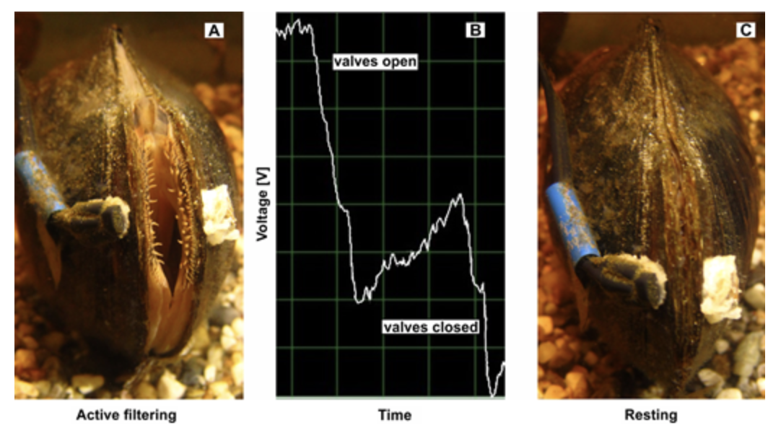

# Figure 1. Mussel Active Filtering (A), Voltage Output(B), Mussel Resting(C).

This project is intended to assist in research for the Food & Science Department at the University of Maryland Eastern Shore. By developing an oyster Activity Detection System, a dataset from the activity of the oysters will be derived and can be observed without putting addition strain on the oysters [3]. This would be extremely beneficial to ecologist and researchers as they can remotely monitor precise data from their experiments [14]. The dataset will be the basis for the development, evaluation, and use of the neural network developed. During this project, there will be models developed for photograph classification, and object detection to further investigate the activity of oysters. By creating this development, the department will have a better insight of the oysters’ behavioral activity with its environment. The Deep learning Convolutional Neural Network will be trained with an image classification model to observe each oyster individually. This neural network is intended to monitor the oysters’ amount of interaction, length of interaction, growth, and its overall adaptivity to its surroundings. This deep learning model will have the ability to integrate the feature extraction and classification process into a whole to record when the oyster is most comfortable.

The purpose of this project is to develop a SMART system that will precisely monitor the activity and interaction of oysters without the tedious strain imposed on their shell. By using deep learning approach to monitor the oyster’s activity the data will be recorded with increased accuracy. As previously stated, there methods on the market that will accomplish similar tasks as the system being created. However, the methods do not offer the precision and comfortability the system can guarantee.

### 1.2 Objective

The objective of this project is to design a program applying deep learning neural networks to monitor oyster activity level and create a website that displays data from the oyster activity level.

### 1.3 Design Requirements

The design requirements for this project are as follows:

1. Create program using a deep learning neural network to monitor activity levels for oysters with an accuracy of at least 90%.

2. Create a website for data analysis of oyster activity, and for the website to access the original data and identification results.

### 1.4 Design Constraints

This project has the following design constraints: ​

- There is only a $200 budget that can be afforded. This limits the type of materials that can be used and the type of software that can be used for the project. While a functioning project is obtainable, it would be able to function much more effectively if had a higher budget was available. ​

- The program can only process a total of up to 600 images at a time due to limited RAM and disk space.

- Since the program takes pictures based on image, the tank must have light inside of it to be able capture a good image. If there is no light available to the tank, then the system will not work because it needs like to take a good picture to process the image. ​

-If an air pump is added to the tank, the quality of the image may be affected. Since the image is being taken from the top of the tank, the picture needs to have still water so it can see the image through the tank. If the water has an air pump attached to it, then the water will not be still and the quality of the picture will be affected. So, if there is an air pump, an underwater waterproof camera might be needed. This camera is out of the budget. ​

### 1.5 Design Method

The first step in creating the project is to set up the lab environment for the project. The second step is to create an image processing program with a deep learning neural network. ​The third step is to test and evaluate the program. The fourth step is to make improvements to the program if necessary and then finalize it. And the fifth step is to create the website that features all data from the program available on it. ​

# Figure 2. Design Method.

## Project Description

### 2.1 System Description

## First, the camera takes pictures of the oyster shells, and the user forwards this picture to the image processing system in the raspberry pi. Then, the raspberry pi processes the image, and the results of this image being processed goes to a cloud storage service [4]. After the raspberry pi communicates to the cloud, the cloud will have data extracted from the image that was processed. It will store this data here in the cloud. The website will get its data from here in order to visualize the data from the program for the users to view. ​

### 2.2 System Diagram (or Flow Chart)

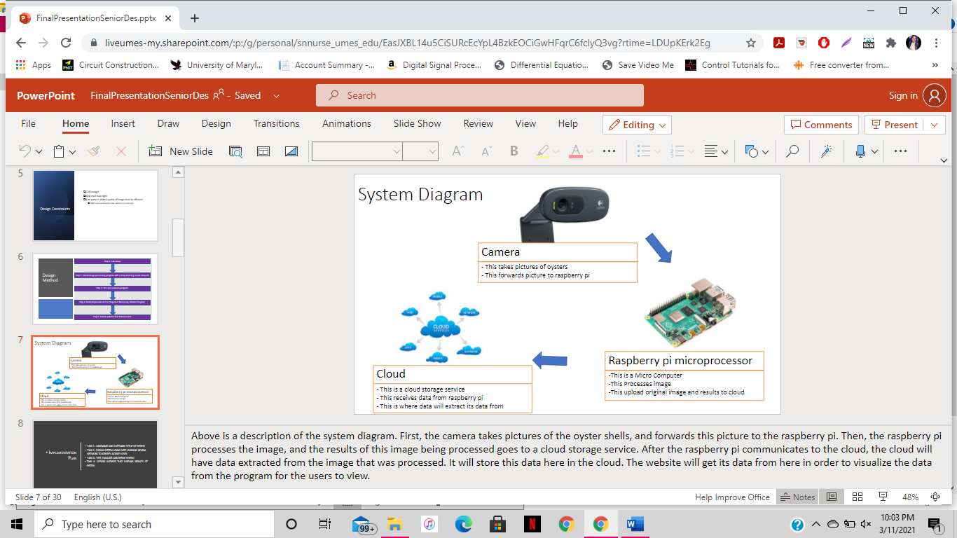

# Figure 3. System Flow Chart

### 2.3 System Functions

This system uses a camera which will monitor the oyster’s various activity. This information is then communicated to the Raspberry Pi [1]. In the microcomputer, there is a system design which utilizes Artificial Intelligence and a Convolution Neural Network to process the data extracted from the images recorded. The data is then transmitted to a local network for visual recordings [6].

## 3. Implementation Plan

### 3.1 - Tasks

All tasks are defined as the following:

* Task 1: Hardware and Software Setup of System
  + Subtask 1.1: Hardware Implementation of Lab Setup
  + -Subtask 1.2: Software implementation of lab setup​
* Task 2: Design Image Processing System Using Neural Networks to Identify Activity Level ​
* Subtask 2.1: Data Collection
* Subtask 2.2: Preprocessing Data
* Subtask 2.3: Create CNN Model
* Subtask 2.4: Run Training and Testing for Model
* Subtask 2.5: Post Processing Model Predictions into Decipherable Output
* Subtask 2.6: Deploying Model for Outside Usage​
* Task 3:  Test, Evaluate, and Refine System
* Subtask 3.1: Test System
* Subtask 3.2: Evaluate System
* Subtask 3.3: Refine System

* Task 4: Design Website that Displays Results of System
* Subtask 4.1: Data for Openings
* Subtask 4.2: Data for Closings
* Subtask 4.3: Numerical/Visual Archived Data
* Subtask 4.4: Contact information​

### 3.2: Team Organization

Team Member 1: Shanice Nurse

Team Member 2: Ashley Afueh

### 3.2.1: Responsibility of Team Member 1:

* Task 1: Hardware and Software Setup of system ​(50%)
* Task 2: Design System Using Deep Learning Neural Network to Identify Activity Level ​(50%)
* Task 3: Test, Evaluate and Refine system​ (50%)
* Task 4: Design Website that Displays results of system ​(50%)

### 3.2.2: Responsibility of Team Member 2:

* Task 1: Hardware and Software Setup of system ​(50%)
* Task 2: Design System Using Deep Learning Neural Network to Identify Activity Level ​(50%)
* Task 3: Test, Evaluate and Refine system​ (50%)
* Task 4: Design Website that Displays results of system ​(50%)

1. **Project Timeline and Delivery Plan**

|  |  |  |  |
| --- | --- | --- | --- |
| Time | Task | Responsibility Personnel for Ashley Afueh | Responsibility Personnel for Shanice Nurse |
| Week 1 | Task 1 | 1.1 | 1.1 |
| Week 2 | 1.2 | 1.2 |
| Week 3 | Task 2 | 2.1 | 2.2 |
| Week 4 |
| Week 5 | 2.3  2.3 | 2.4 |
| Week 6 |
| Week 7 | 2.5 |
| Week 8 | 2.6 |
| Week 9 | 2.5 |
| Week 10 |
| Week 11 | Task 3 | 3.1 | 3.1 |
| Week 12 |
| Week 13 |
| Week 14 | 3.2 | 3.2 |
| Week 15 |
| Week 16 | 3.3 | 3.3 |
| Week 17 | Task 4 | 4.1 | 4.2 |
| Week 18 |
| Week 19 |
| Week 20 | 4.3 | 4.4 |
| Week 21 |
| Week 22 | 4.5 | 4.5 |

## 4. Implementation

### Task 1: Design software for practice image identification

For the first task, the hardware and software setup for the system was done.

### Subtask 1.1:

In this task, the shells were glued together in various different positions using a glue gun. These positions represented how the oysters were positioned in real life. The oysters had 3 positions, which were completely closed that was open by 0cm, slightly opened, which had a shell opening of 0.5cm, and largely open, which had a shell opening of 1cm. Once the oysters were completely glued, they were put in the tank. ​This task can be illustrated in Figure 4 below.

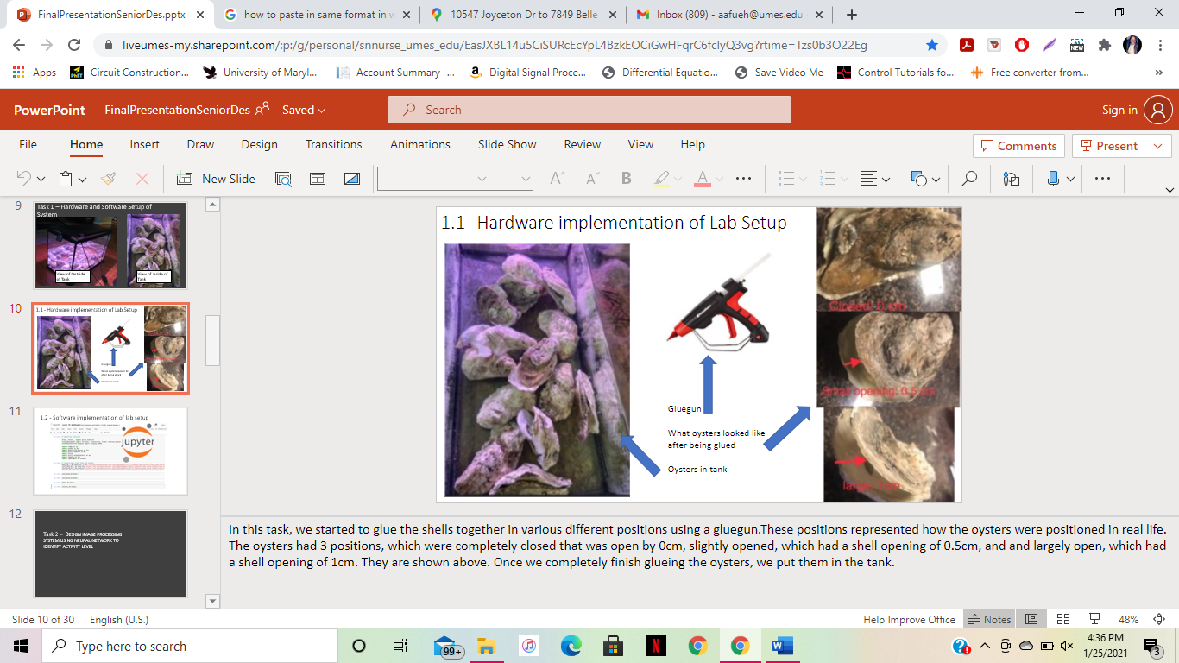

# Figure 4: Depiction of Glued Oysters

### Task 2: Design Image Processing System Using Neural Network to Identify Activity Level

In order to have the program identify the oyster shell's position while they are in the tank, an image processing program was created. An image processing program is a computer science program where the operations are performed on an image, in order to extract some useful information from it [2]. The input is an image and output may be image or characteristics/features associated with that image. In this case, the input was the pictures taken with the camera and the output was the classification and identification of the position of these oysters [15]. ​

### Subtask 2.1: Data Collection

Before the image processing system is created, a model needs to be created, trained, tested, and validated. In order for that to happen, images must be created in for the model being trained, tested, and validated. First, images must be obtained in order to create the data for the model. 750 pictures of the oysters were taken. There are 3 folders – 600 images in the training folder, 112 images in the testing folder, and 38 images in the validation folder. Each of these folders include pictures of various different oysters in various positions. The following figure, Figure 5, depicts the different types of pictures of oysters used for this process.

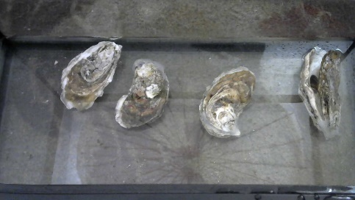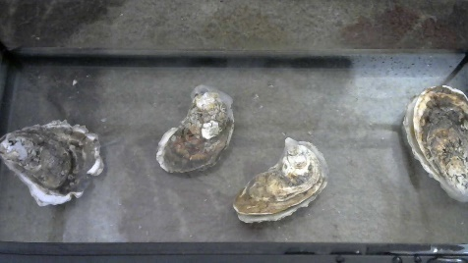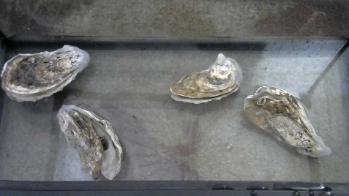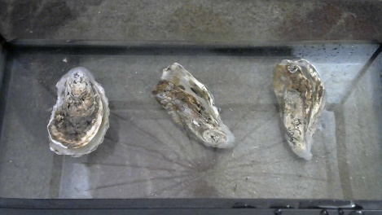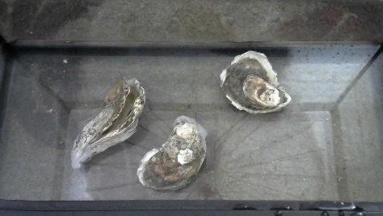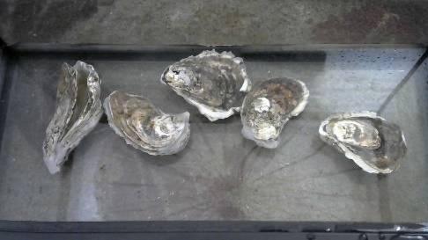

# Figure 5 – Depiction of Different Types of Oysters

### Subtask 2.2: Preprocessing Data

It is obvious for the human eye to determine whether an oyster in in different positions, but it is not obvious for a machine to determine such a position. This is why images had to be translated from the input to the program, which are images of oysters in different positions, into an input that a machine can actually understand. This is called **preprocessing** the data. Preprocessing the data changes the dataset from data that humans can understand into data that machines can understand. Preprocessing the data changes the dataset from .jpg pictures into **arrays**. Arrays are numbers that resemble the pictures that is used by the model for input data. Arrays essentially resemble these pictures in numbers so the program, written in the coding language “python”, can read and comprehend it.

In order for the image to be preprocessed, the number of different **classes** in the data must be identified. Essentially, classes are just the different categories of data. There are 3 classes here: closed, largely open, and slightly open. The training data must have labels for what system will identify in the picture. There are 750 images available in the data for the training process.

Once the data is collected, it’s time to annotate and label these images. Since the object detection model learns from the data that it is shown, in order to train an object detection model to detect the oysters, a labeled dataset of pictures must be created. The 750 pictured dataset is broken down into different folders for the training process. During the training process, 80% of the images will be used to train the model on what to identify in the image. The remaining 20% of the images will then be used on testing the model in order to test what the model can identify. It will be tested twice, with 15% of the images being used for regular testing, and 5% of the images being used for the validation, which is the final testing. This means that there will be 600 images (and their respective .XML files) used for training, 112 images (and their respective .XML files) used for testing, and 38 images used for the validation, or final training. The images in validations will be able to be visually seen when the second set of testing is run.

The object detection model used in this project uses bounding boxes to classify objects in an image. The images were given classes by drawing **bounding boxes** around each oyster in the picture, which gives the oysters a class. Bounding boxes are rectangular grid coordinates drawn over the object of interest in an image. Bounding boxes were drawn around each object that the was desired to be seen by the detector, and each box was labeled with the object class that was desired for the detector to predict These boxes are then saved in an extensible markup language format, or .XML. These .XML files have data annotations of the object of interest (which is the hand in this case) in the format of X and Y grid coordinates. The .XML files will later communicate to the model what parts of the picture should be the object of interest to the model, thus making it able to identify the oyster. The use of bounding boxes can be depicted below, in Figure 6 and Figure 7.

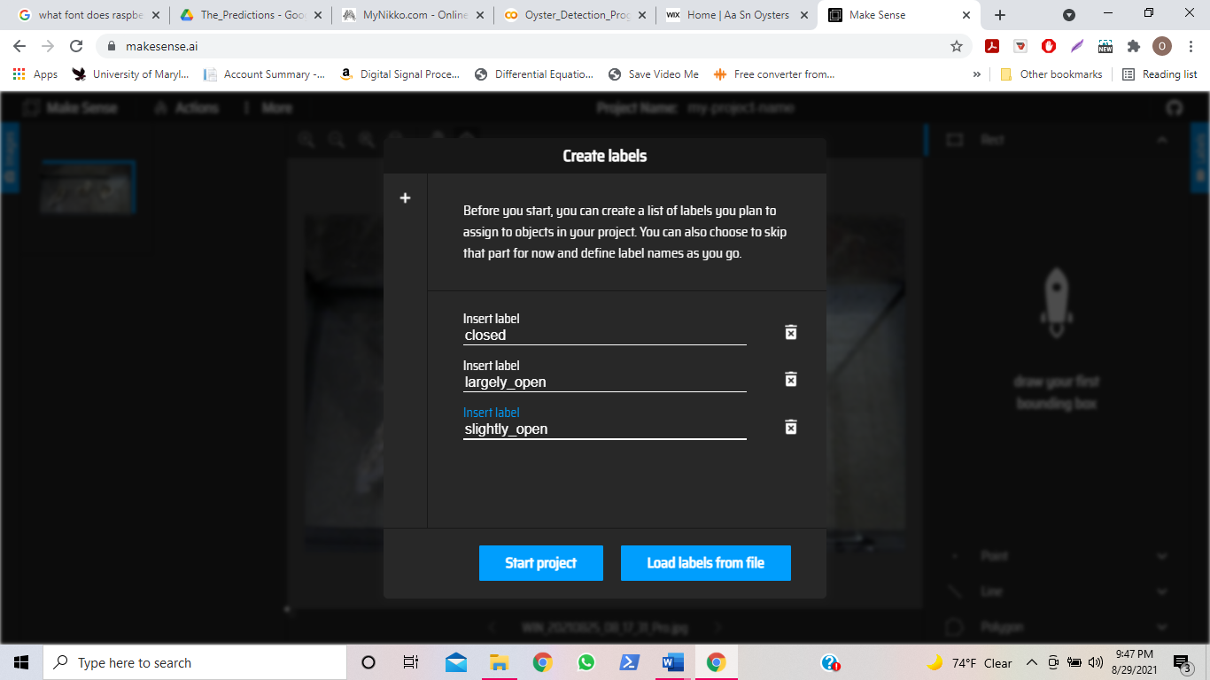

Creating Labels

# Figure 6: Usage of Bounding Boxes (1)

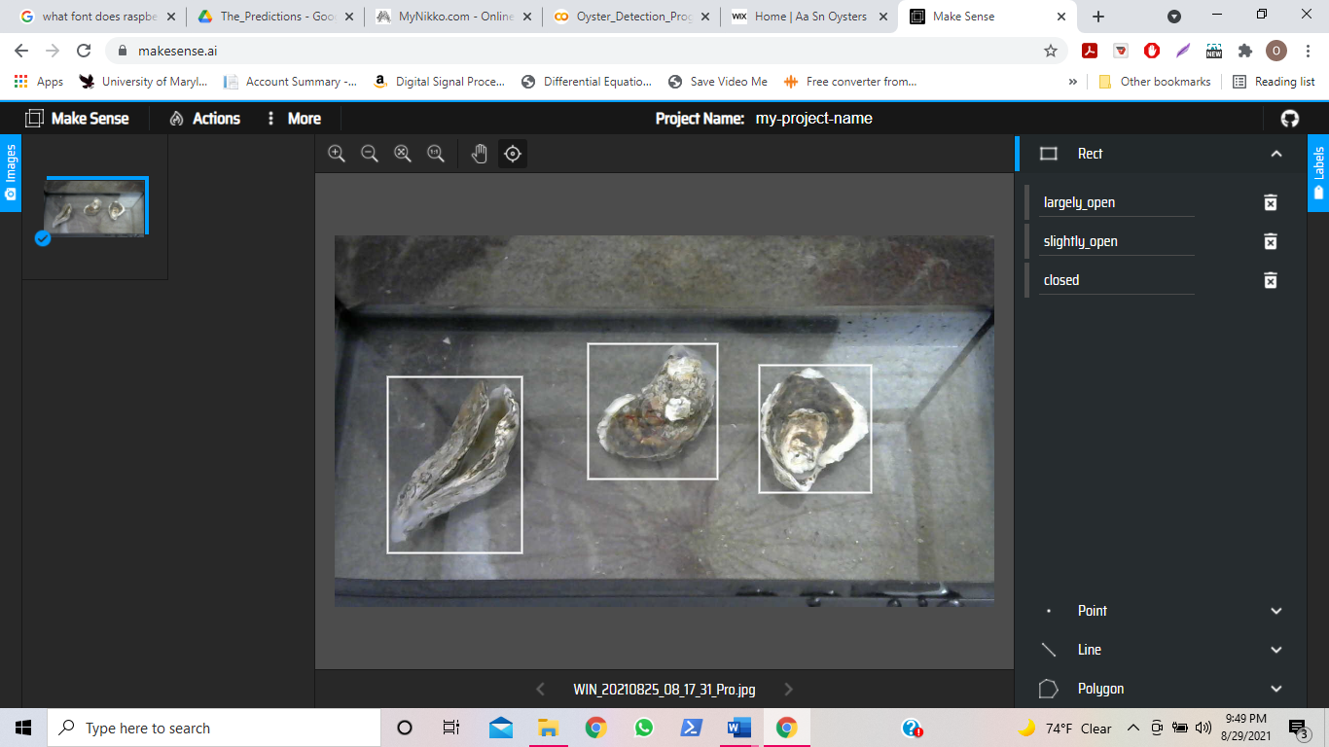

Class 3 – “Slightly_Open”

Class 2 – “Largely_Open”

Class 1 – “Closed”

# Figure 7: Usage of Bounding Boxes (2)

After all the photos and their respective .XML files are obtained, these images and their respective .XML files are concatenated into .CSV files. A **.CSV** is short for a comma – separated value file, and these files include the grouped list of all of the .XML files for each image. This is done for the .XML files in the testing folder and the .XML files in the first training folder as well. This returns 2 CSV files. The .CSV files are then translated into arrays, which, as stated before, are decipherable to the machine learning system. In addition to CSV files being created in this step, a label map is also created in this step, which basically is a map generated from the .CSV files that tell the system what classes the images contain, which are closed, largely open, and slightly open in this case. This label map helps in identifying the images during the final testing step and later when the model is used for real time usage on a website.

And finally, the images are resized before they go into the model in order to create a faster training time. The images are resized into a different dimension. The smaller they are, the faster it is to train. The original images which had dimensions of 1280x720, were resized them into images with dimensions of 300x300.

### Subtask 2.3: Creating the CNN Model

Next, the model is created. This is done by defining the **model architecture**. The model architecture is a list of parameters set to define what the model is going to do, and what the structure of the model will look like. The goal for the project is to create a system that can identify different oyster positions. The input to the system would be a picture of oysters in different positions while the output would be determining what position these oysters are in. A **model** is essentially a function with different trainable parameters that receives an input that is fed to it, and generates an output based on what the model was trained to deliver when given an input. The model that was created was very similar of that of the tensorflow object detection model “Mobilenet V2 SSD”. This model can be viewed at the following website: <https://colab.research.google.com/github/luxonis/depthai-ml-training/blob/master/colab-notebooks/Easy_Object_Detection_With_Custom_Data_Demo_Training.ipynb?authuser=1#scrollTo=9z8kgcs0E7iV>

The first thing to do is to set the number of layers and nodes for each layer in the model. Models consist of layers and nodes. These layers and notes together create a network of layers that make up a model. **Layers** are the building blocks of a model, and they are a series of bridges that, when put together, create a series of a network that can learn trainable things about a model. Each layer changes the shape of the output of the data you put in the model. These layers are made up of nodes. **Nodes** are little computational units that have weighted input connections, and transfer functions that combine the inputs and output connections. This structure comes together to create a **convolutional neural network, or CNN**. A CNN is a type of network that the model uses where images that are used as input data combine with, or “convolve” with matrices to come to an output. This happens by filtering results in a feature map which help to extract data from these features and make predictions about an image. Within the model, there are 156 layers total, and 52,264 nodes total. Each layer has a specific task assigned to it, aka a specific function it will be carrying out when the model starts training. The different types of layers include 1 input later, 35 two dimensional convolutional layers, 51 batch normalization layers, 34 “relu” layers, 19 depthwise convolutional layers, 10 add layers, 4 zero padding layers, 1 global average pooling layer, and 1 output dense layer. The model is heavily based on the Mobilenet v2 SSD object detection model by Tensorflow. Tensorflow is essentially engineering encyclopedia. This model has a 98% success rate, which is why it was selected as the standard for this specific model. The following figure, Figure 8, depicts what the model looks like, descaled by a degree of 10.

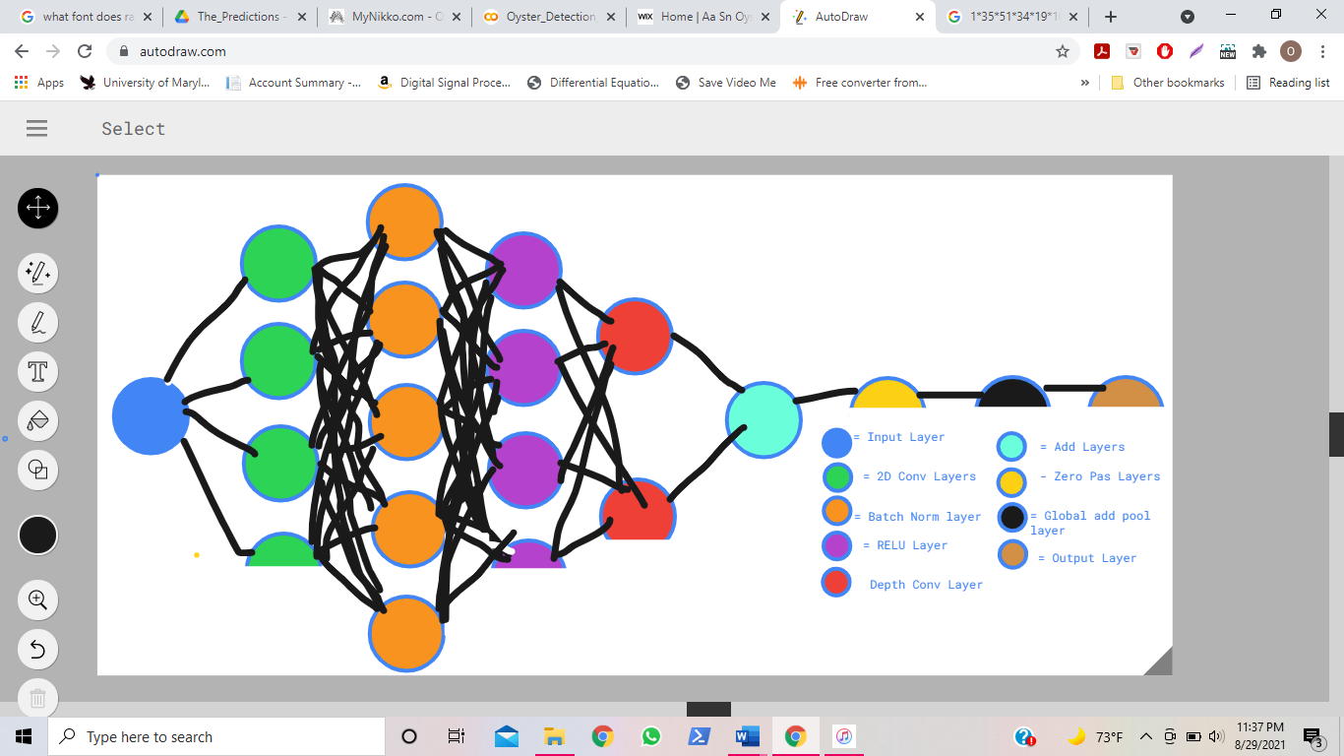

# Figure 8: Descaled (x10) Depiction of Object Detection Model

CNN’s consist of layers, and these layers consist of nodes. Each node is connected with each node from the next layer and each connection, which is the black arrow has a particular numerical numbered weight. Weight can be seen as impact that that node has on the node from the next layer. The data from these nodes are put in a vector and calculated to give an output of a specific number. This number will be able to represent the output of data. ​

​

Within this convolutional neural network, a system of layers will be created and those layers will consist of nodes. These nodes are what the image passes through to become identifiable. A node is a computational unit that has one or more weighted input connections, a transfer function that combines the inputs, and an output connection. Nodes are then organized into layers to create the CNN.

It is vital to explain what each layer in the model does to understand the image processing process. The **input layer** takes the input picture and resizes it from 1280x720 to 300x300. It also has an output of 3 because it separates the classes into 3 categories. There is only 1 input layer because it only needs to be resized once, and will only get inserted into the CNN once. **Convolutional layers** apply a filter to an input that creates an activation. As the activations keep happening as the images pass through the layers more and more, the applications keep repeating. Repeated application of the same filter creates the activations. These activations create something called a feature map, which determine the strongly educated estimate of the locations and strength of a detected feature in an input, which, once again, is an image in this case. A neural network is a system of units designed to compute an output through a mathematical process [11]. A CNN grasps the importance of filters using images as input data. Convolving an image with filters results in a feature map which help to extract data from these features and make predictions about an image. **Batch Normalization** layers add extra layers in the CNN in order to reduce the time of training and create a more sequential and structured way of training. It also adds non-linearity to the model. A batch normalization layer makes the activations pretty set and standard. This way, the previous layer will maintain the same allegedly correct assumptions that the model is trying to identify. It makes sure the weights, or “guesses about the correct answer”, in the nodes do not chase way too severely. This, in return, makes the training process faster than before because the correct answer to the guesses is copied and pasted from layer to layer. Also, adding non-linearity to the model is very important because it is vital in giving an answer that will detect the desired object. When non-linearity is added to the model, it will be better able to give predictions because it is able to capture better different characteristics that help to identify the image. **Relu layers** are layers that start the activation spoken about in convolutional layers. While utilizing trigonometric functions including the sigmoid function and hyperbolic tangent activation function, relu layers either give an output of the direct input if the magnitude of the output is positive. If the magnitude is negative, it will give an output of zero. Relus transfer the data into non-linear data used in batch normalization. **Depthwise convolutional layers** basically interpret the amount of RGB in each pixel within an input. RGB stands for the three basic colors that a picture is made up of, which is red, green, and blue. When the input goes through the Depthwise convolutional layer, the “redness”, “greenness”. and “blueness” of each pixel is counted. What it counts is called channels. This helps later because when this layer splits the images and disperses them into channels, the channels are organized and stacked in a manner of similarity, making the process of feature extracting to identify the object in the image easier. **Add layers** are essentially just more layers added to the CNN for better performance. When the input goes through more layers, it adds more filters to the model, which steers the output in the right direction by making it capable of identifying more features needed to detect the desired object, and in turn strengthens the set structure of the output. **Zero padding** layers are layers added to the model to ensure no information given to the model is lost or forgotten about. It also makes sure that the image’s input dimensions will match with the images output dimensions. **Global average pooling layers** basically reduces the total number of parameters in the model in order to make sure the model does not overfit. **Overfitting** essentially means when the model is overtrained and thus gives error because there are too many parameters for the given data set. Also, these layers create a label map for each corresponding class that was created in the preprocessing step. The last layer, which is the **output dense layer**, takes all of the previous weights, or “guesses” that the nodes produced from the model and transfers it to the last output (itself) in order to make a strongly educated guess on detecting the object in the image.

After the architecture for the model itself is created, it is time to start the training session that the model is going to go through. The **training session** is a process where the model begins to be trained, and the data is put into the CNN in order to train it for an outcome. The training works as follows: input data is given, which is the pictures, to the model, and the model trains itself to give an output of strongly guessed estimations on what class the object is in. It does this over and over again until it starts to give accurate answers. But before the training session can start, certain parameters must be set for the training session to adhere to. First off, the number of epochs for each training session must be decided. **Epochs** are the amount of training iterations that the model will complete. Within 1 epoch, the model went through an entire iteration of training. After each iteration, the model improves itself. In this case, 125 epochs were chosen. The **batch size** for each epoch must also be chosen. The batch size basically means the amount of training examples used in one epoch. 24 was chosen as the batch size. The number of classes are 3, since there are 3 types positions that will be identified. For the model to be utilized during training, it needs an activation function. When the model is being trained, various nodes give a numerical output after being given an input. This numerical output (called weights) is the result of an arithmetic function from called the activation function. The activation function used in this model is “relu”, which, similar to the “relu” layers, will utilize the trigonometric functions sigmoid and hyperbolic tangent to yield an output. The **optimizer** is then defined. Optimizers change the characteristics of neural networks, including the learning rate or the weights of the outputs in order to reduce error in the model. The optimizer chosen was the RMS prop optimizer. This optimizer uses the magnitudes of the error in the weights and returns only a certain type of magnitude back to the network such that the error is reduced by the correct amount. This also helps the model reduce error because if the errors are defined in a strict manner, then the model will be trained in an arranged fashion, thus reducing error. Another parameter that must be defined is **loss metrics**. The loss metrics are the numbers given that determine how much error is reducing in the model training. However, in order to identify how much error is reducing, what an error is must first be defined. There are two types of errors that will be identified. The first error is whether or not the model detected the correct class of the object in the picture and the second error is how far away the guessed bounding box is from the original bounding box being drawn. The first and second error are referred to as the **classification loss** and the **localization loss**. How far away the model was from guessing the correct answer is determined by using a similarity calculator. The similarity calculator chosen was the **IoU (Intersection over Union) similarity calculator**. This means that when an object is identified, the model will take the bounding box that was originally labeled there, and intersect the area of that box with its own bounding box in order to create the final bounding box prediction on that image. Also, in order for the convolutional layers to work, a kernel size must be added. What a CNN does is this: it puts a numerical filter on the images to later group different parts within the filter and extract features from these images to detect an object in them. The filter that the CNN uses is called a **kernel**. The kernel is defined by a **kernel size** which is the width and height of the feature mask. The kernel size used for the model is 1.

Now that all of the parameters are set, it is time to run the training and testing and then do the final testing (validation) right after.

### Subtask 2.4: Run the Training and Testing for the Model

Now that all of the parameters are set, it is time to begin training, testing, and validating the model. The training model is started by calling the “training” command to start the model.

Like stated earlier, the way the training works is as follows: the model essentially runs the pictures through itself, creates guesses on detecting the object, saves those guesses, and tries over and over again to try to detect the object until it learns what the object is and where it is in the picture so it can detect the object over and over again. The model will train itself to try to identify the objects in the images with the training pictures, and will test what it can train on the testing images. The way the model will know whether it is right or wrong when trying to identify the testing images is as follows: the testing images are already labeled in terms of their class and where they are on in the picture (due to the bounding box). The model will make an educated guess on where it identifies the object and what class it belongs to, and will deliver an error percentage during every epoch that depicts how much error the model had during its guess.

Like stated earlier, 125 epochs were used. Each epoch took, on average, 45 seconds to complete. The entire training process took about 2 hours. For every epoch, the model shows the total loss number. This total **loss number** is a combination of the classification loss number and the identification loss number, and this loss number is telling the amount of error that is being lost from the model every time the model runs through an epoch. The loss number is given in terms of a percentage. So, for example, if the loss number for a given epoch was 3.74930, then that means that the model currently has an error rate of 3.74930%. This also means that it has a success rate of 96.2507%. The model started off with a loss of 4.942403%, and ended with a loss of 0.50429666. This means that the model started off with an accuracy of 95.057597% and ended with an accuracy of 99.49570334%.

After the model was done with all 125 epochs, it went through a final test called **validation**. Validation uses the pictures that were set away for the final training and basically tests them to see if it can identify the pictures or not. Essentially, it’s the same thing as the regular training but can be visually seen by users. The following figure, Figure 9, depicts what the model can identify in the validation process.

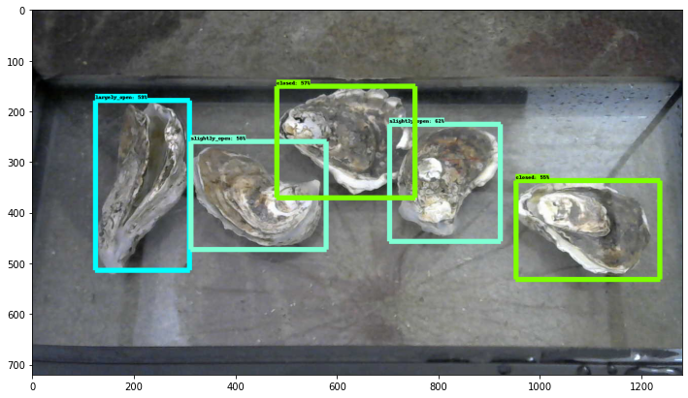

# Figure 9: Depiction of What Model Can Identify in Validation Process

As shown, the model gave the images labeled as largely open a bounding box with a light blue color (similar to this). The model gave the images labeled as slightly opened a teal blue-green color (similar to this). The model gave the images labeled as closed a light green color (similar to this).

During the validation process, the model was fed 38 pictures with oysters in various different positions and was given as task to identify every oyster in each image and its position. In regards to identifying each oyster in the image, the model identified 132/144 oysters. In regards to identifying each the position of each image that it actually did identify, the model identified 132/132 oyster positions correctly. This gives the model an accuracy of 95.5%.

While the model was running through different epochs, the tensorflow graphs visually depicted the model becoming more and more accurate as it was being trained. The model was set such that the graphs of the different training parameters as it was training was viewable. As it improved itself, the training parameters’ accuracy increased, thus depicting a positive

increase in slope on the graph. Figure 10, the figure below, depicts the training parameters

graphs as they went through the program.

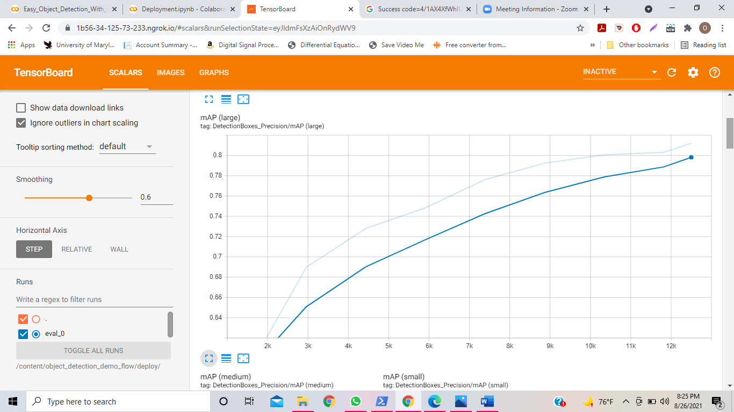

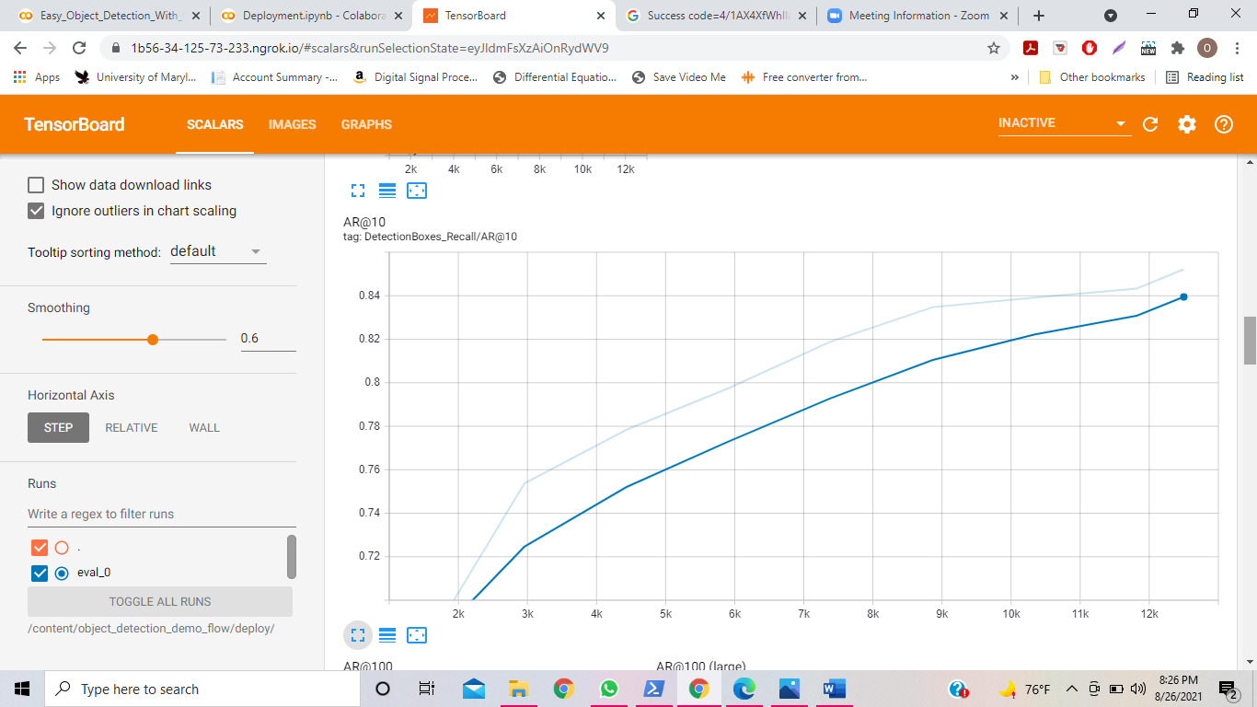

# Figure 10: Graphical Representation of Training Data

The graphs in Figure 10 are **mean average precision (mAP)** **graphs**. Basically, mAP graphs measure the performance of the model doing object detection tasks. For the graph on the top, the model calculates the classification, which is whether it identified the correct class of the object in the image, and how far off it was from the correct answer, and returns a score of how accurate it was. The closer the image was to detecting the correct class, the higher the score will be. It did this for every epoch. For the graph on the bottom, the model calculates the localization, which is the comparison of the actual bounding box of the image to its estimated bounding box in the image. It compares its coordinates, and then returns a score of how accurate it was. The closer the coordinates are in proximity, the higher the score will be.

When the model was finished training, it was saved in the photobut (.pb) format, which is a format compatible with TensorFlow.

### Subtask 2.5 – Post Processing Model Predictions into Decipherable Output

When the model is run, it returns labeled pictures of what it identified and numerical values as an output. The pictures are something the average person can identify, but the numerical values are only decipherable to computers and not to humans. This is where the label map comes into play. The label map is a map created when the model was being created that assigned a numerical value to each class in the program. The label map was assigned to the classes as follows: 1 = the closed position, 2 = largely opened position, and 3 = slightly opened position. Also, the model gives multiple guesses on what each oyster position could possibly be, and gives a score to each position it identified. The score is how close the model thinks it is to the right answer. The closer the score is to 1, the more likely the model guessed the correct answer. For example, say the model an oyster as “2”, and guessed that the prediction for “2” gave a score of 0.97. This means that since the score for the prediction “2” was very close to 1, and 2 is the largely opened position, then the model strongly believes that the identified oyster is largely opened.

When the model is doing its predictions, it was coded in a way such that it saved the predictions of the output in a numerical format in a text file. The text file was then uploaded back into the system as an array, and this array was written to a google excel file. The google excel file was then programmed such that it tells the user how many 1’s. 2’s, and 3’s are spotted in an array, and in return, depicts how many closed, largely opened, and slightly opened oysters are in each picture. This way, the user is given a numerical archive of each picture’s oyster activity.

### Subtask 2.6: Deploying Model for Outside Usage

For the next task, the model was deployed in order for other users to be able to utilize the program. Now that the model is trained and saved, it is time to deploy the model. To **deploy** a model means to export the model to a production environment so it can be utilized by a web application and consumers and detect images for them. The production environment that will use is a production environment called “Google Colab”. The production environment and can change the user settings to be able to be utilized by anyone on the internet. Therefore, it is best to create a web application and web page where consumers can upload pictures of their oysters so the model will detect what position each oyster is in, and depict the oyster activity level on a visual and numerical basis.

The web application (which would be Google Colab) will get the data (which would be the pictures) that is given to into it, and, through a command, send the data thorough the CNN model that was created, and then give an output. This output is then fed to the web service (which is a website created) that it will be served through. The web service will receive this data and then construct an output based on the data it receives. The web page displays this output it was given to the consumers using it. These widgets have a lot of back-and-forth communication with the production environment.  This back-and-forth commination is what happens when a webservice is built that uses tensorflow model to detect objects. ​

A google colab notebook was created for the user to insert their data into. The model was embedded into this google colab notebook, and created in a way such that it can receive data (i.e., the pictures) and return predictions on these pictures as output. The predictions that the model gives to these pictures, along with the number of different positions within the model, is then exported into a google excel sheet. This data from this google excel sheet is then embedded into a website for users to view their oyster activity data.

### Task 3: Test, Evaluate, and Refine System

In this task, the system was tested, evaluated, and refined for finalization.

### Subtask 3.1: Testing System

The system was run in order to be tested. This task was very important in the project because it found any errors in the system in order to fix. After finding the best lighting position for the oysters in order to take clear pictures, and fixing any errors the Google Colab notebook, the program was tested. The camera took a picture every 1 minute for an hour, and then was loaded into the program. The position of the oysters changed every 1 minute. The following figure, Figure 11, depicts some images of properly identified oysters.

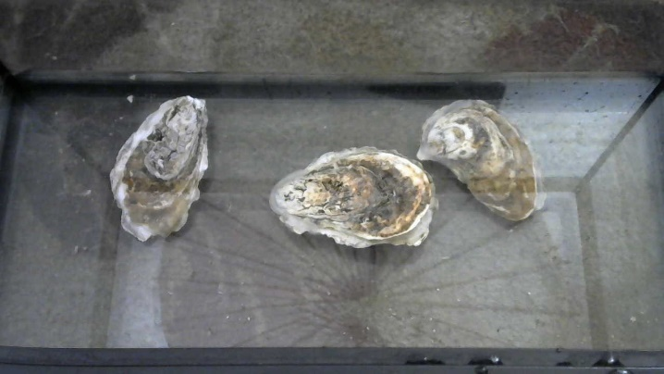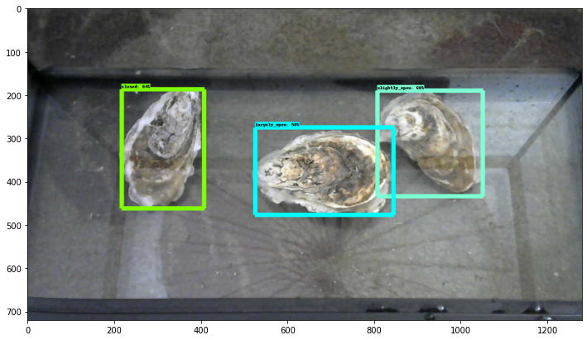

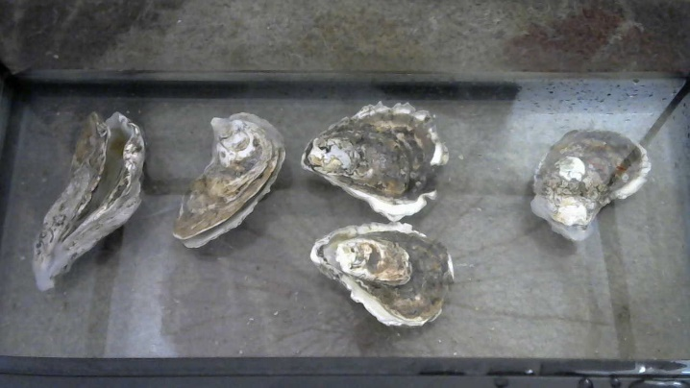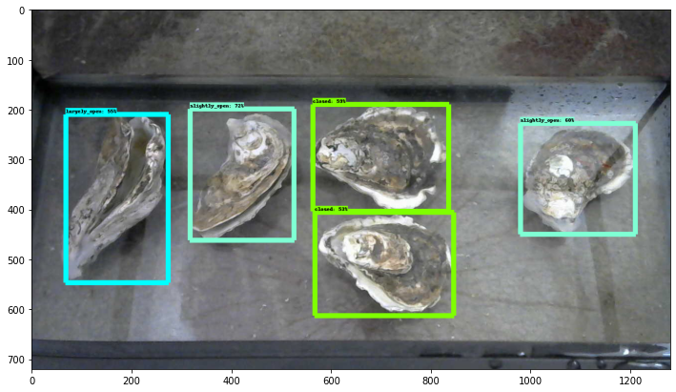

# Figure 11: Properly Identified Images

### Subtask 3.2: Evaluating the System

The system was then run in order for its accuracy to be evaluated. This task is very important in this project because it finds any errors in the system in order to fix. After finding the best lighting position for the oysters in order to take clear pictures, and fixing any errors the google collab notebook, the program was tested. The command prompt camera took a picture every 1 minute. Therefore, there were 60 images taken. Out of those 60 images, there were 151 oysters total. The system identified 139 out of 151 of these oysters. Out of the 139 oysters that it did identify, it identified all 139 oyster positions correctly. This yields a total accuracy of 96.03%

### Subtask 3.3: Refining the System

The system was refined and finalized in this step. This was just a troubleshooting step. Essentially, this step just reinsured everything was running smoothly, and any errors were taken care of.

### Task 4: Design Website that Displays Results of System

In this task, the website was generated using a free website database. This website obtains all of the information regarding the oyster activity levels. This task is important because the user will have a way to visually view the data and extrapolate essential information from that data. This data will be embedded from a file from google sheets, which is a data source that will be used with the project due to it being compatible with the code that will be used for this project. ​The data will run as long as the user desires and can be stopped and reset by the user. However, it should be noted that due to limited Hi-RAM and disk space, the program can only handle 600 images at a time.

The website will show the data in the format as shown via the tabs above. There will be a viewing for large and small openings, total openings, total closings, archives, and contact information for help. ​The website was configurated fairly easily. It was a user-created website with self-helping tools that allow users to create pages and websites without any programming tools. The layout and formatting of the webpage was made possible by the easy self-designing website.​ The following Figure, Figure 12, depicts what the website looks like.

​

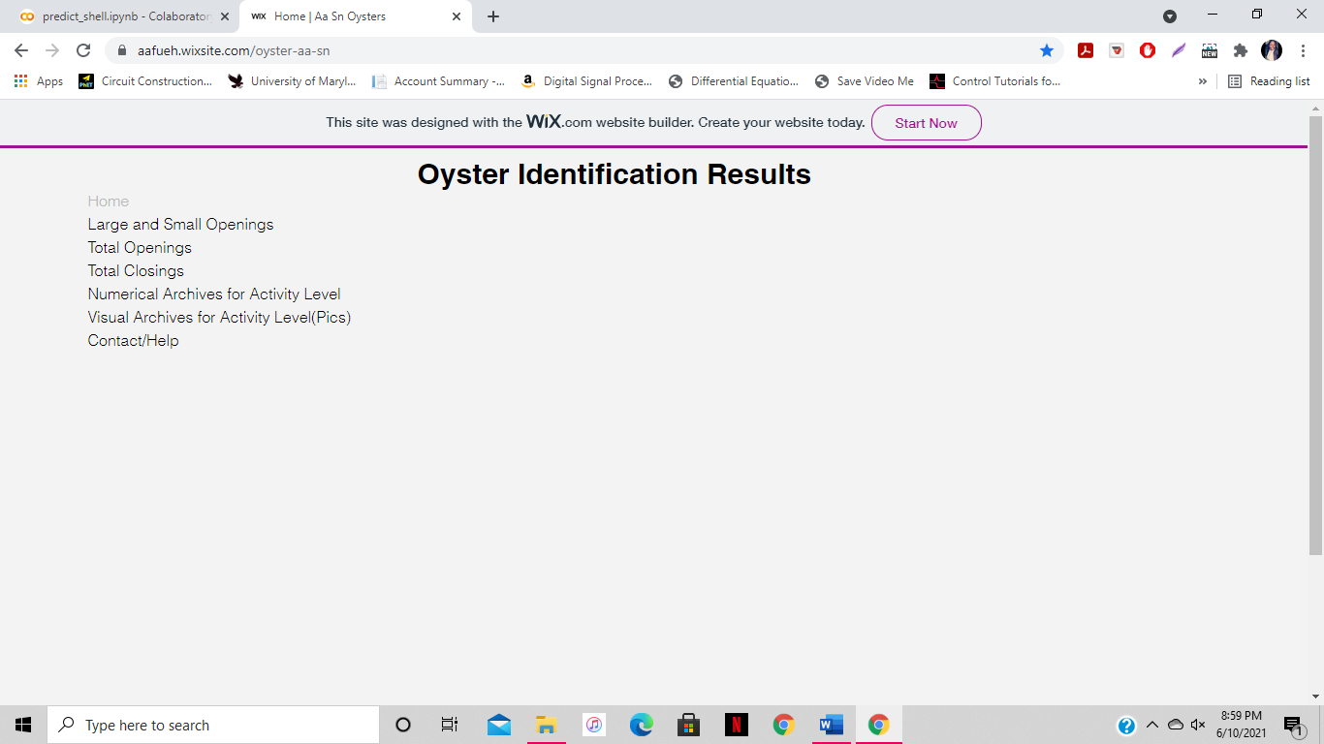



# Figure 12: Depiction of Design of Website

### Subtask 4.1: Data for Openings

The number of opened oysters can be viewed in 2 ways – total openings overall or small and large openings. If the user would like to see the entire number of openings, they can do that in the second tab, where the entire openings will be shown. If the user wanted to see how many were small openings and how many were large openings throughout the time, the user can go to the first tab, where the large and small openings are differentiated. The following figure, Figure 13, depicts the graphs for the total openings, and the large and small openings. ​

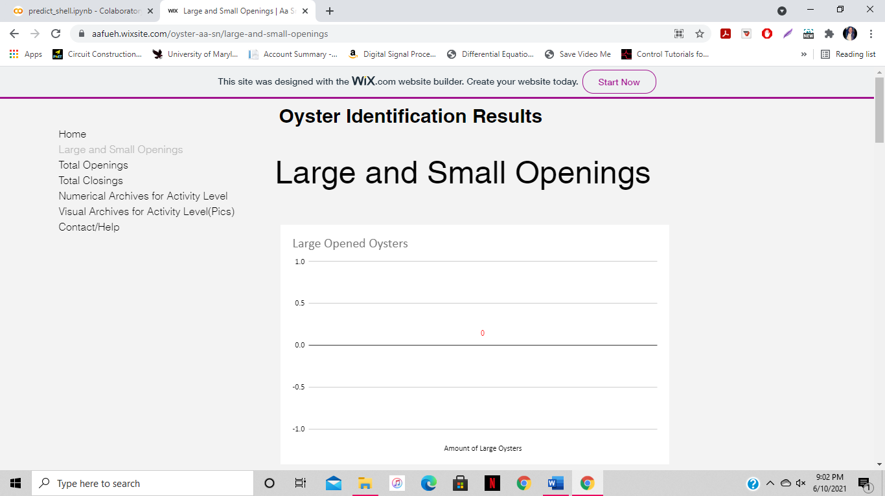 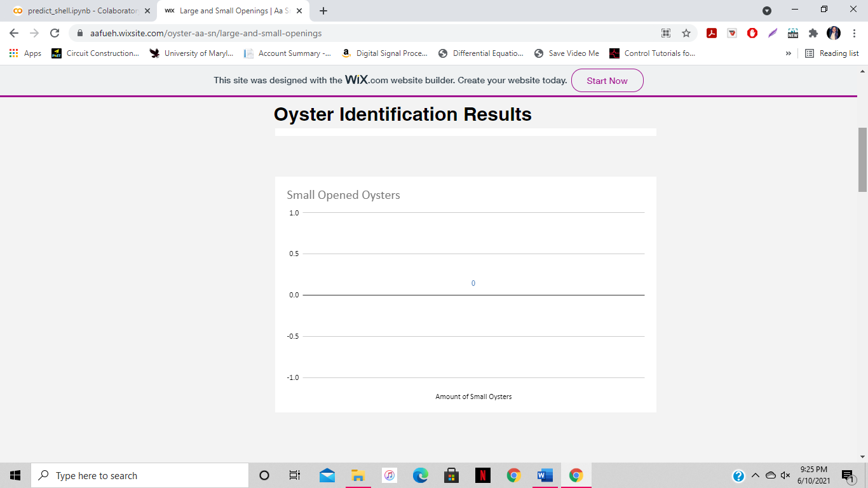

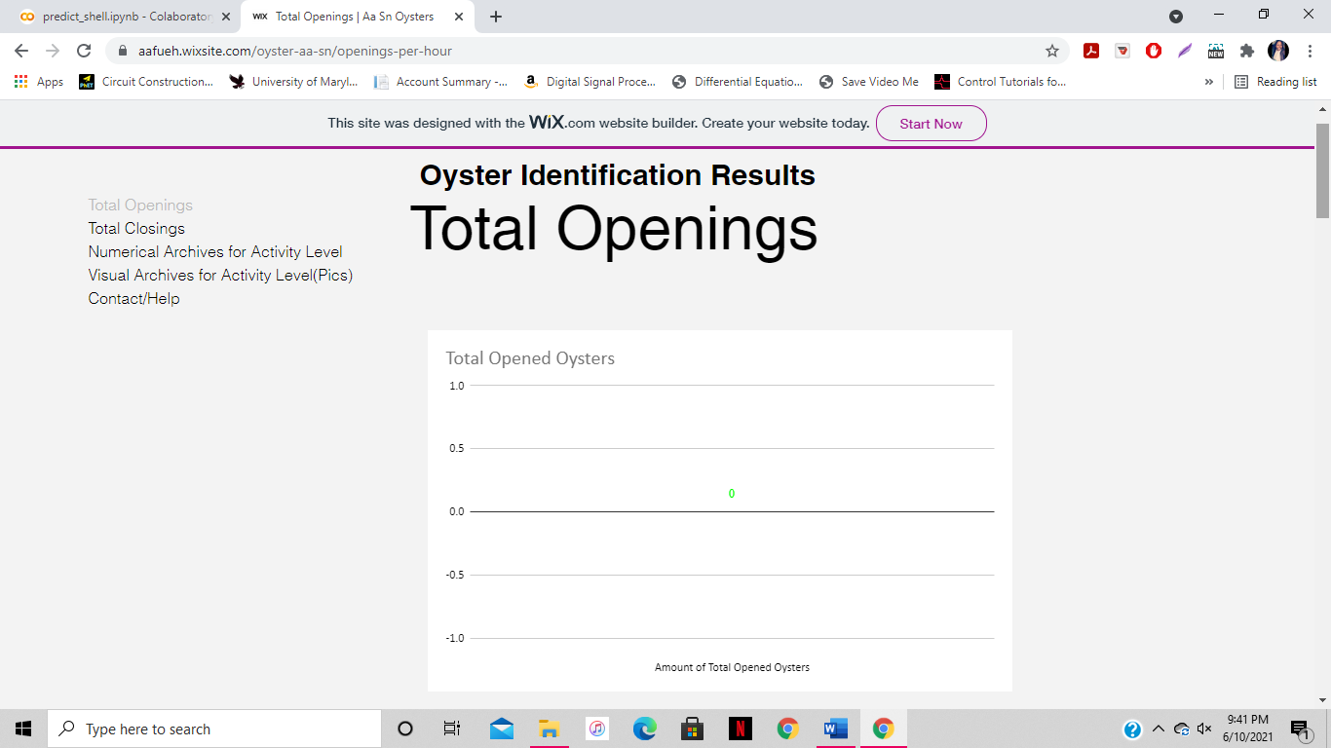

# Figure 13: Depiction of Tab for Data for Openings

This part of these webpage was configured by adding a new tab to the webpage, and embedding graphs from the google spreadsheet that includes the output data there. The following figure, Figure 14, depicts the configuration of these webpages.

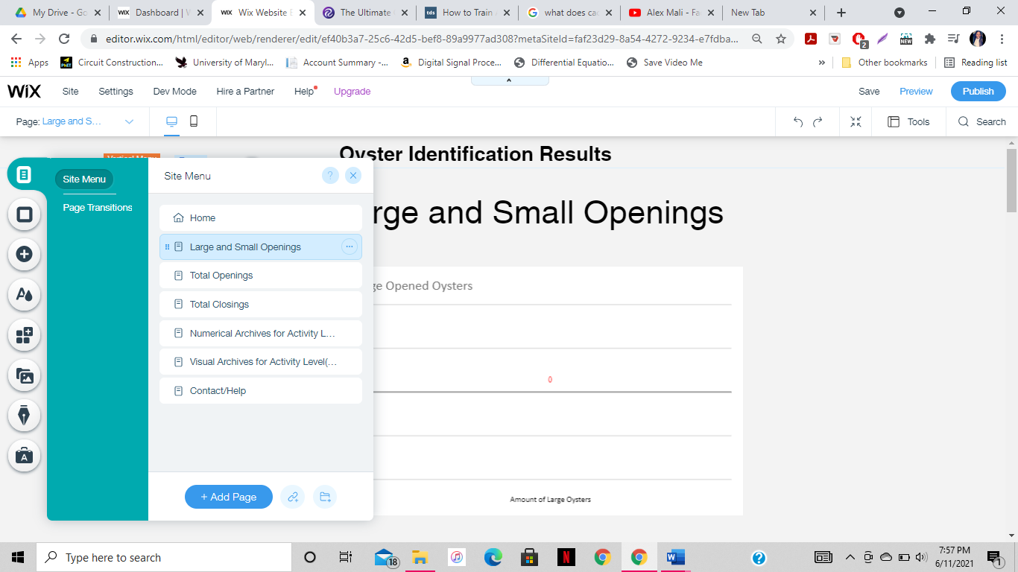 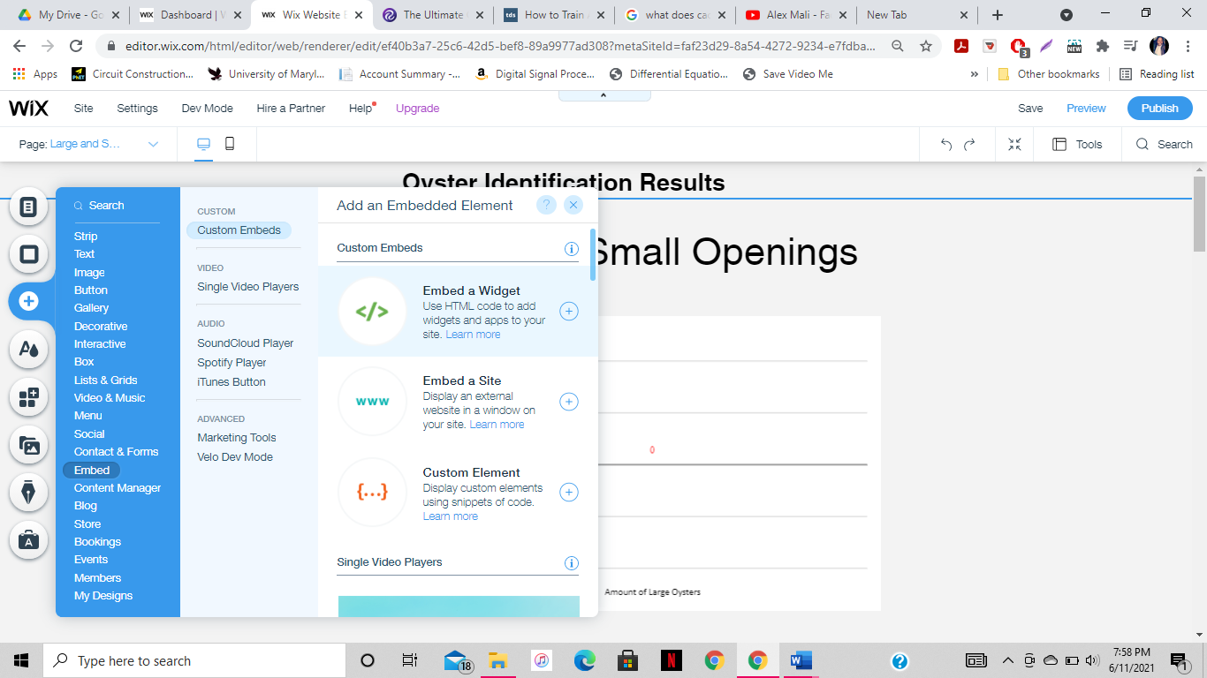 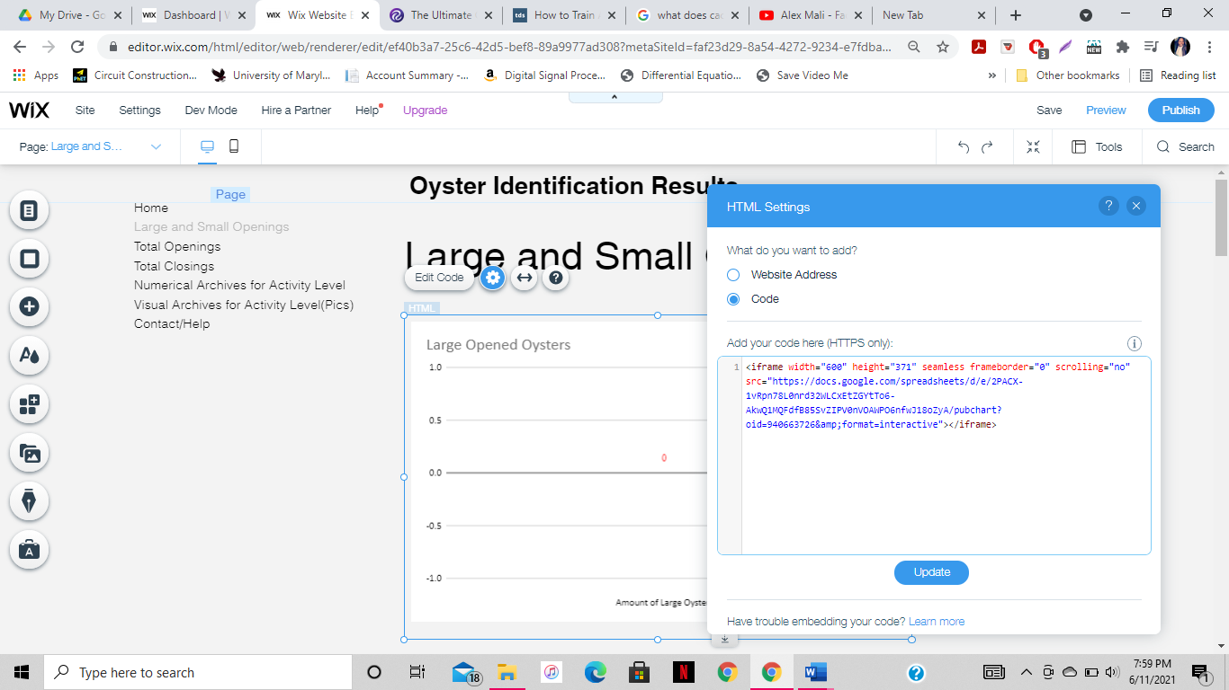

# Figure 14: Configuration of Openings Webpages

### Subtask 4.2: Data for Closings

The number of closed oysters can be viewed in the fourth tab. This will tell the user the amount of closed oyster shells. ​The following figure, Figure 15, is a depiction of a tab for the data for the closings.

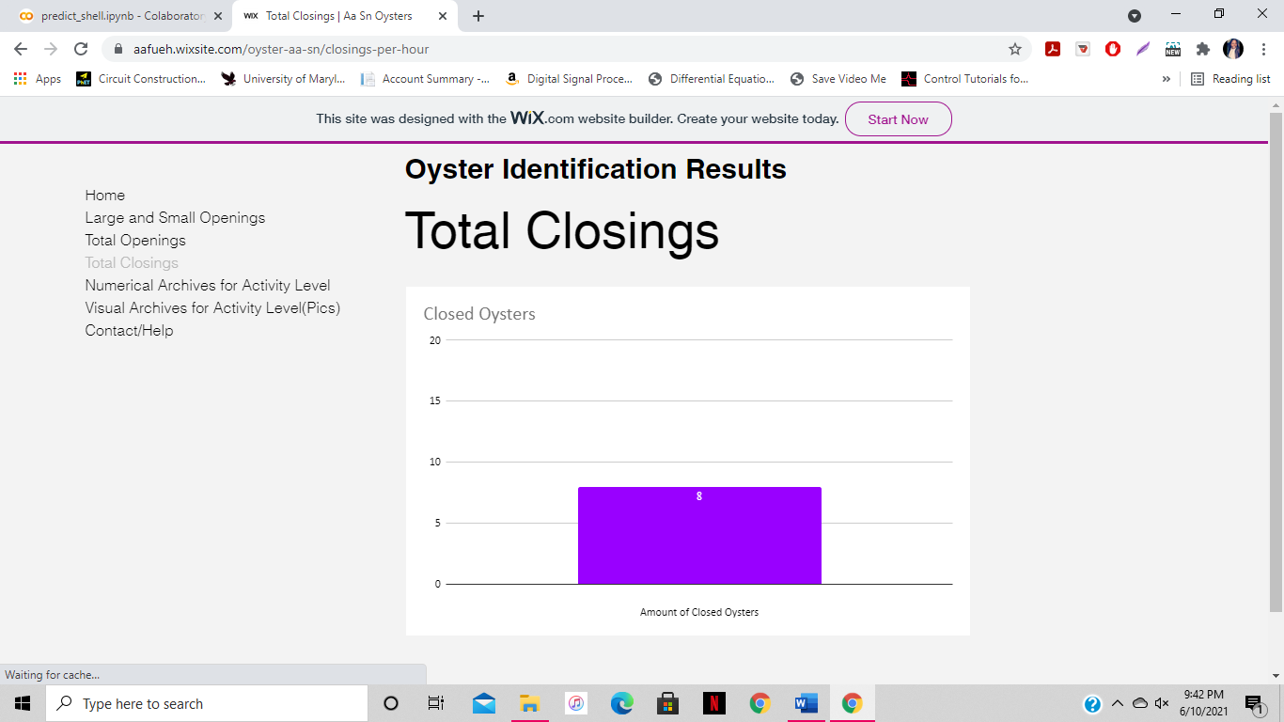

# Figure 15: Depiction of Tab for Data for Closings

This part of the webpage was configured by adding a new tab to the webpage, and embedding graphs from the google spreadsheet that includes the output data there. The following Figure, Figure 16, depicts the configuration of this webpage.

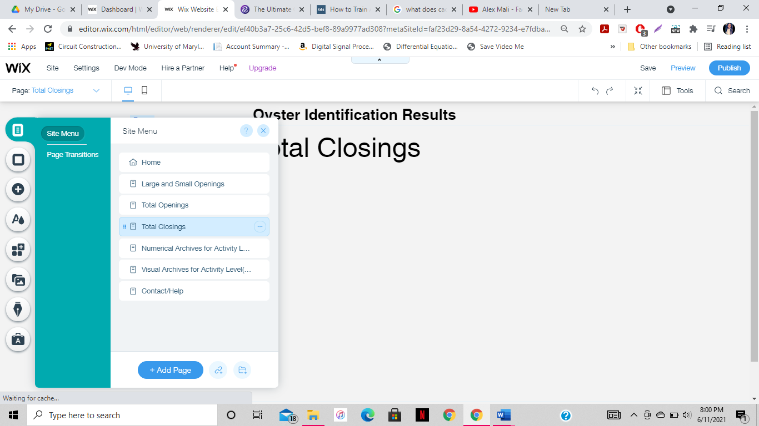 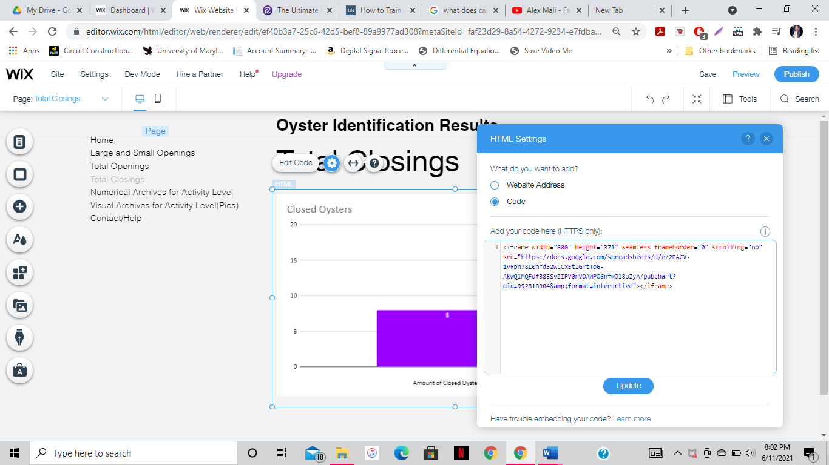

# Figure 16: Configuration of Closing Webpages

### Subtask 4.3: Numerical/Visual Archived Data

In this task, the tabs for the numerical and visual archived data were created. These two tabs depict the archived data from the system. The numerical data will be shown via a spreadsheet, and it will have the numerical data from the program. ​The visual data, AKA the labeled pictures that went through image processing, will be uploaded to this website for viewing. Every picture that is taken during the time the program starts will be viewable. ​Labeled images are stored in the visual archives link and can be accessed through the link provided. The following figure, Figure 17, depicts the image of the numerical and visual archived data.

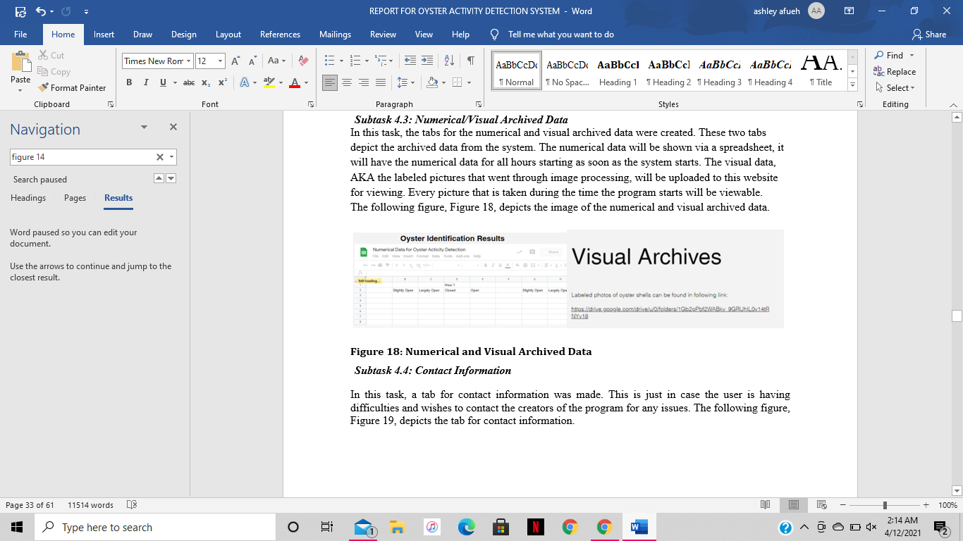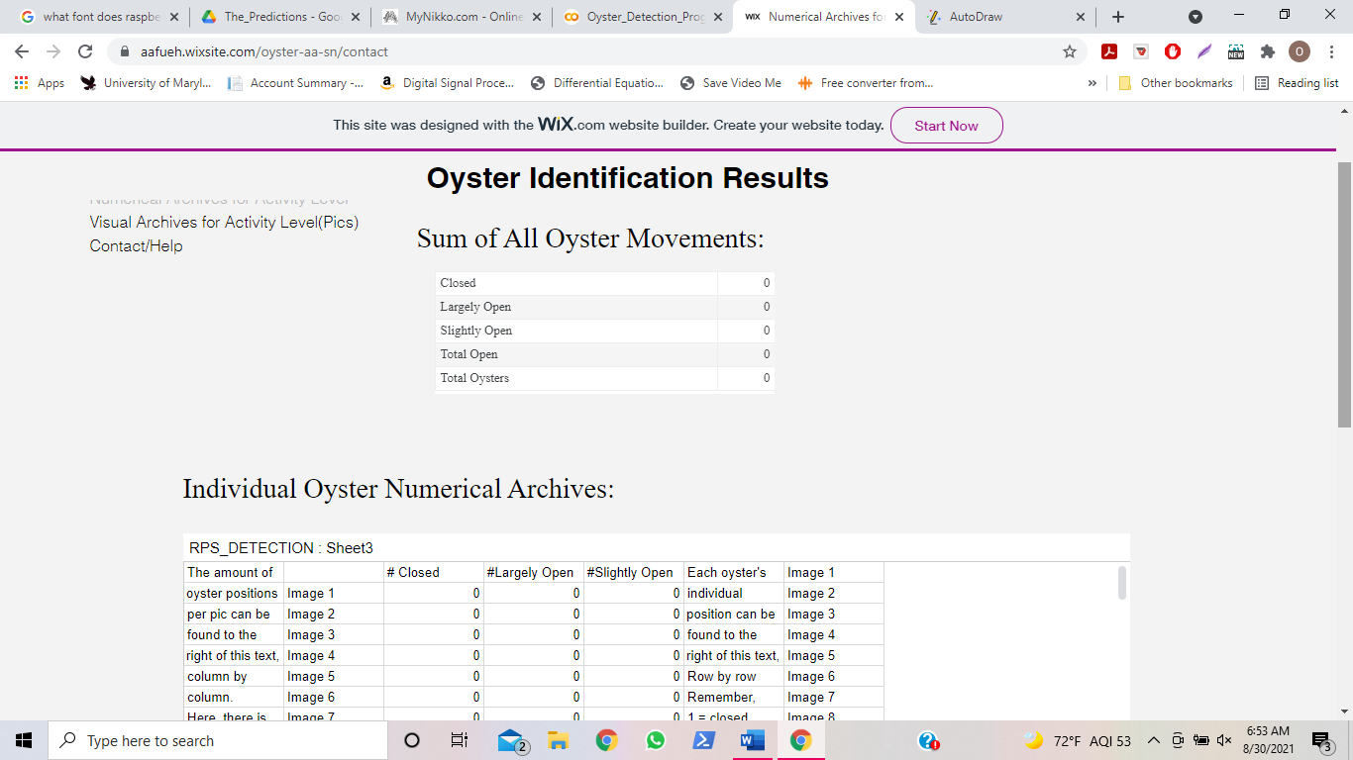

# Figure 17: Numerical and Visual Archived Data

This part of these webpages was configured by adding a new tab to the webpage, and linking chart data/google drive folders from the google drive account that includes the output data there. The following figure, Figure 18 depicts the configuration of this webpage.

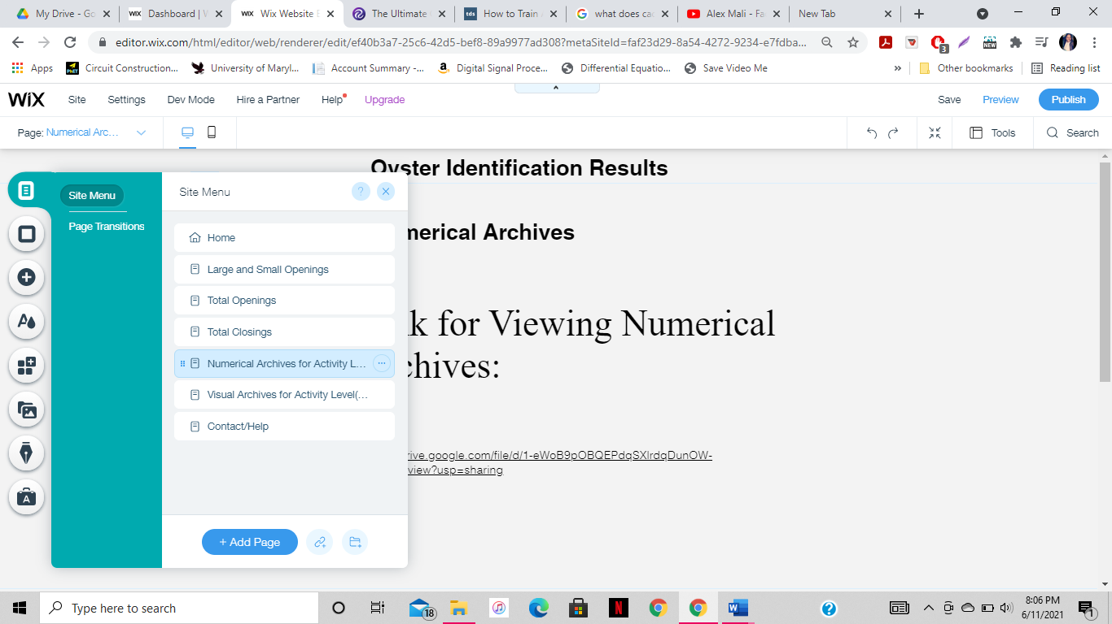 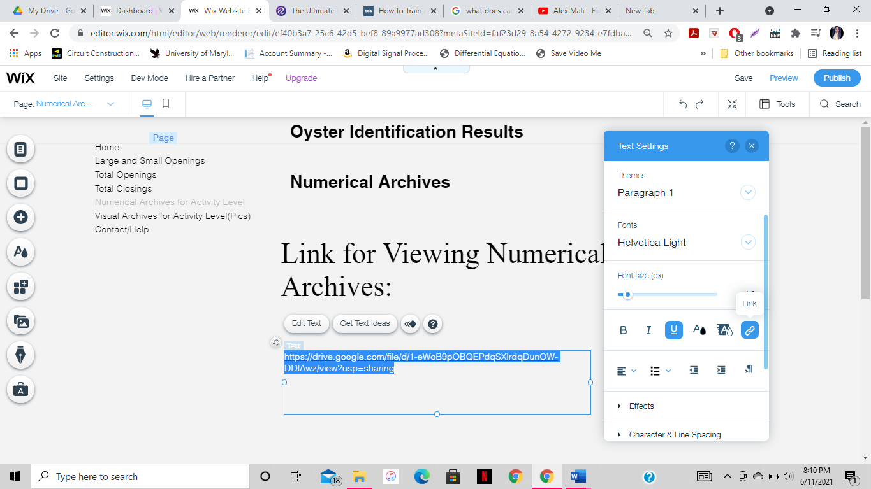

# Figure 18: Configuration of Numerical and Visual Archive Webpages

### Subtask 4.4: Contact Information

In this task, a tab for contact information was made. This is just in case the user is having difficulties and wishes to contact the creators of the program for any issues. The following figure, Figure 38, depicts the tab for contact information.

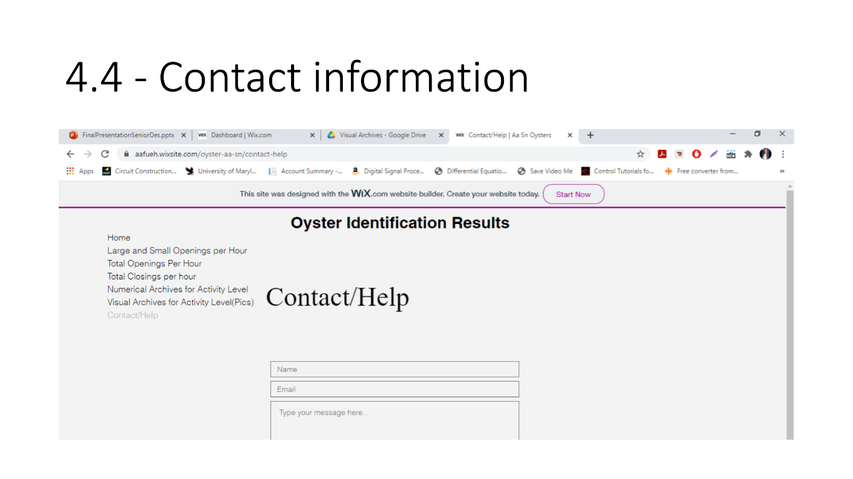

# Figure 19: Tab for Contact Information

This part of the webpage was configured by adding a new tab to the webpage, and adding a feature called "wix forms" that links to an email, which allows users to leave messages that will be directed to said email. The figure below, Figure 39, depicts the configuration of this webpage. ​ 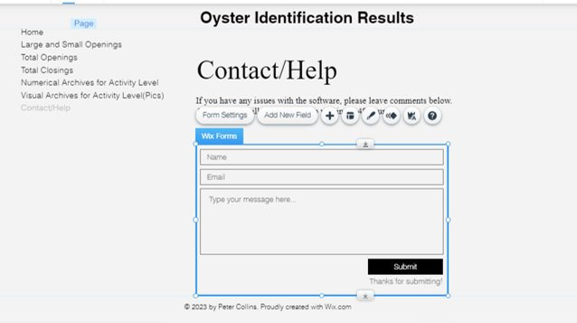

# Figure 20: Configuration of Tab for Contact Information

## 5. Project evaluation

1. Public health/Environmental factors

Monitoring oyster activity can assist greatly in helping to clean dirty and tarnished oceans across the globe. Since oysters have the ability to clean water, they have grown in my filter feeding, monitoring oyster activity can assist public health by determining the factors that they thrive best in. After determining these factors, this information can be utilized to move oysters to environments they thrive best in. In return, they will filter and clean the water around them, helping with clean water supply in the environment.

1. Safety/Welfare

In previous methods of oyster identification, many biologists and ecologists had to touch the oysters manually and check their shell openings manually. The method that was created in this project for oyster activity does not require consistent manual touching of the oysters, seeing as how their position will be determined by camera. Since there is minimal human contact with the oysters, this reduces the possibility of bacteria and/or other dangerous germs transferred from the oysters to humans. This program assists in safely tracking the opening of the oyster shells while still maintaining the welfare of the biologists and ecologists.

1. Global factor

Monitoring oyster behavior can positively affect how ecologists conduct research for oysters. Since these ecologists now have a means of monitoring oyster activity, they can use this to conduct experimental research regarding how various factors in oyster environments affect oyster development.

1. Economic factor

Previous methods for oyster research include methods requiring various sensors. These sensors require more electrical power to work. In this project, the only thing that was used to monitor clam activity was a raspberry pi camera. Seeing as how only one electrical component was used to determine oyster activity instead of multiple electrical components, the program is much less costly. Using this system to determine oyster activity is a much cheaper and more economical way to conduct research regarding oyster activity.

## Conclusion

* Project Summary

Conclusively, this project was about using image processing in order to develop a system that identified oyster activity. In this project, a problem was identified and by using engineering problem solving techniques, it was solved. The problem that was identified was that the University of Maryland Eastern Shore’s food and technology department struggled with being able to track oyster activity to determine oyster development. In order to solve this problem, an image processing system was created such that a continuous picture stream of the oyster shells was created, and the position of the oyster shells could be identified. This way, when these oyster shells are replaced with live oysters, their openings can be identified easily, as well as the type of openings they have. A website was created in order to display the results for the oyster activity as well. Also, the goal of creating a system with 90% accuracy was not only met but also exceeded to 96.03%.

* Learning and Practice Experience

In this project, a hands-on experience with many different engineering methods that are used for problem solving was gained.

One of these methods include image processing. Image processing is done when a code is programmed to be able to process an image. Throughout various tutorials, former online projects, and python coding manuals, it was easy to learn how to write a python script that can process an image, and determine what an image consists of. It was also easy to learn about how computers read images by their pixels, and break them down into even smaller pictures in order to find patterns throughout the image that can be traced and found in other pictures. It was also easy to learn how to create a neural network, which is essential for image processing. There was so much experience gained in how neural networks work, how they are trained, how they are tested, and how they are processed. This neural network was the algorithm that helped decide what position the oysters are in when pictures are being taken of them.

Another problem-solving method that was learned about is extrapolating data to be eligible for interpretation. When receiving all of the results for the image processing program in the outcome of the program, an easily understandable way to interpret said data was needed so that it would be easy to understand for the user. It was then realized that the best way to express the data was with designing a website with embedded data from a spreadsheet to display the data that displays their oyster activity.

* Future Plan (How to Improve)

There are various ways to improve this project. One of the main ways to improve this project is to use actual oysters, and not oyster shells. The reason for this is because there would be authentic data collection from real, live oysters themselves and not oyster shells. Also, another way to improve this project would be to find a better way for filtration within the tank. After a few days, the water from the tank becomes less clear due to there being no filtration in the tank.

## Acknowledgment

We would like to take this time to thank many of the various online references including stackoverflow, keras FAQ, python FAQ, and YouTube for giving us resources for help for our project. We would like to thank Dr. Yuanwei Jin and Dr. Lei Zhang for their assistance with helping us learn about creating image processing models. We would like to thank our fellow current and former classmates with their assistance in tips for the project, Timothy Riley and Jesudara Omidoku. We also would like to thank the various online engineering encyclopedias and articles (later listed in our references) that gave helpful tips on image processing. We also would like to thank Tensorflow for all of the helpful tutorials on object detection online.

## Appendix

### 1. Tutorial for How to Run System:

**Tutorial for Oyster Activity Detection System**

By: Ashley Afueh & Shanice Nurse

Table of Contents

**Overview/Hardware Setup……………………………………………………………………………………………………………….3**

**Software Setup………………………………………………………………………………………………………………………………4-5**

**Picture Taking System Setup…………………………………………………………………………………………………………5-9**

**Image Processing System Setup…………………………………………………………………………………………………10-13**

**How to Erase Data and Restart Program…………………………………………………………………………………………14**

**How to Read Data on Website……………………………………………………………………………………………………15-18**

**Hardware Setup:**

Hardware Components (or materials):

1. Logitech C270 webcam Camera
2. Raspberry Pi 4
3. Keyboard with USB cable
4. Mini HDMI to HDMI chord
5. USB-C charger cable
6. Mouse with USB Cable
7. Monitor with USB Cable and HDMI port
8. Outlet with 2 open sources available
9. Duct tape

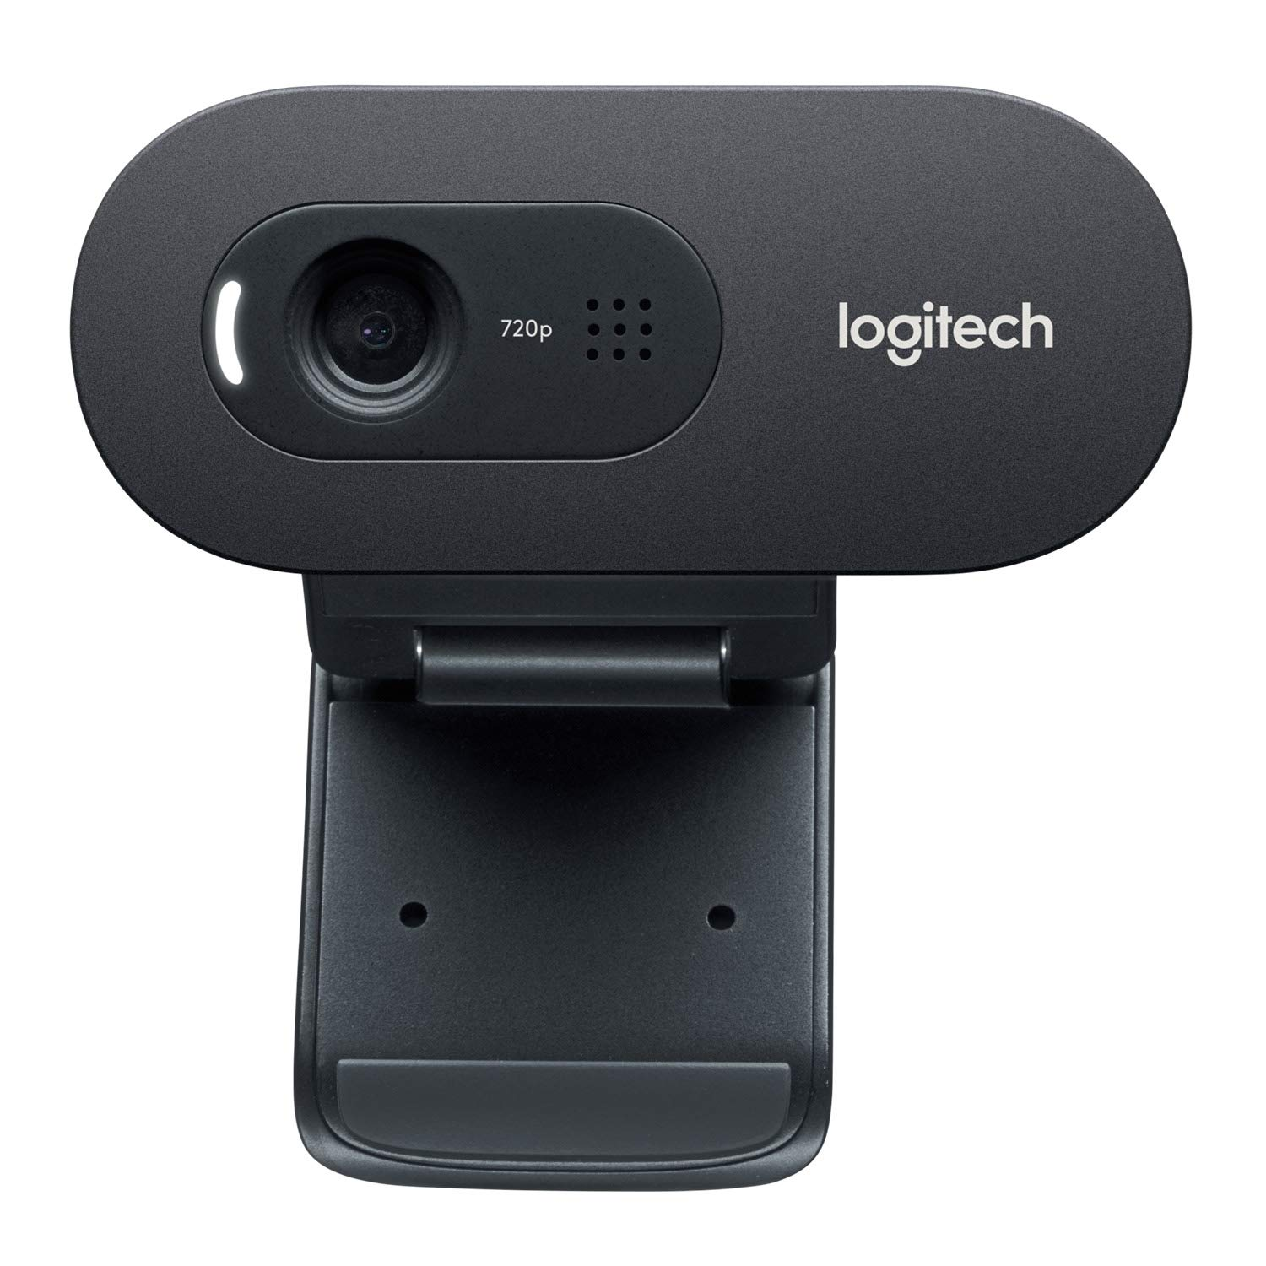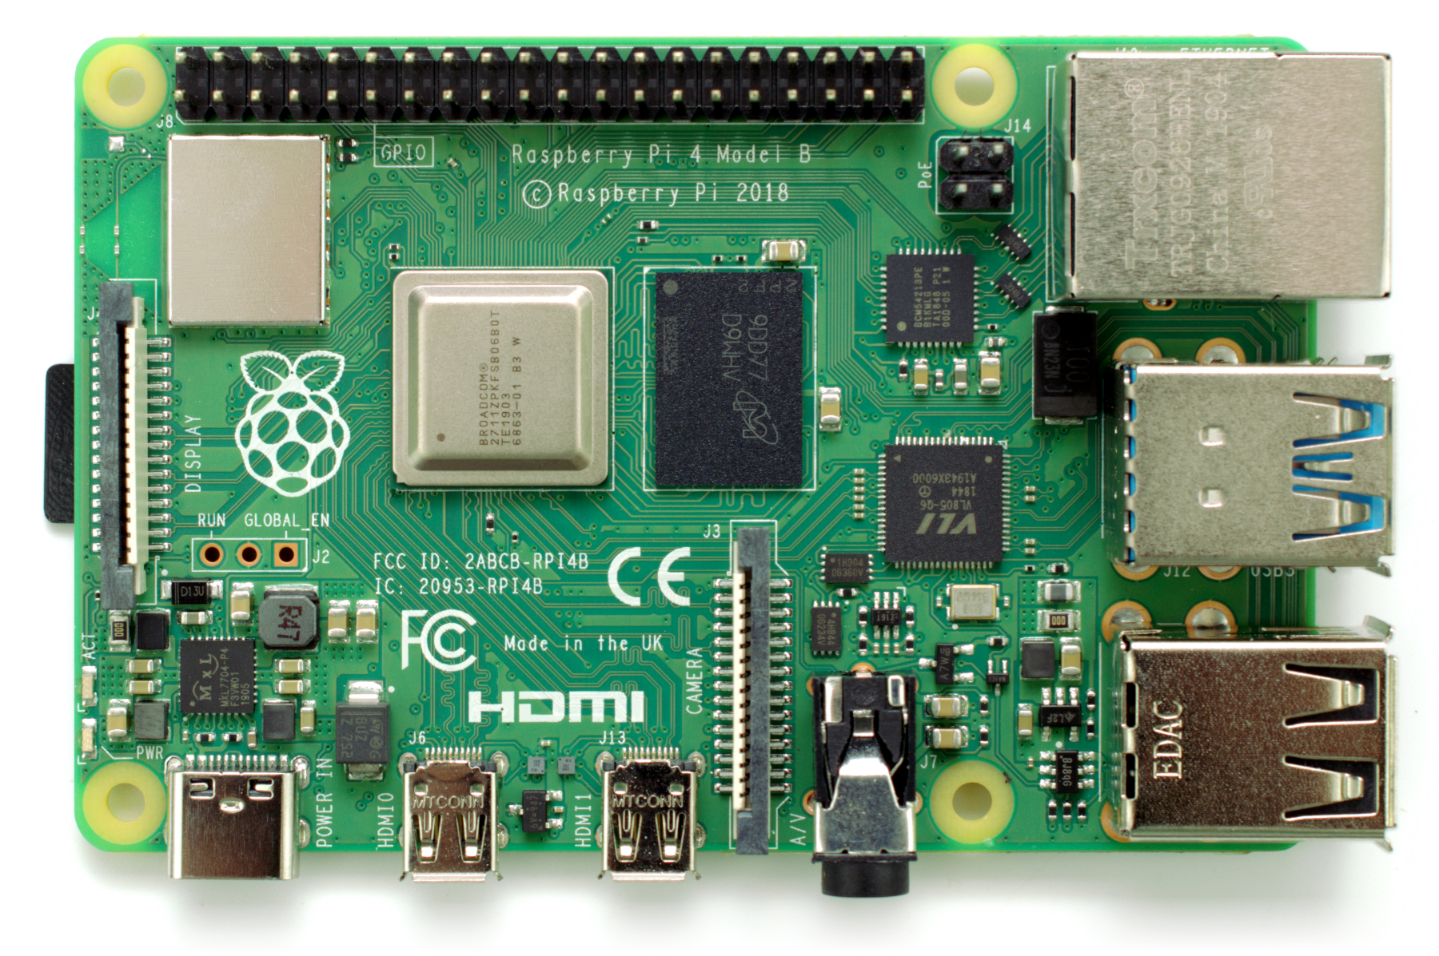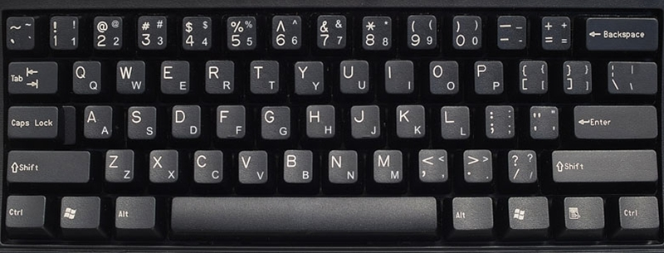

1. (2) (3)

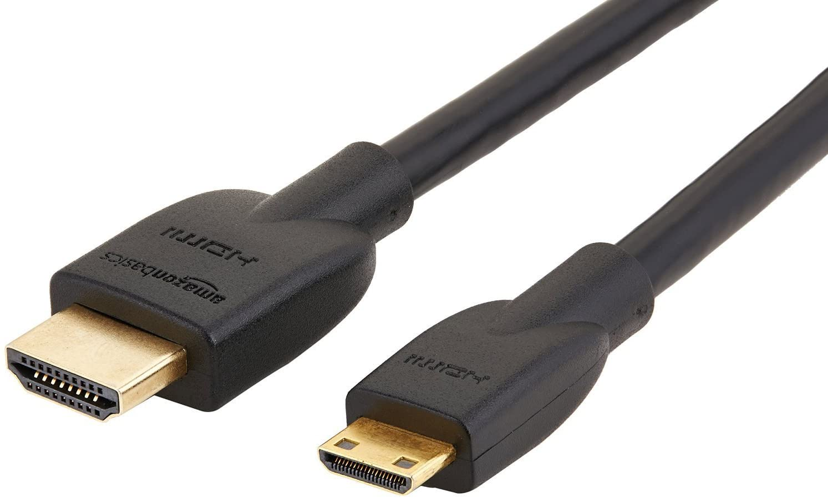 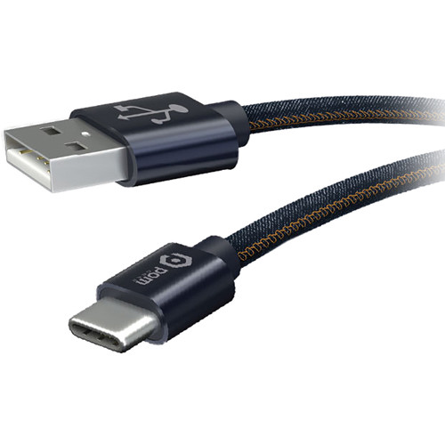 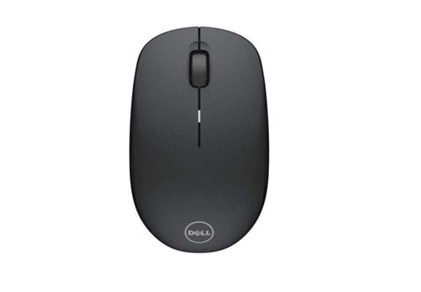

(4) (5) (6)

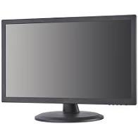 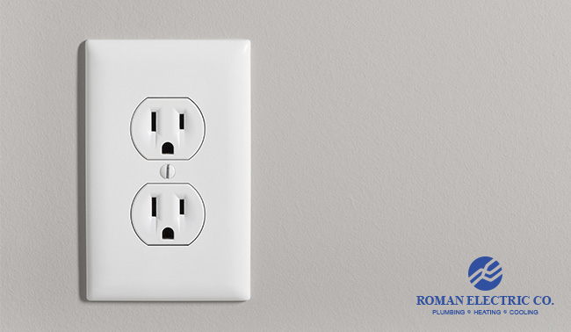 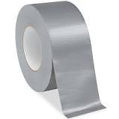

(7) (8) (9)

**Overview:**

The Oyster Activity Detection System determines the level of oyster activity in an aquatic tank. The following pages are a tutorial on how to work this system.

**Software Setup: Part 1**

Using duct tape, tape the tail of the Logitech camera to any one top of vertices of the tank. Adjust it so the camera is looking down at the oyster shells.

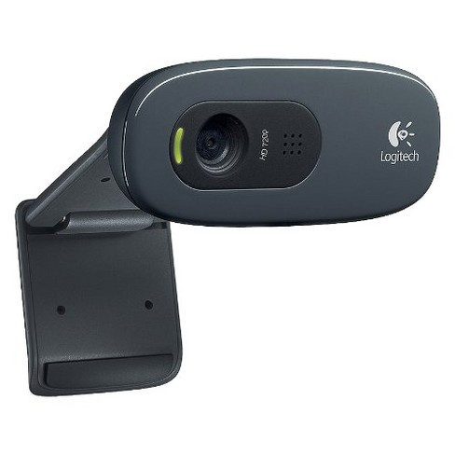 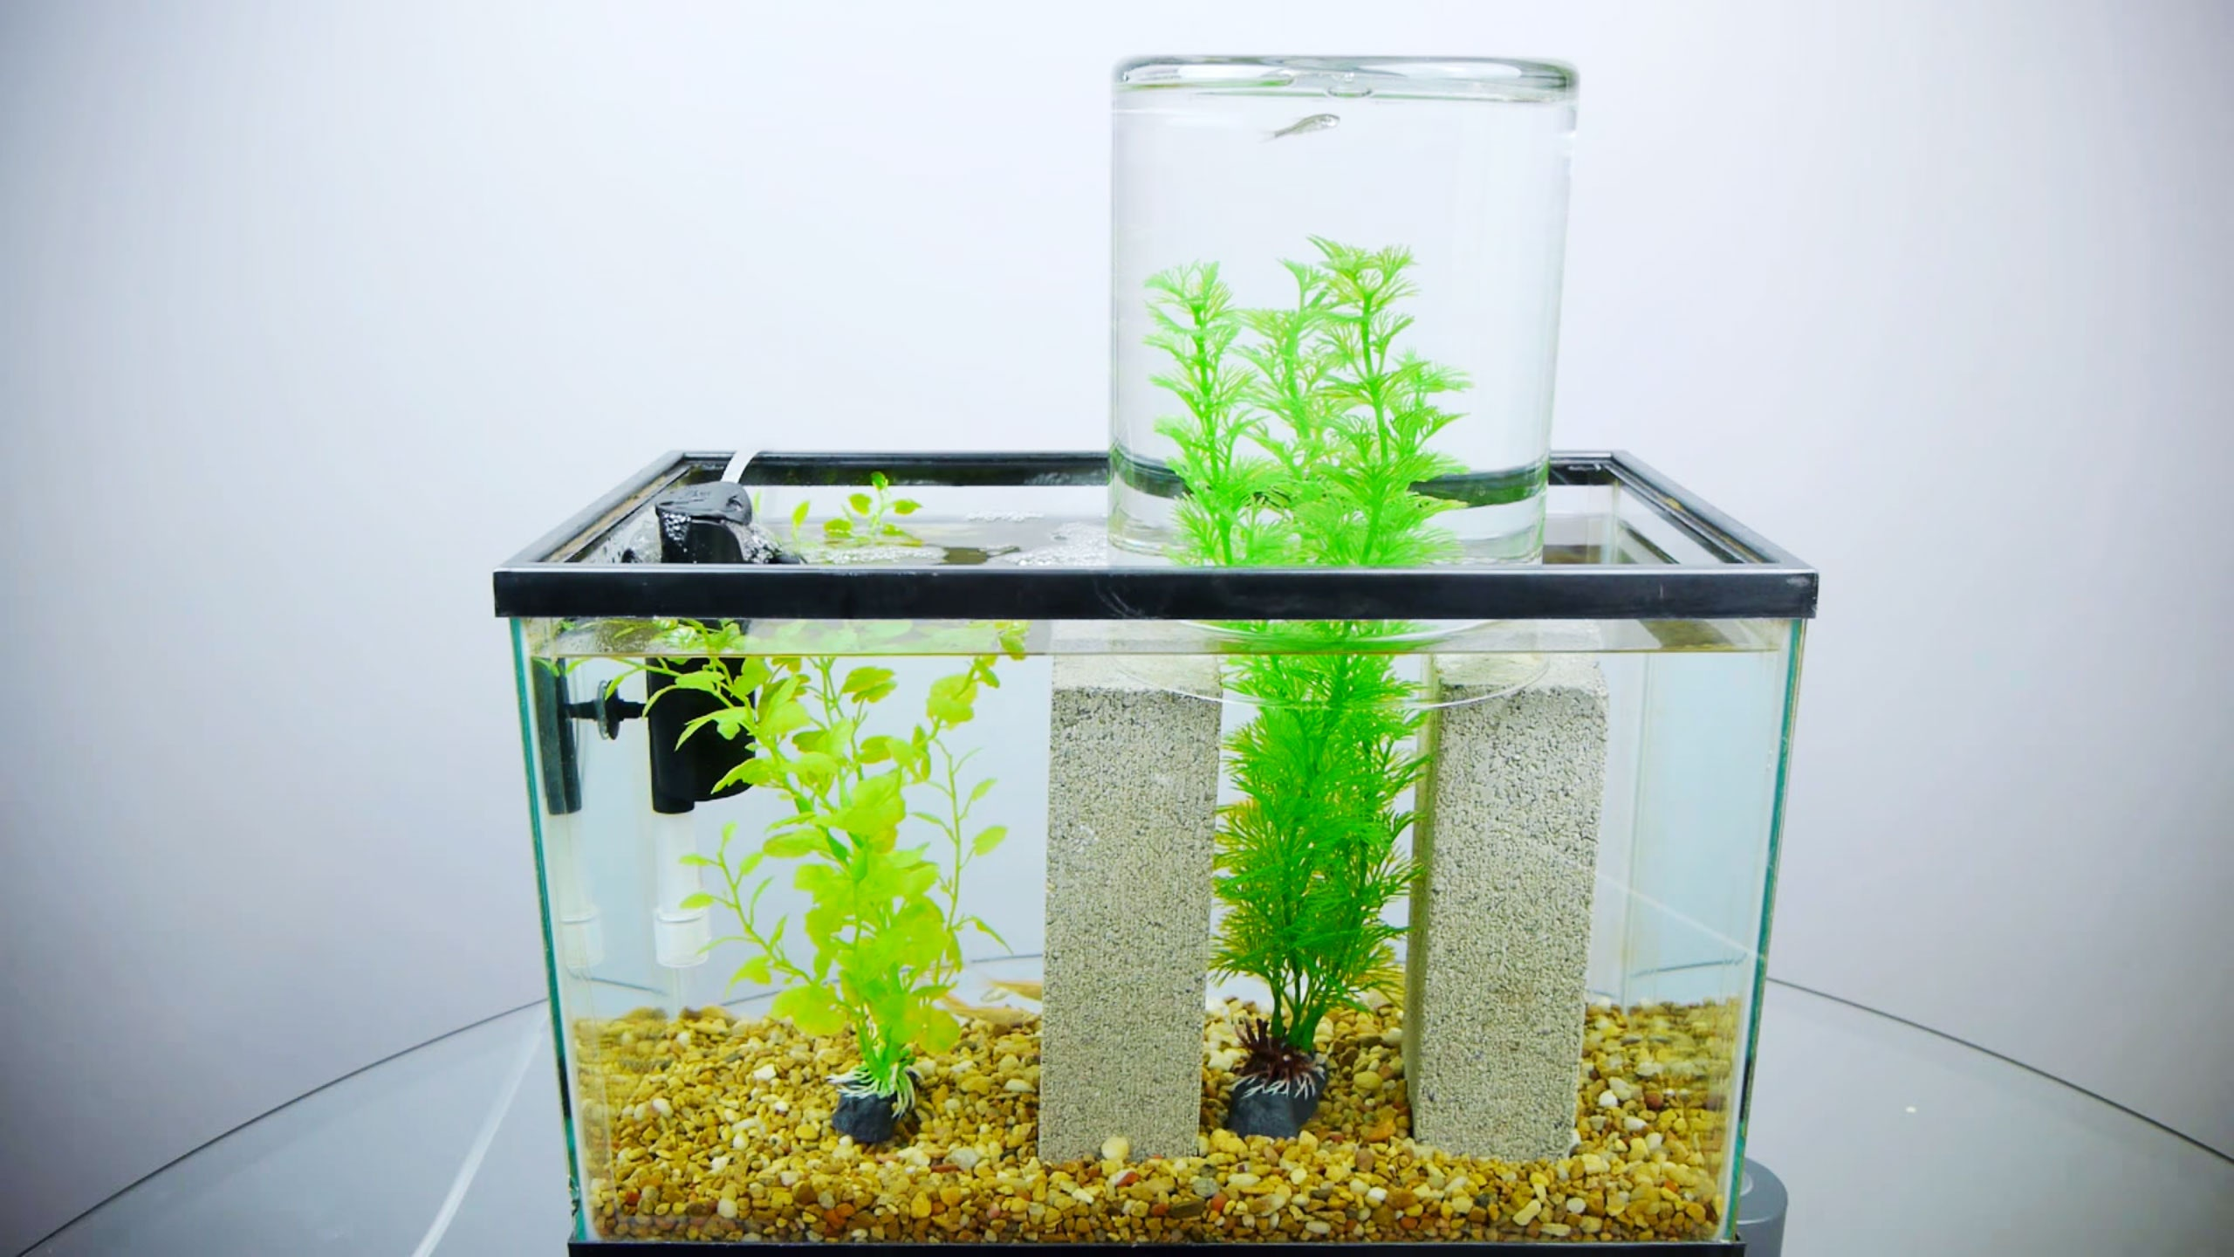

**Software Setup: Part 2**

Plug the USB part for the camera into the raspberry pi. Also, plug one end of the USB-C cable into the raspberry pi port and the other end into the monitor port. Do the same with the keyboard and mouse. Also, plug in monitor power cord to outlet. Turn on monitor.

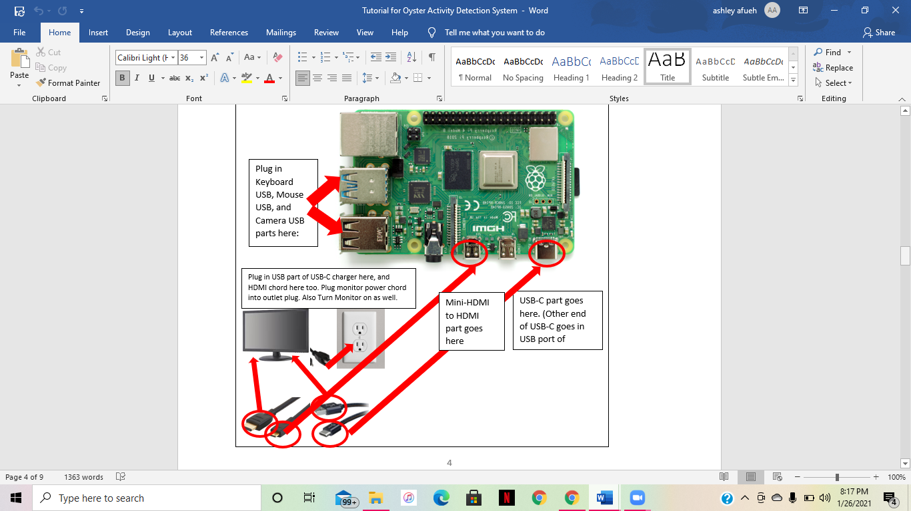

**Picture Taking System Setup:**

Click the “file” button and go to pi>Pictures. Here, create a folder and name the folder “oysters”, as shown below.

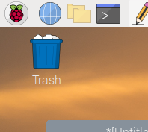

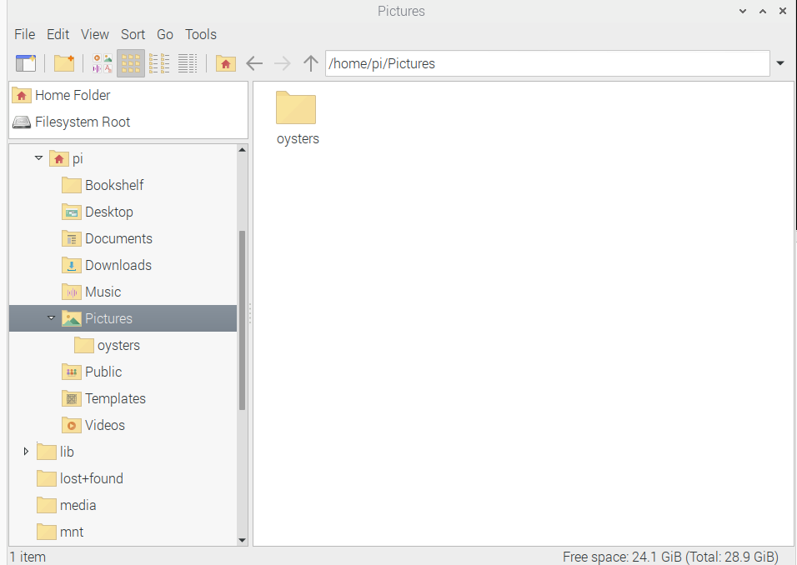

1

2

3

“DuckDuckGoo” should pop up here, click that

**Software Setup: Part 4:**

Now that your raspberry pi operating system is setup, you can now access the internet on the system. Click on the 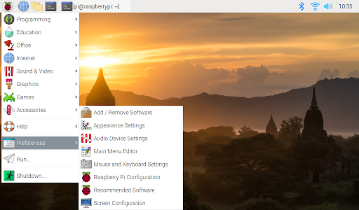 icon and then scroll over “internet”. From there another list of items should pop up. Click “duckduckgo” and then an internet browser will pop up.



new folder

**Software Setup: Part 3:**

Go to the following website to setup your raspberry pi operating system: <https://projects.raspberrypi.org/en/projects/raspberry-pi-setting-up>

new folder

Open the command tab on your raspberry pi software.



This should pop up. This is called the command box.

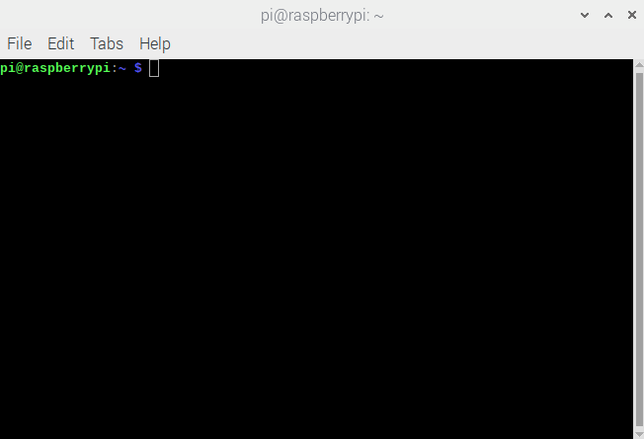

Type in the command ‘install sudo apt-get install fswebcam’ then click enter. This will install your webcam.

Next, type in the command ‘sudo apt-get install motion’ and then click enter. This will install the system needed to install the program needed to take pictures periodically.

Next, type in ‘lsusb’ and click enter. You should see a list of all of the devices connected to the raspberry pi. Be sure to ensure that the camera is listed here. If it is not, try to install the webcam again by typing in the command ‘sudo apy-get install fswebcam’.

Next, type in the command ‘sudo nano /etc/motion/motion.conf’

This will open up the configuration tool for the timelapse motion system, seen below.

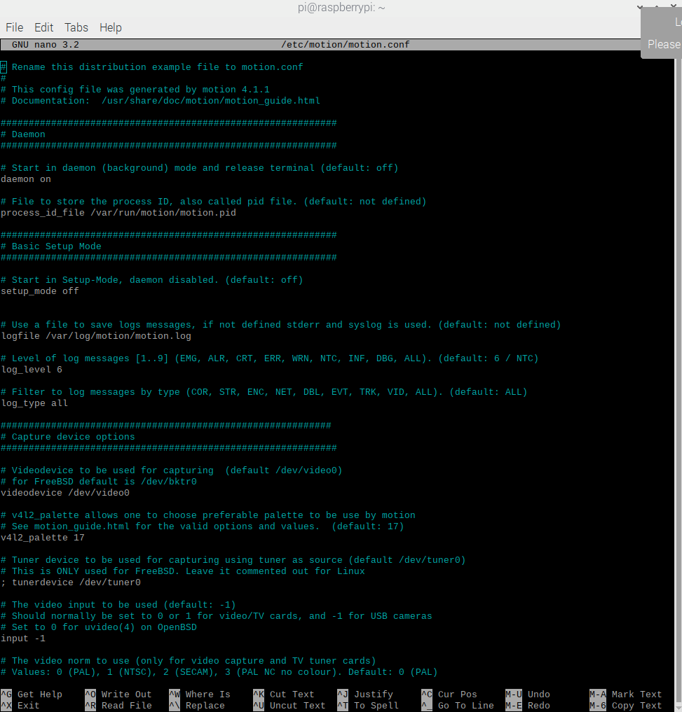

There are some adjustments that must be made in this configuration tool before we can start the system.

Since the configuration tool includes such a long list, we will navigate around using the “cntl + w” keys to search for what we are looking for within the configuration.

Change the following parameters:

1. Make sure **'daemon'** is **ON**.
2. Set '**framerate**' anywhere in between **1000 to 1500.**
3. '**Stream_quality**' should be **100**.
4. Change '**Stream_localhost**' to **OFF**.
5. Change '**webcontrol_localhost**' to **OFF**.
6. Set '**quality**' to **100**.
7. Set '**width**' & '**height**' to **1280** & **720**.
8. Set '**Snapshot_interval'**equal to **10**. (***every 10 seconds 1 photo will be taken*** )
9. Set '**target_dir**' as the path in the folder of where the oysters are, which is /home/pi/Pictures/Oysters (this is what you type in, instead of the path that is already there)
10. Press **ctrl + x** to exit. Type **y** to save and **enter** to conform.

Again, type in the command '**sudo nano /etc/default/motion** ' and press enter. Then, set ' **start_motion_daemon** ' to **yes**. Save and exit.

Next, restart the system by typing ‘sudo motion service restart’. This way, we can get the system nice and refreshed in order to start the system.

Next, type ‘sudo motion’ and press enter. This will start your system. You should see your camera’s green light turn on.

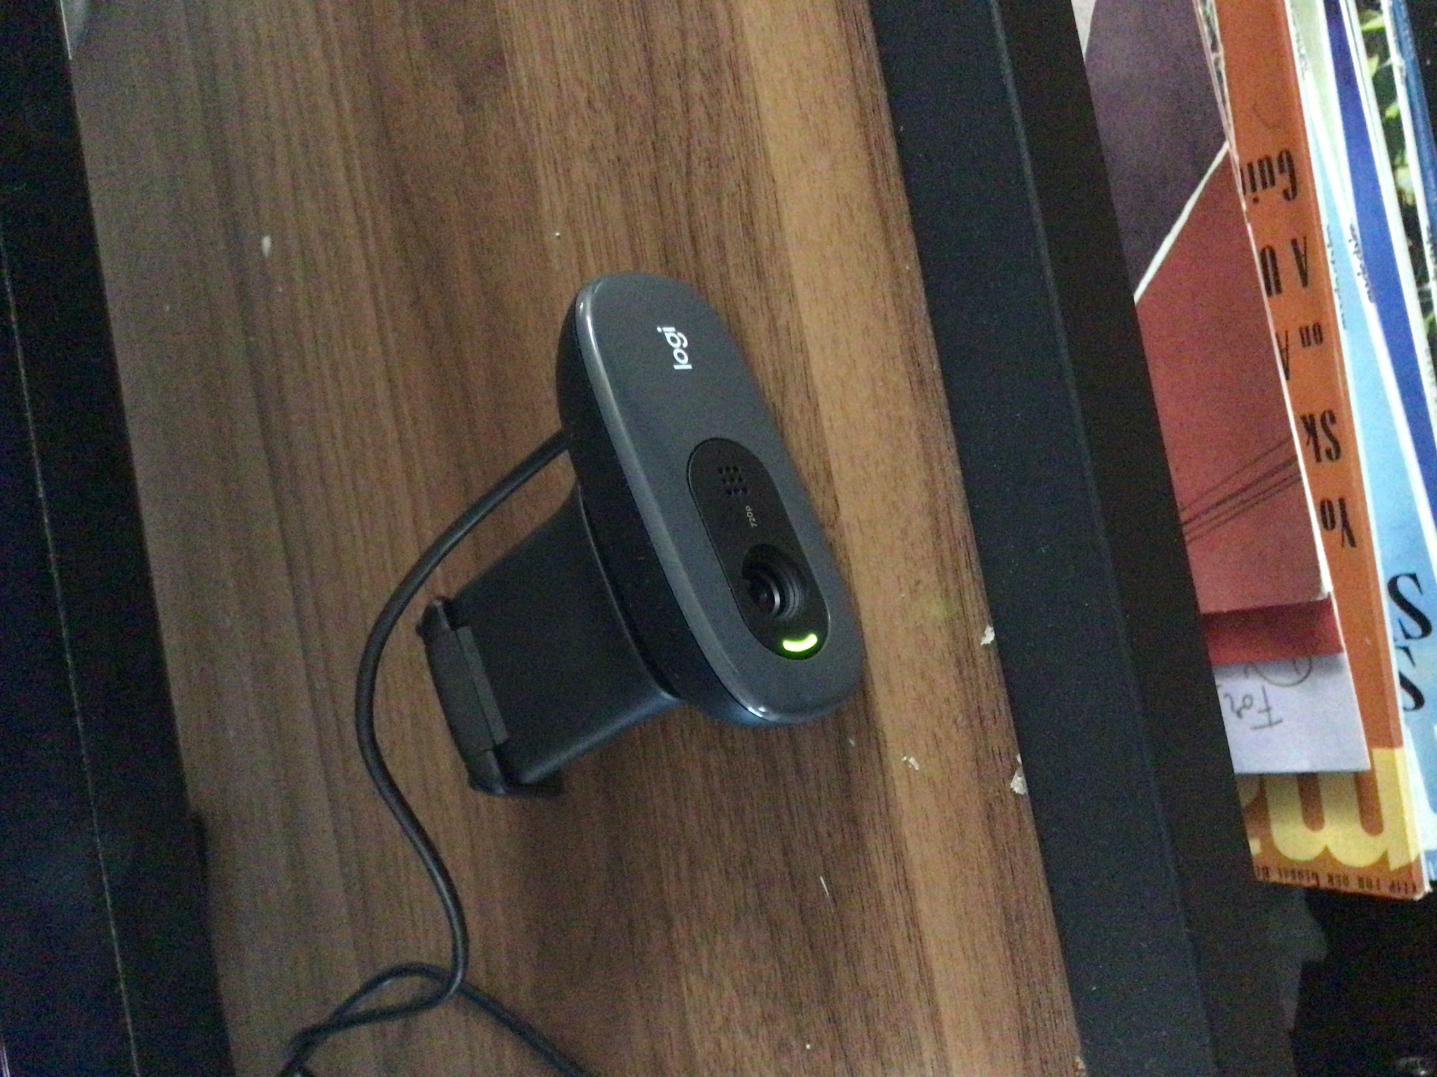

In order to stop the system, type ‘sudo service motion restart’ in the command box. You should see the green light in your camera turn off.

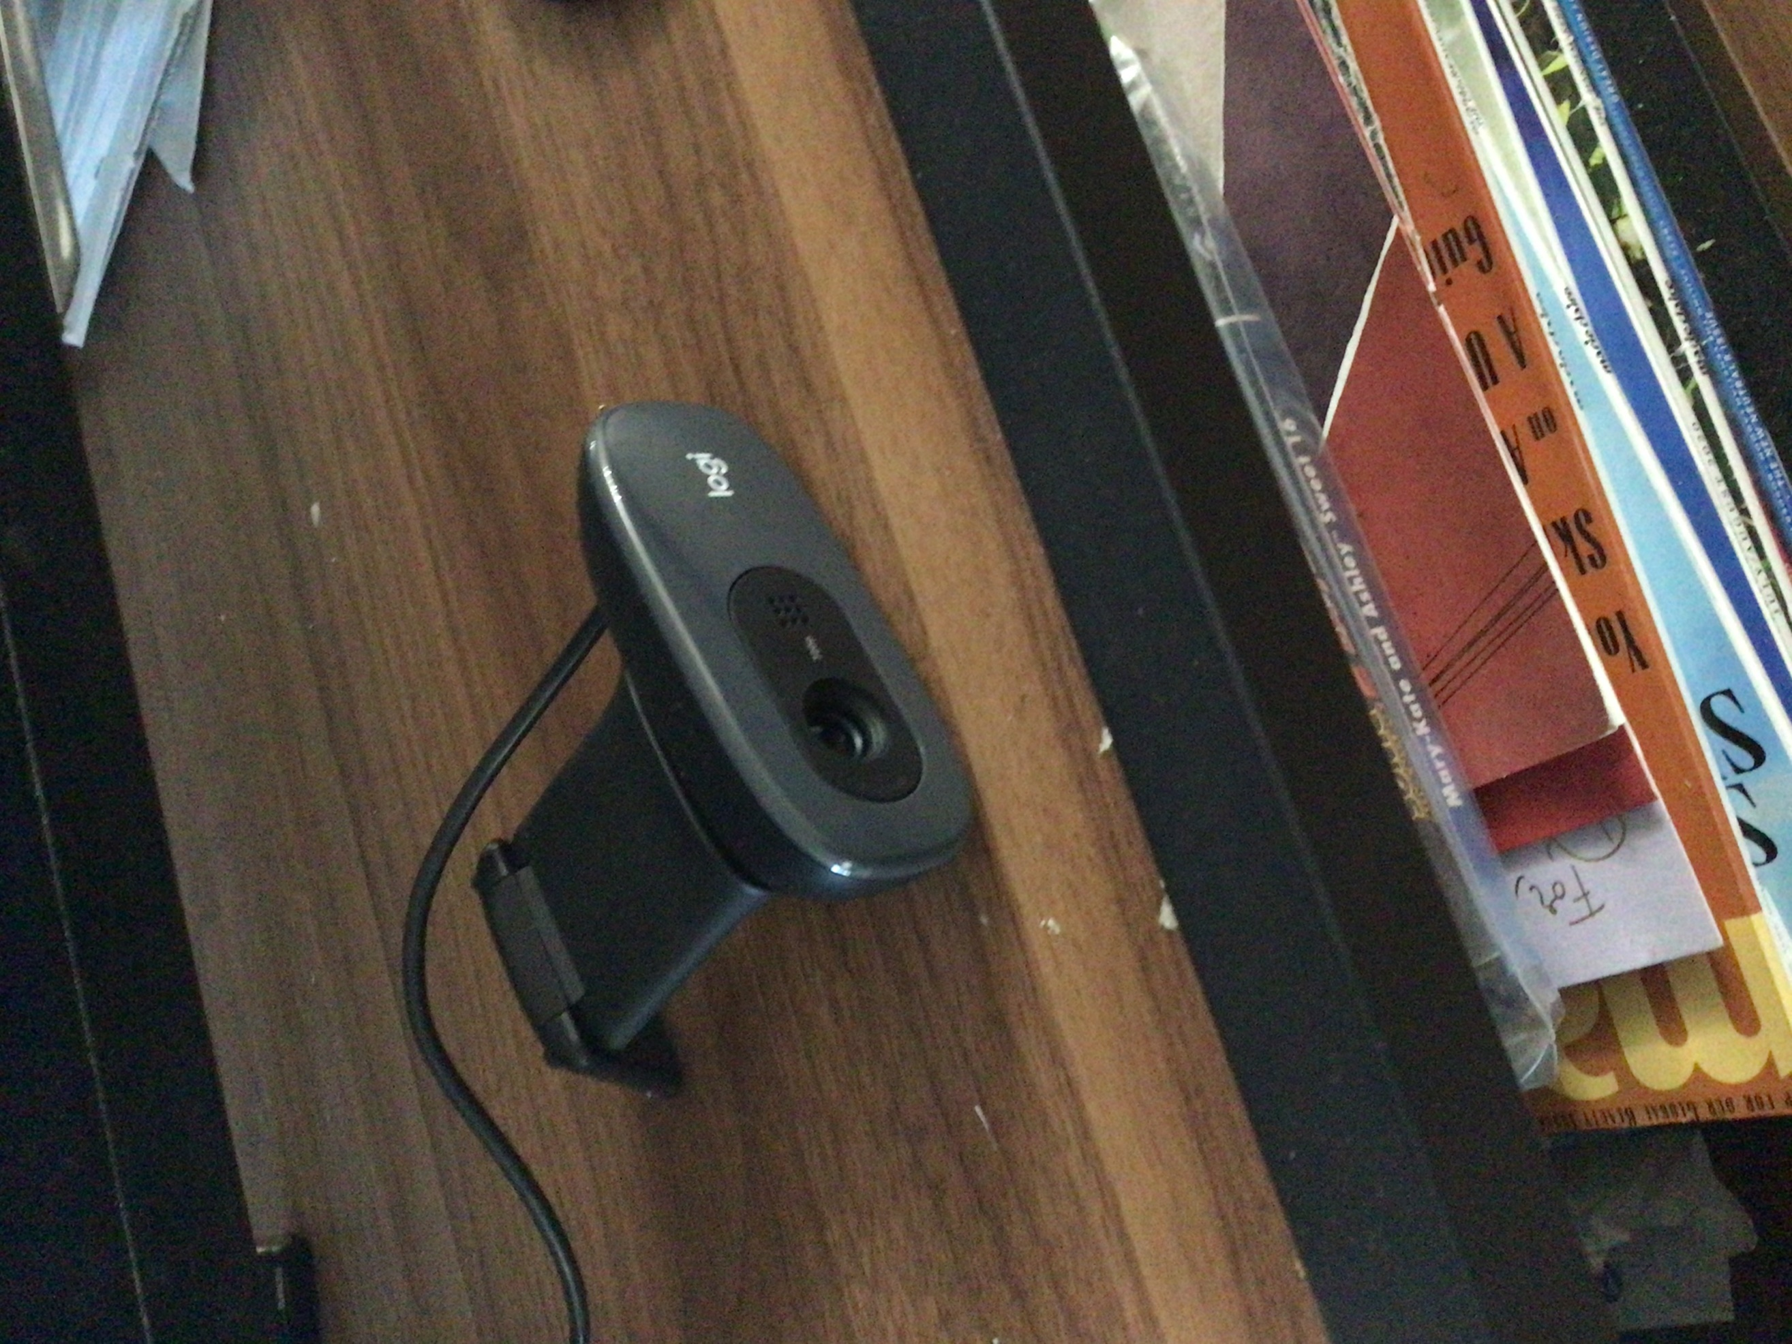

Also, in order to change the interval that the camera takes a picture, you can changer parameter #8 on the list above. You can do this by going back to the configuration page. Type ‘sudo nano /etc/motion/motion.conf’ in the command box Remember, you can use ‘**cntrl + w**’ in order to navigate throughout the entire configuration page. Changing '**Snapshot_interval'**to whatever interval you would like the pictures to be taken at, in seconds. (It MUST be in seconds. not minutes).

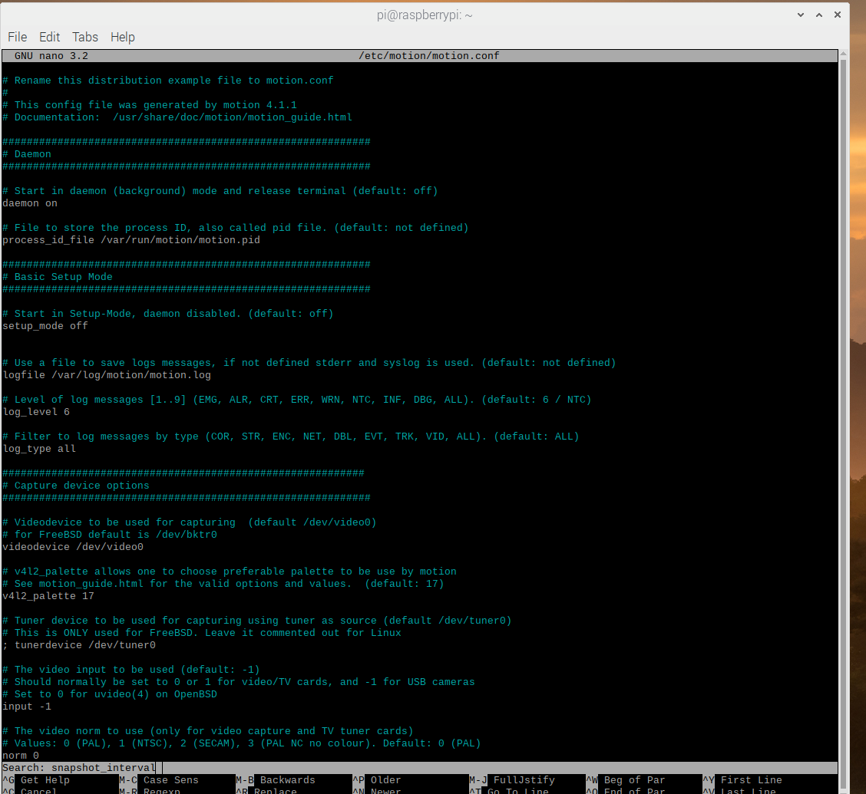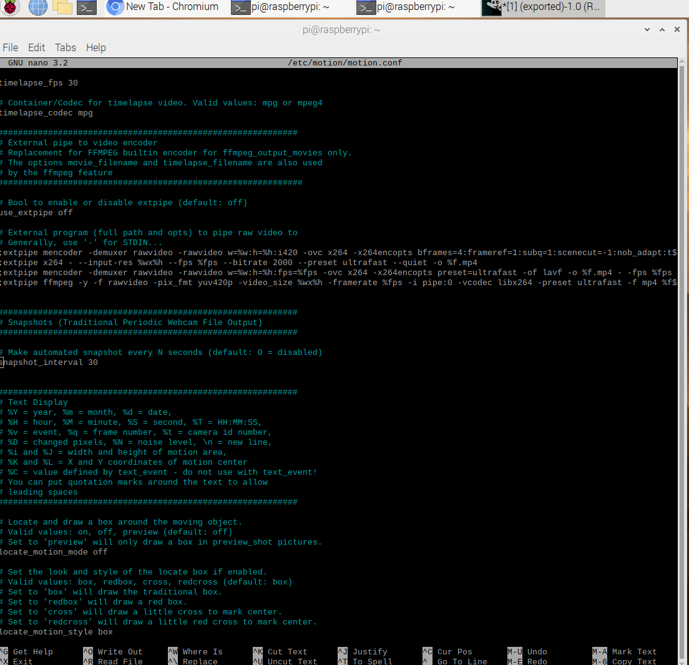

 

When your desired time to run the system has finished, turn off the system and go to the folder where all of the pictures are stored. Right click the folder and click “copy”. Then right click any blank space in the file box and click “paste”. This will create a new folder which is a copy of the oysters’ folder. We have the new, copied folder with the name “data”. When the following box pops up, click “rename”, and make the new file name “Test”. Please keep in mind that it is case sensitive, so capitalize the first letter “T”.

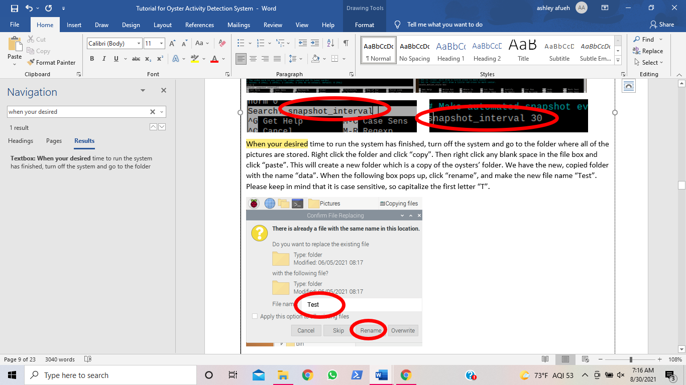

**Image Processing System Setup:**

Now that we have all of the data, we can begin the image processing process. First, we have to upload our Test folder to our google drive account.

Go to <https://www.drive.google.com> and sign in to google drive with the following username and password:

username: [oysterdetection2021@gmail.com](mailto:oysterdetection2021@gmail.com)

password: DetectOysters2021!



Next, click on the button “(+) New”:

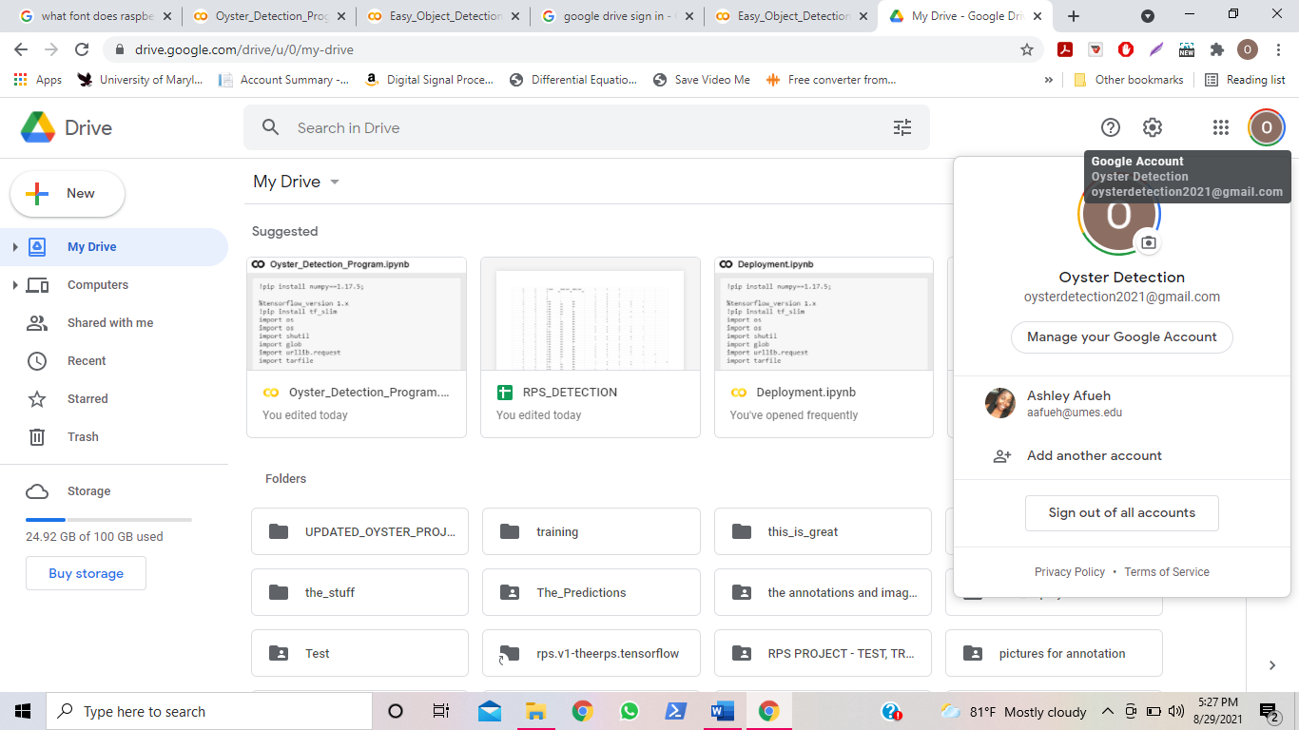

**Image Processing System Setup:**

After you click the “(+) New” button, click “Folder Upload”, then select the “Test” folder that we created earlier, and then click “Upload”.

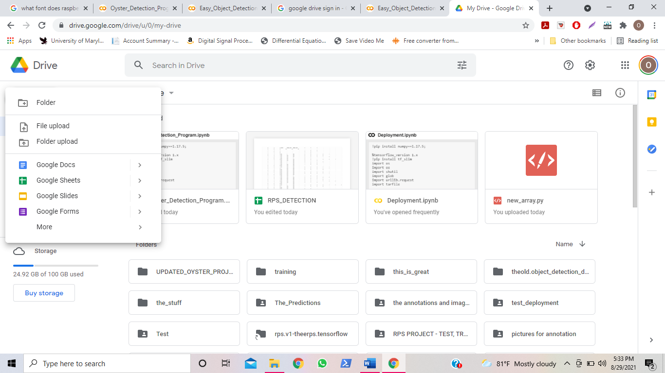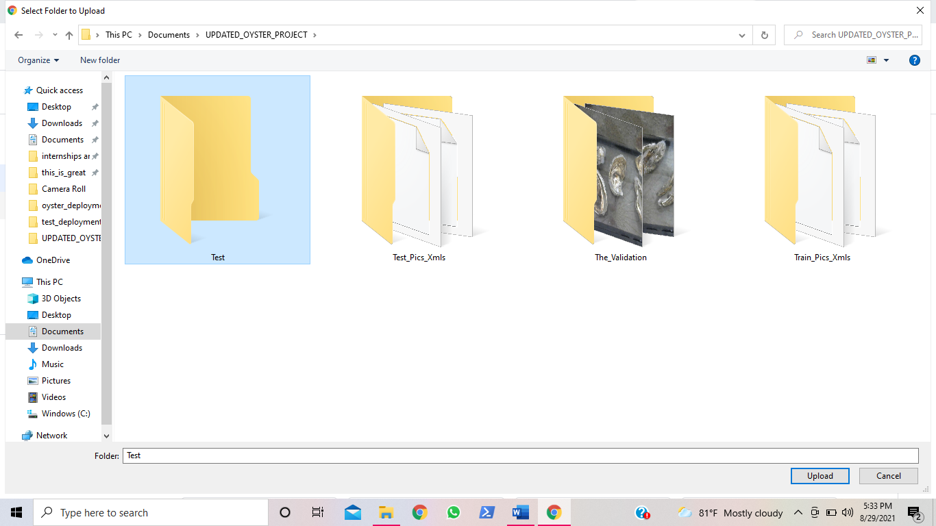

Now that we have all of the data, we can begin the image processing process. Click the following link and login with the username and password set below:

<https://colab.research.google.com/drive/1r36I0R-ySbhTSGx4ZILBQhbGuVlUhqHF?usp=sharing> 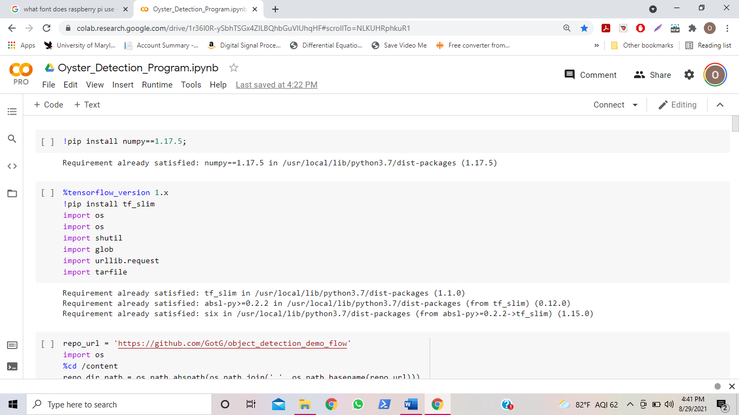

username: [oysterdetection2021@gmail.com](mailto:oysterdetection2021@gmail.com)

password: DetectOysters2021!

**Image Processing System Setup:**

Under the tabs, hover over “Runtime” > “Change Hardware runtime” > and then choose “GPU” as the hardware accelerator., and High-RAM as the “Runtime shape”.

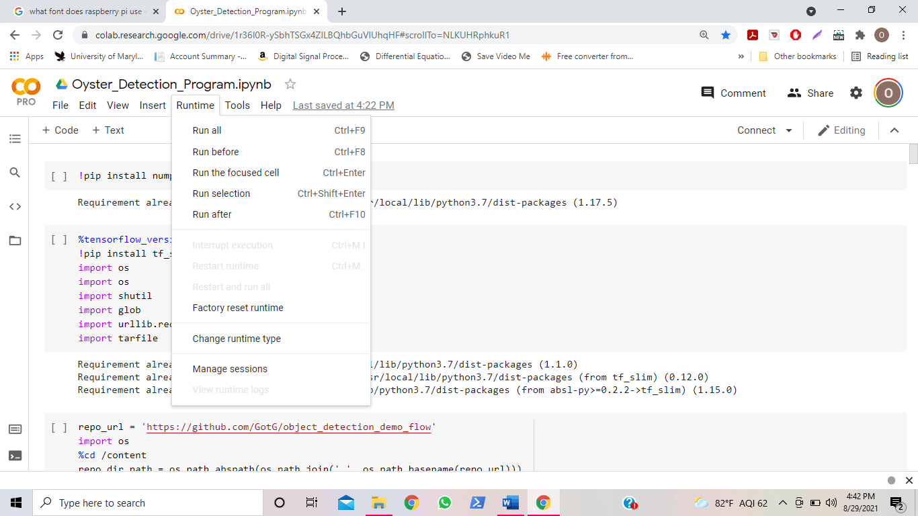 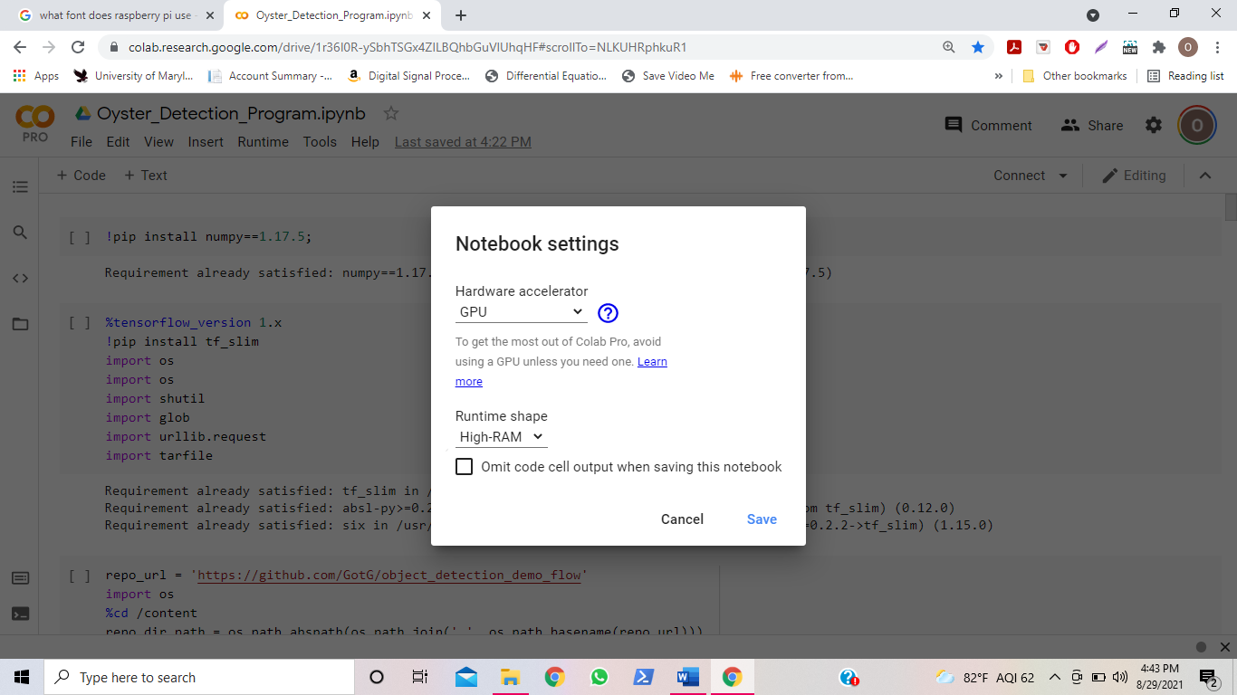

Next, click on the first block of code, aka cell.

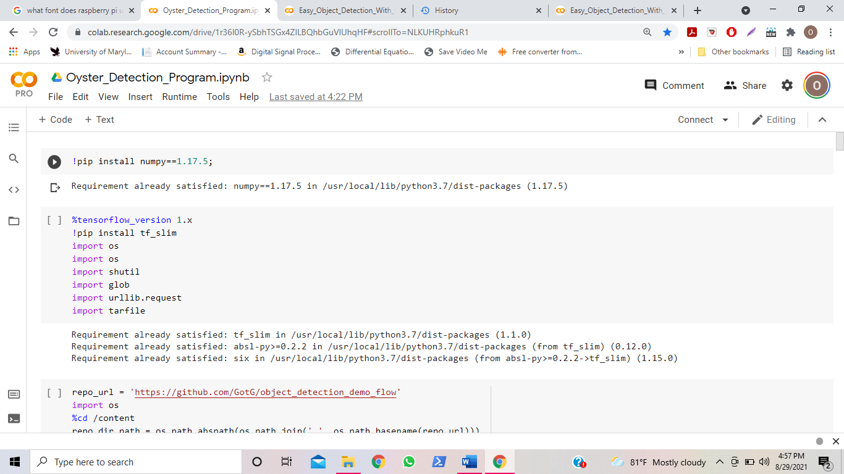

After you click this cell, you will have to restart the runtime. Click the button “Restart the Runtime” at the bottom of the output.

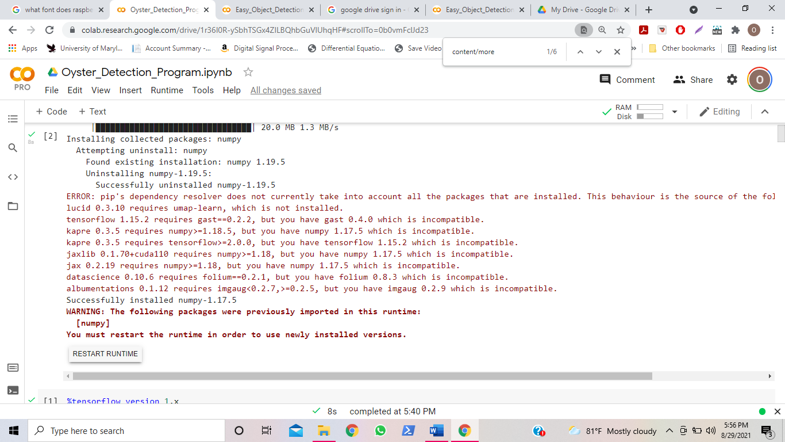

Next, click the play button on the Cell 1 again.



First cell: Click 1st cell

First cell: Click 1st cell again

After that, click the “play” button in every cell, one by one, in sequential order.

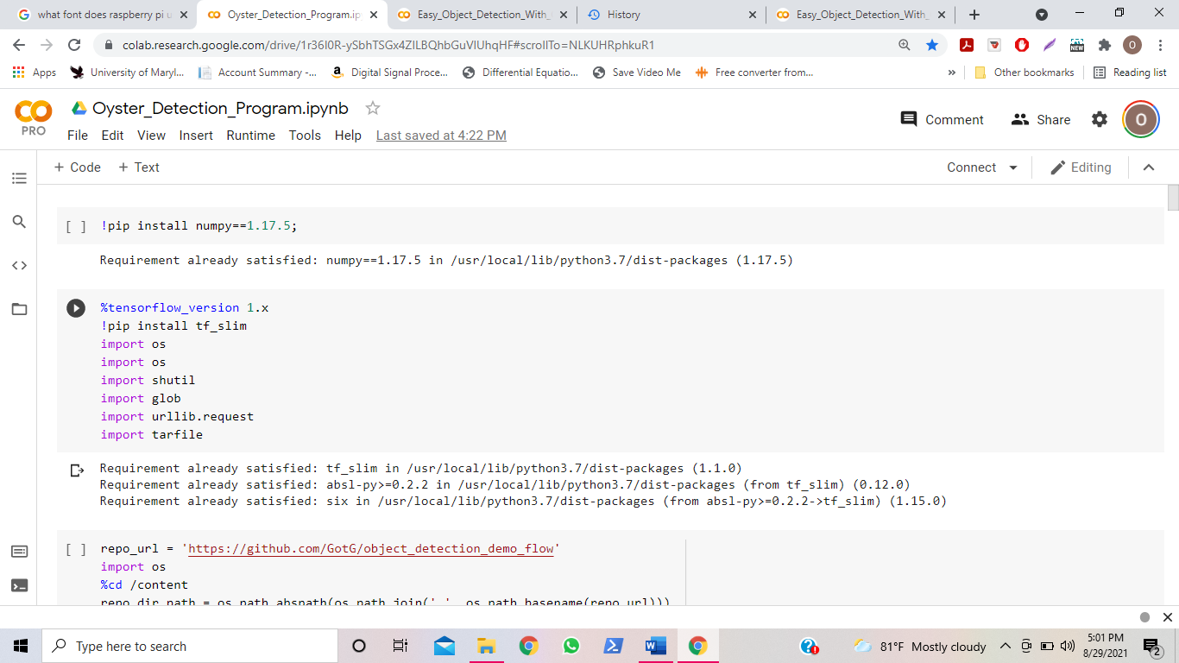

Before you run every cell, make sure the previous cell is finished before going to the next cell. Some cells may take a couple seconds to finish while other cells will take a couple minutes. When the cell is finished, it will have a number enclosed by brackets “[]” where the play sign was, along with a green checkmark to the left of the number enclosed by brackets. For example, after the second cell is finished running, it will look like this:

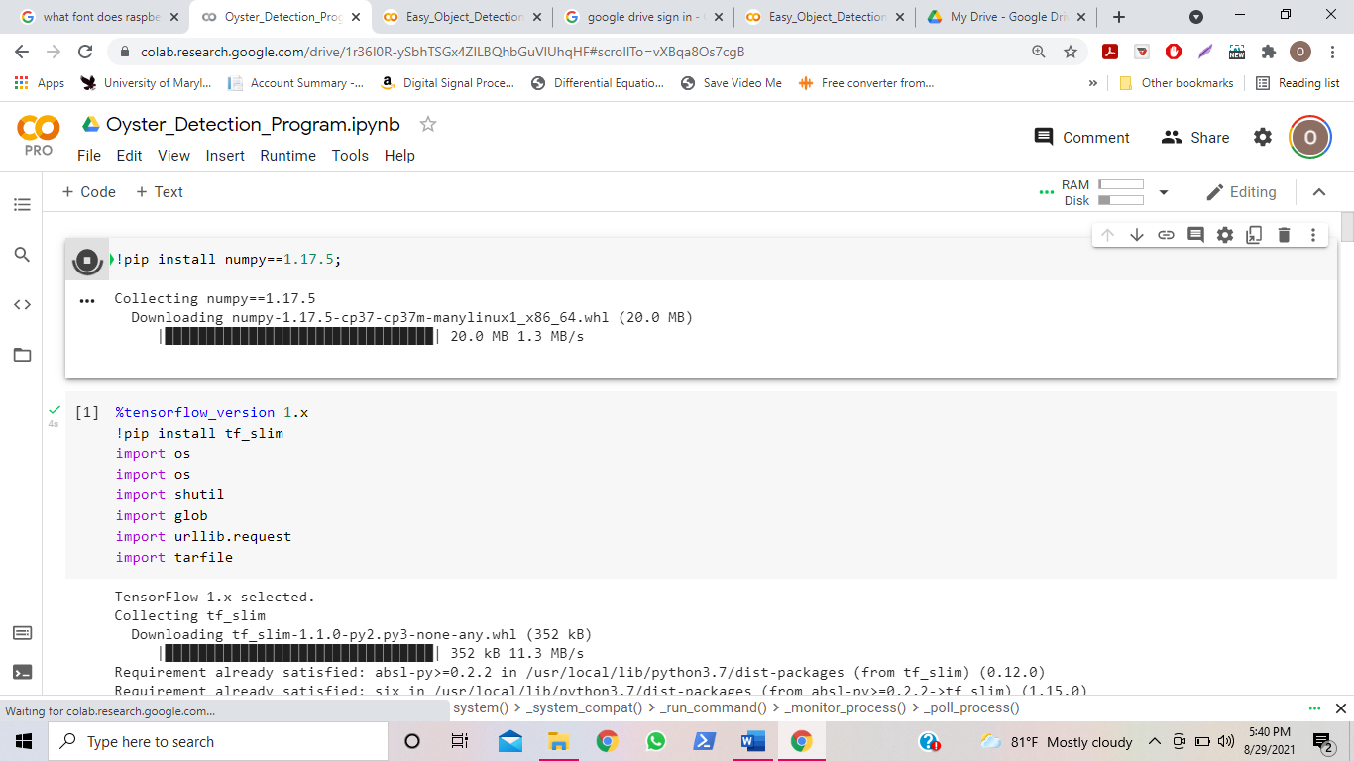

Also, If you come across a cell where there is the phrase “Go to this URL in a browser” and a link afterwards, then click the link.

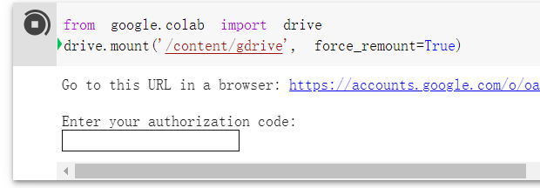

Then, connect to the [oysterdetection2021@gmail.com](mailto:oysterdetection2021@gmail.com) account in google drive.

Copy the text that is below this and enter it in the box that says “enter your authorization code”, and then click enter. When it is finished connecting, you should see the following output for that cell:

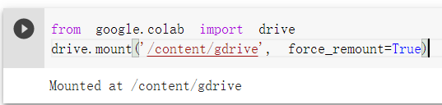

Continue to click all the cells one by one, waiting until they finish in between, until you get to the point in the program where it displays the text “Stop and Proceed Depending on Images Amount”.

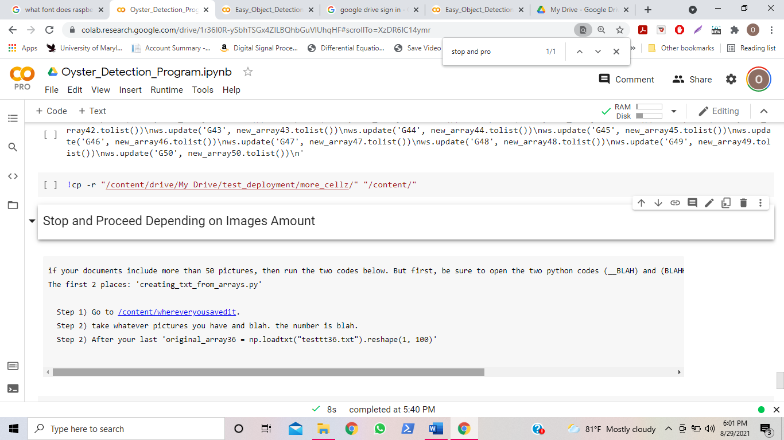

If you have exactly 50 images, you can continue clicking the play button for the cells for the code until you get to text “Stop Here if you Have 50 Images Exactly or More” in the program.

If you have more than 50 images, then keep continue clicking the play button for the cells for the code until you get to text “Stop Here if you Have 50 Images Exactly or More” in the program. Then go to page 18 of this tutorial.

If you have less 50 images, then follow the following steps:

(Hint: if you need to know how many images you have, then do this:

* Go to the location on your desktop where you saved your “Test” folder
* Click “ctrl” + “a”, and at the bottom left of the page, it should show how many items are selected. It should say “X items selected”, where X is a number. That is the number of images you have.

Locate the cell that starts with the text “#creating texts from arrays”. Do NOT run this cell yet. There are repetitive lines of code with the syntax format “original_array[x] = np.loadtxt("testtt[x].txt")”. Take the number of images you have, and go to the line of code where [x] matches the number of images you have. For example, if you have 10 images, go to the line of code that states “original_array10 = np.loadtxt("testtt10.txt")”. Click this line such that your insertion point (which is the blinking vertical line that indicates where you are) is at the end of the line.

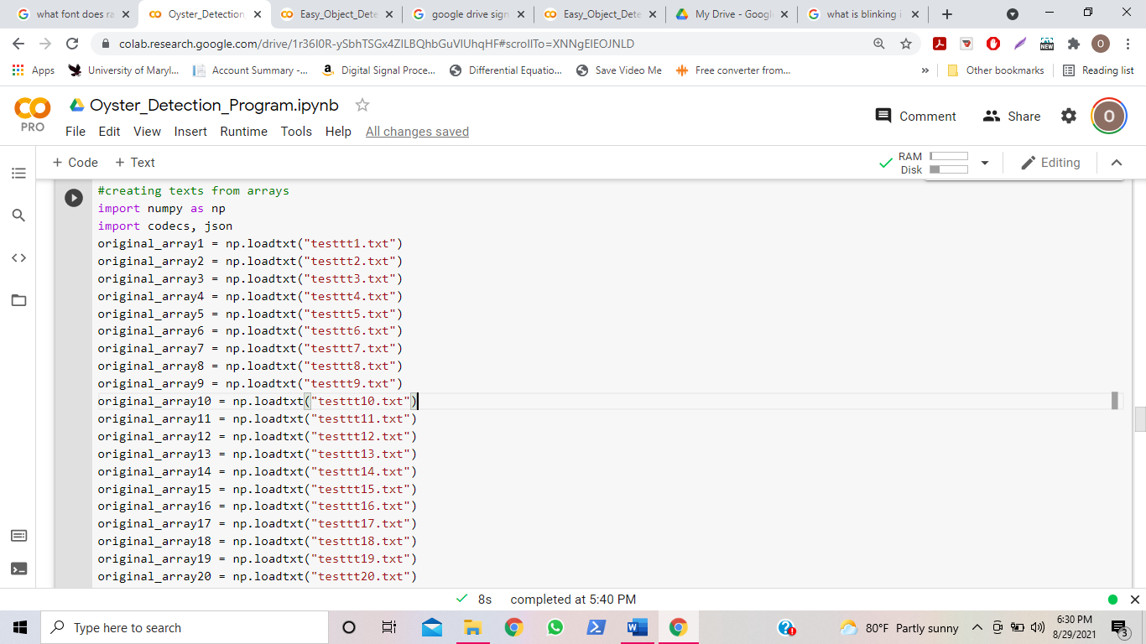

Click “enter” to insert a new blank line underneath the line of code that matches the number of images you have. For example, if you have 10 images, you should insert a new blank line under the line of code “original_array10 = np.loadtxt("testtt10.txt")”.

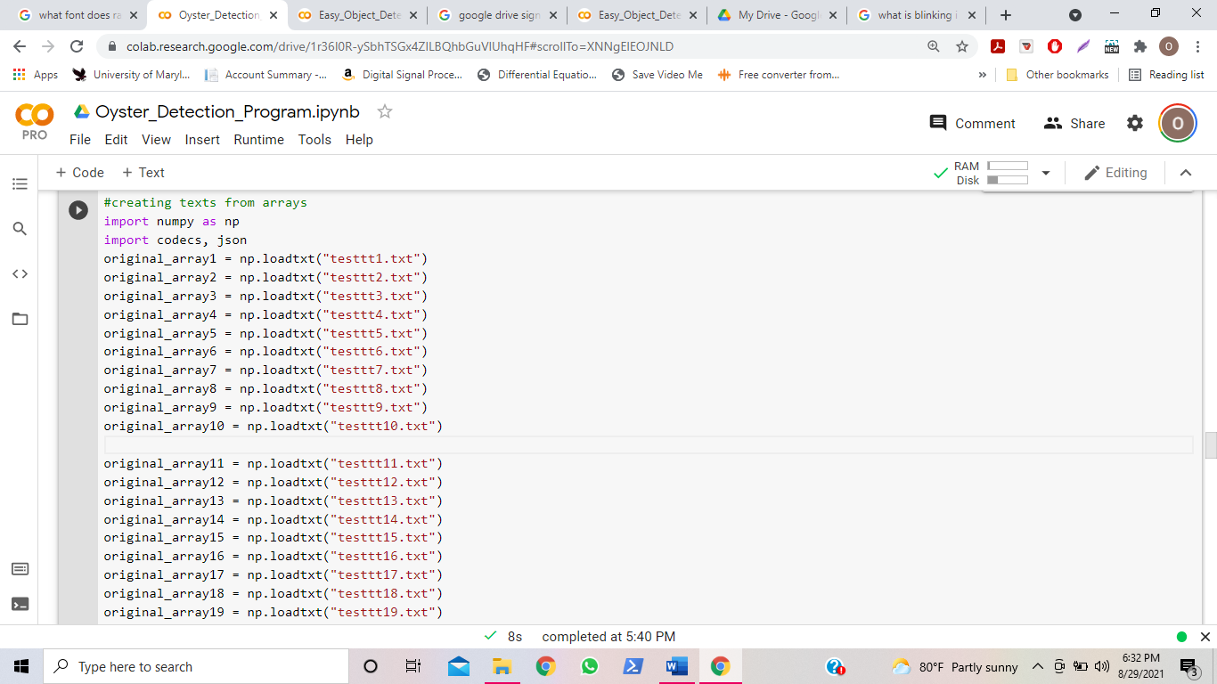

In this blank line of code, write three single quotation marks, like so: ‘’’

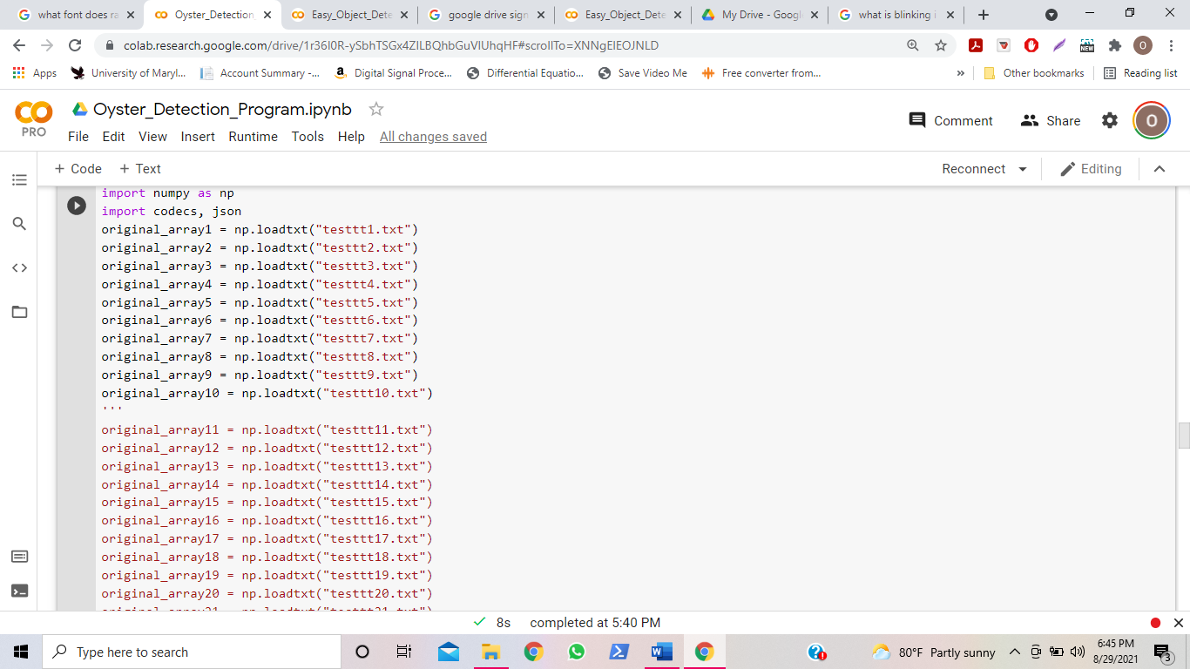

You should see all the text in the lines beneath the three single quotation marks turn red.

Also, create a new blank at the end of the cell as well, underneath the line original_array50 = np.loadtxt("testtt50.txt").

Within this blank line, write three single quotation marks, like so: ‘’’

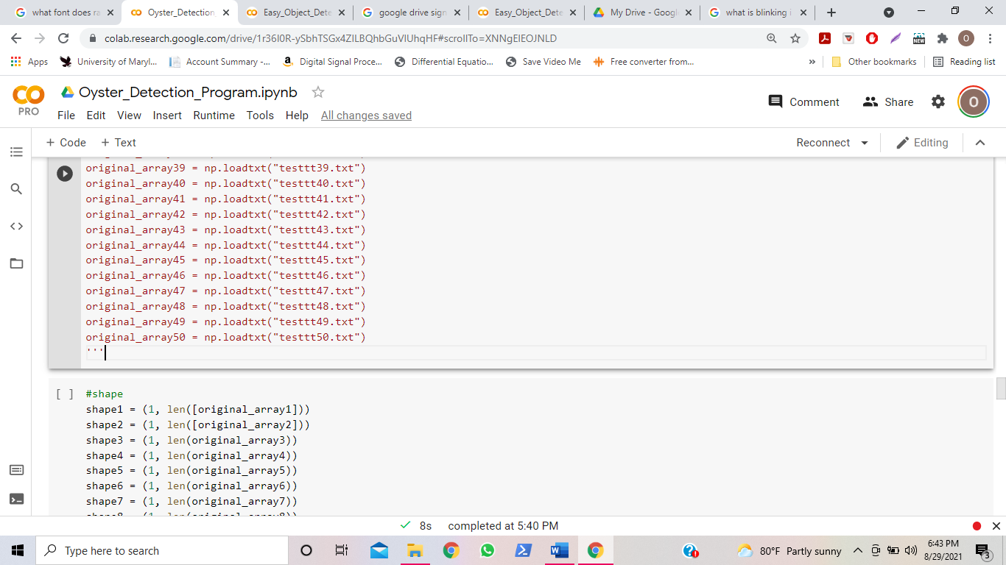

Then, run the play button for this cell.

When that cell is finished running, go to the next cell, which starts with the line “#shape”.

Do NOT run this cell yet. There are repetitive lines of code with the syntax format “shape[x] = (1, len(original_array[x]))”. Take the number of images you have, and go to the line of code where [x] matches the number of images you have. For example, if you have 10 images, go to the line of code that states “shape10 = (1, len(original_array10))”. Click this line such that your insertion point (which is the blinking vertical line that indicates where you are) is at the end of the line.

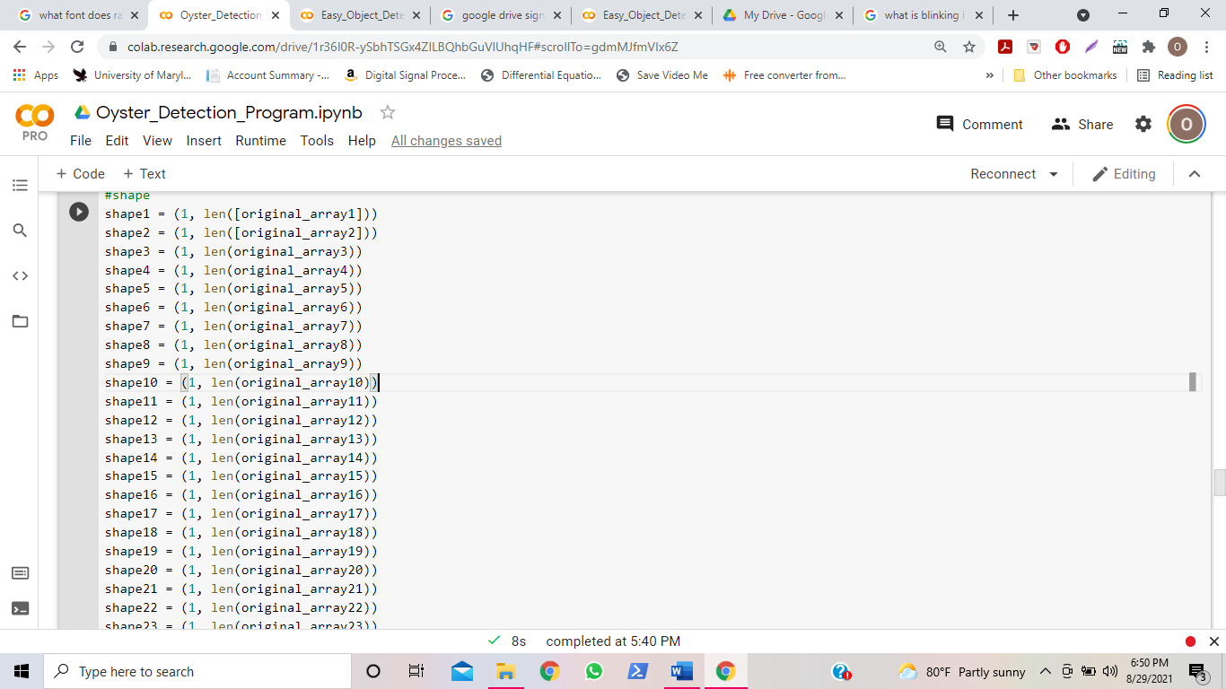

Click “enter” to insert a new blank line underneath the line of code that matches the number of images you have. For example, if you have 10 images, you should insert a new blank line under the line of code “shape10 = (1, len(original_array10))”.

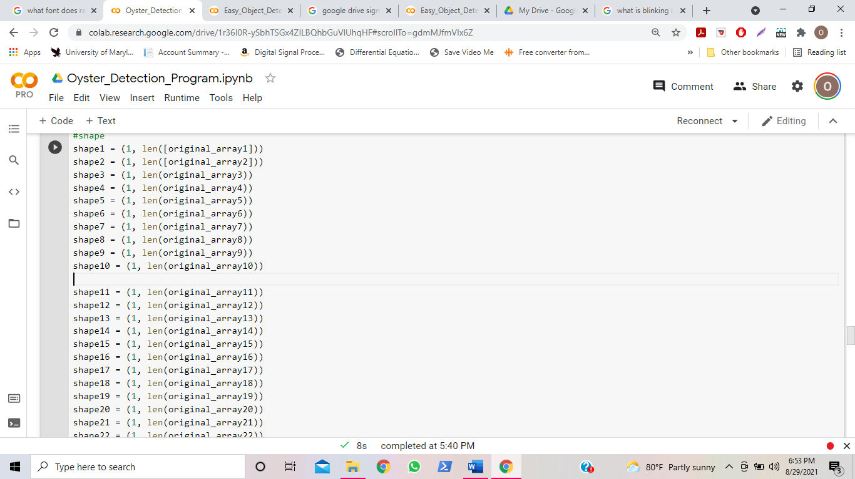

In this blank line of code, write three single quotation marks, like so: ‘’’

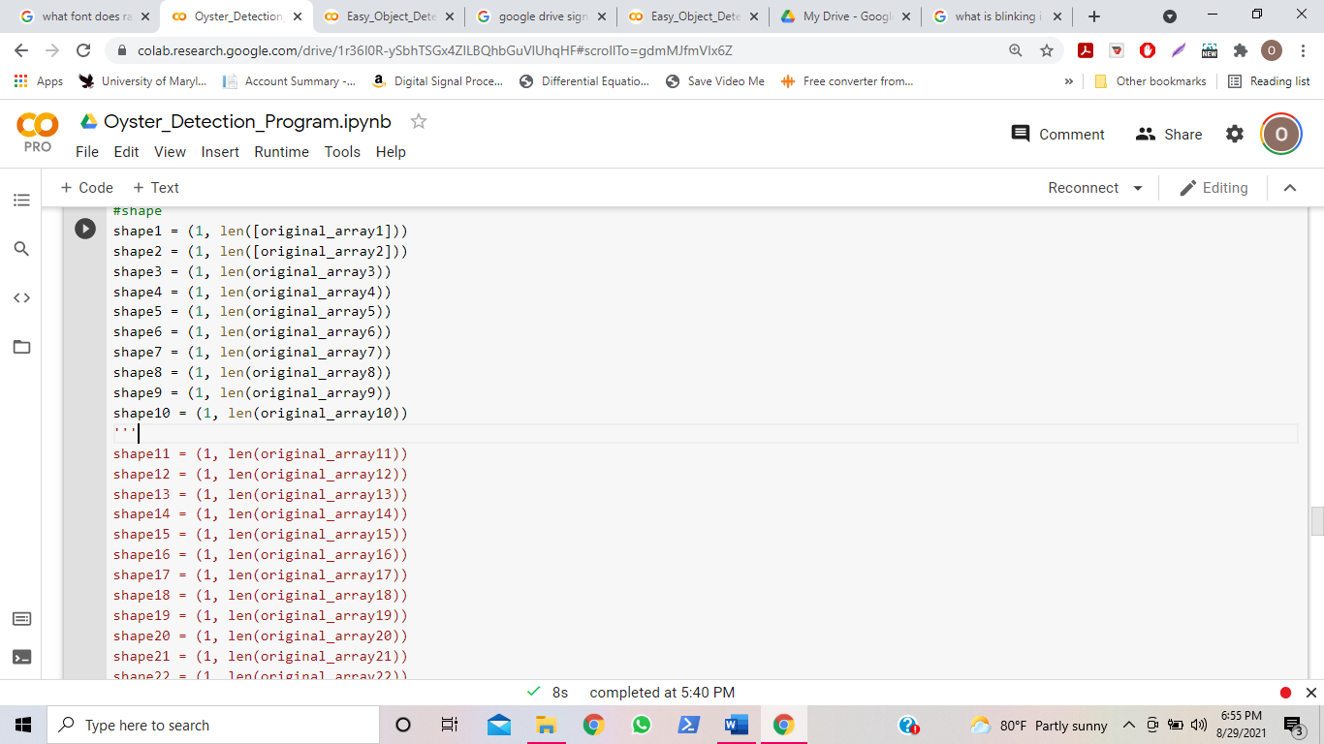

You should see all the text in the lines beneath the three single quotation marks turn red.

Also, create a new blank at the end of the cell as well, underneath the line “shape50 = (1, len(original_array50))”.

Within this blank line, write three single quotation marks, like so: ‘’’

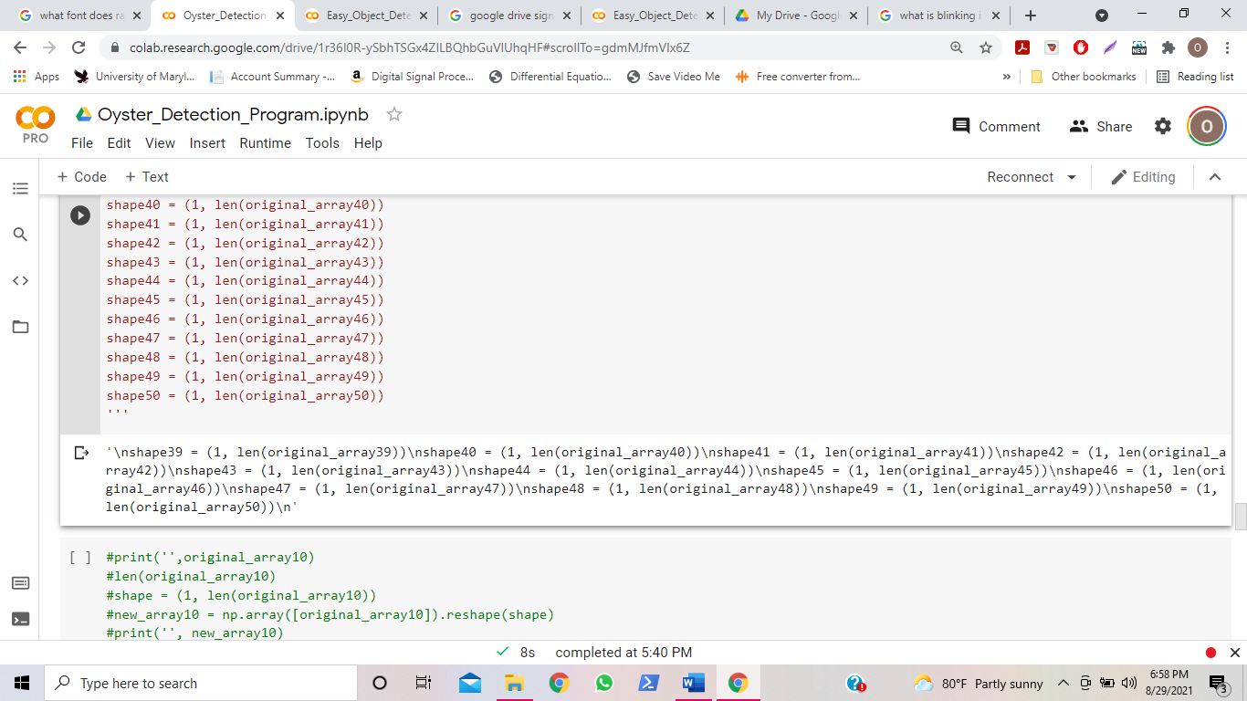

Then, run the play button for this cell.

When that cell is finished running, go to the next cell, which starts with the line “#new array”.

Do NOT run this cell yet. There are repetitive lines of code with the syntax format “new_array[x] = np.array([original_array[x]]).reshape(shape[x])”. Take the number of images you have, and go to the line of code where [x] matches the number of images you have. For example, if you have 10 images, go to the line of code that states “new_array10 = np.array([original_array10]).reshape(shape10)”. Click this line such that your insertion point (which is the blinking vertical line that indicates where you are) is at the end of the line.

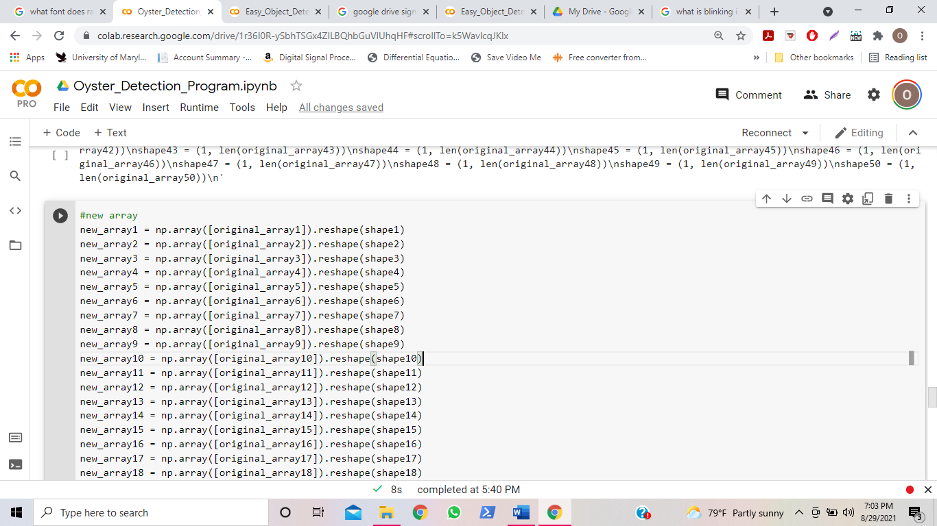

Click “enter” to insert a new blank line underneath the line of code that matches the number of images you have. For example, if you have 10 images, you should insert a new blank line under the line of code “new_array10 = np.array([original_array10]).reshape(shape10)”.

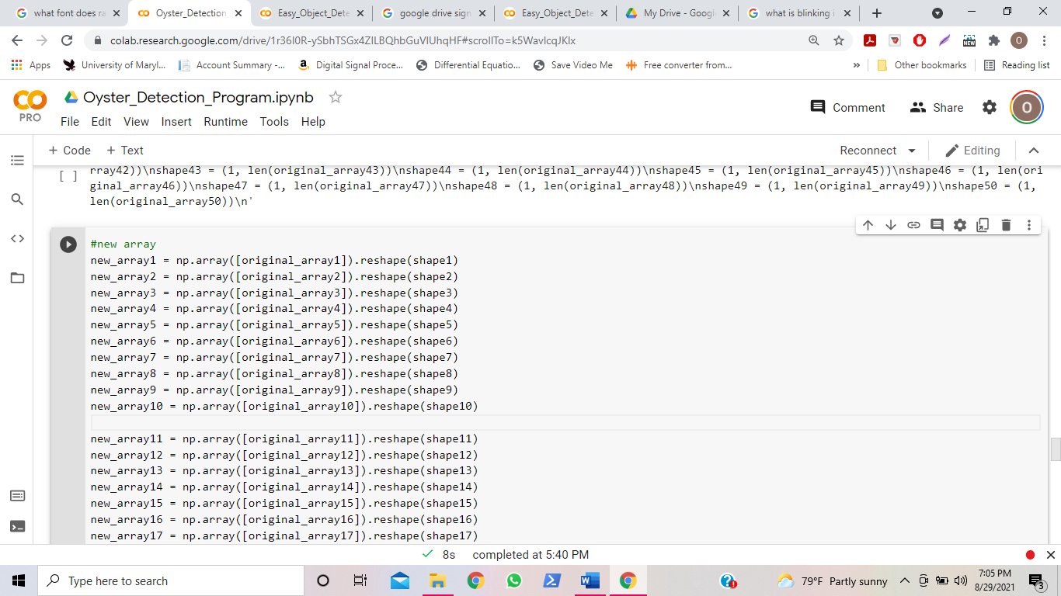

In this blank line of code, write three single quotation marks, like so: ‘’’

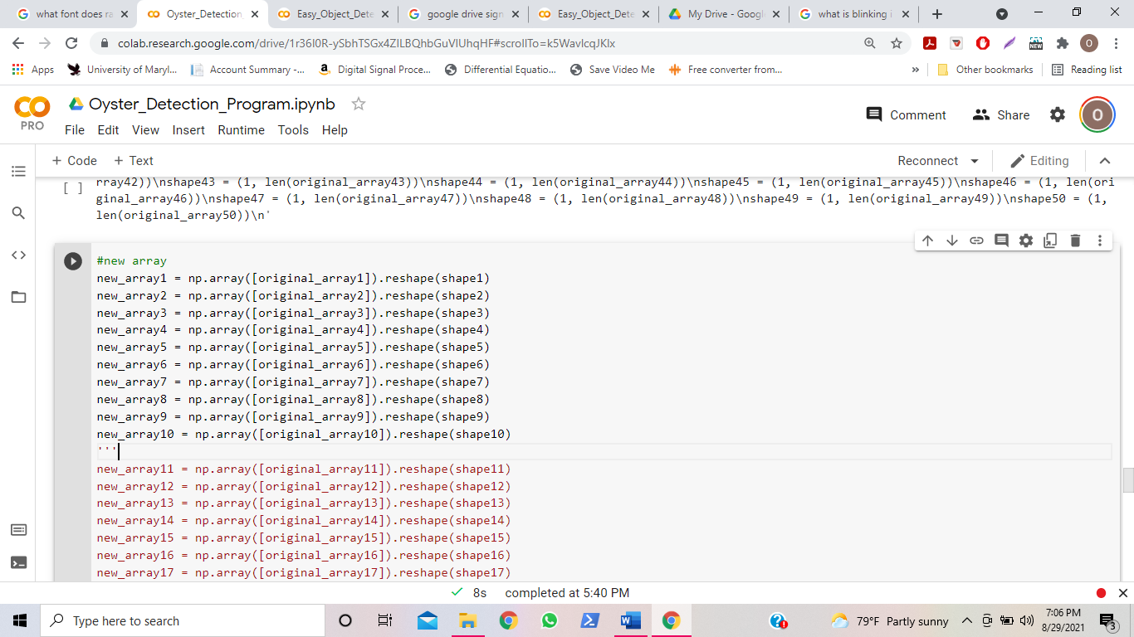

You should see all the text in the lines beneath the three single quotation marks turn red.

Also, create a new blank at the end of the cell as well, underneath the line “new_array50 = np.array([original_array50]).reshape(shape50)”. Within this blank line, write three single quotation marks, like so: ‘’’

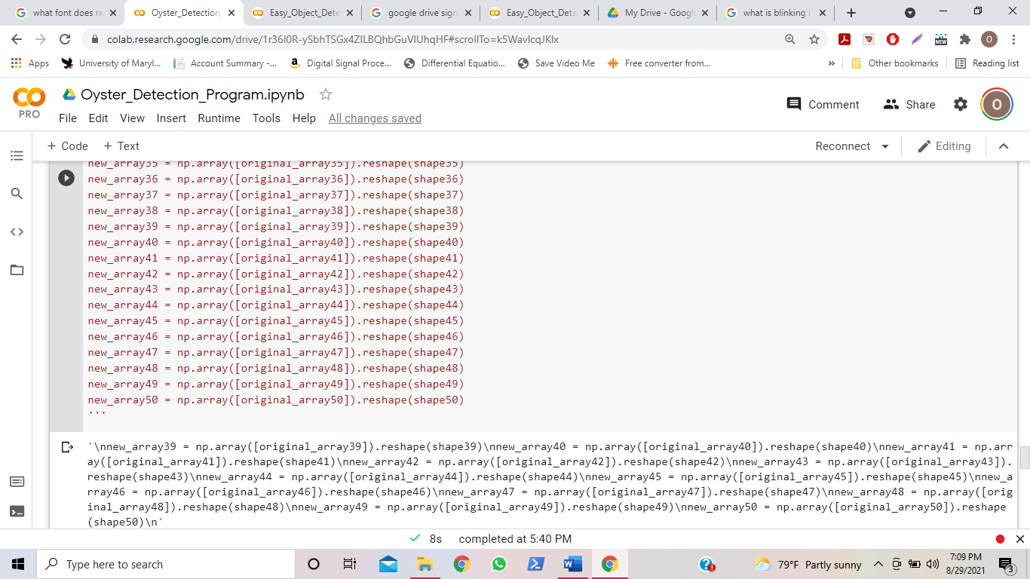

Then, run the play button for this cell.

When that cell is finished running, go to the next cell, which starts with the line #update cells”.

Do NOT run this cell yet. There are repetitive lines of code with the syntax format “ws.update('G[x]', new_array[x].tolist())”. Take the number of images you have, and go to the line of code where [x] matches the number of images you have. For example, if you have 10 images, go to the line of code that states “ws.update('G10', new_array10.tolist())”. Click this line such that your insertion point (which is the blinking vertical line that indicates where you are) is at the end of the line.

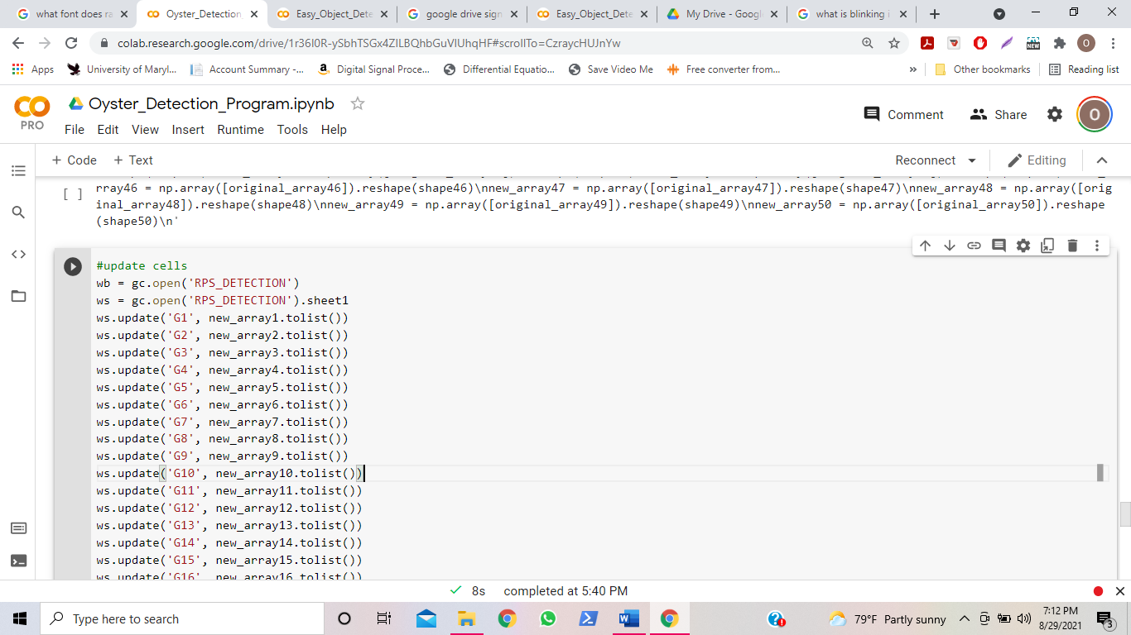

Click “enter” to insert a new blank line underneath the line of code that matches the number of images you have. For example, if you have 10 images, you should insert a new blank line under the line of code “ws.update('G10', new_array10.tolist())”.

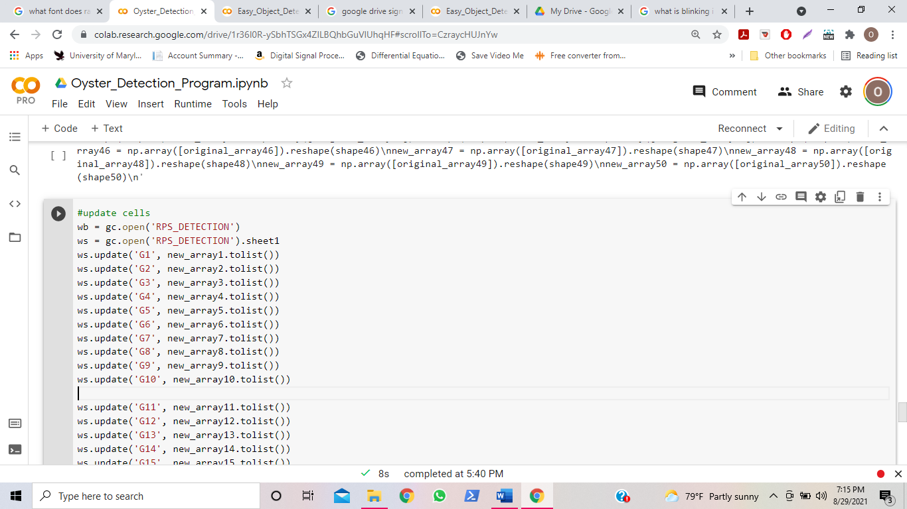

In this blank line of code, write three single quotation marks, like so: ‘’’ 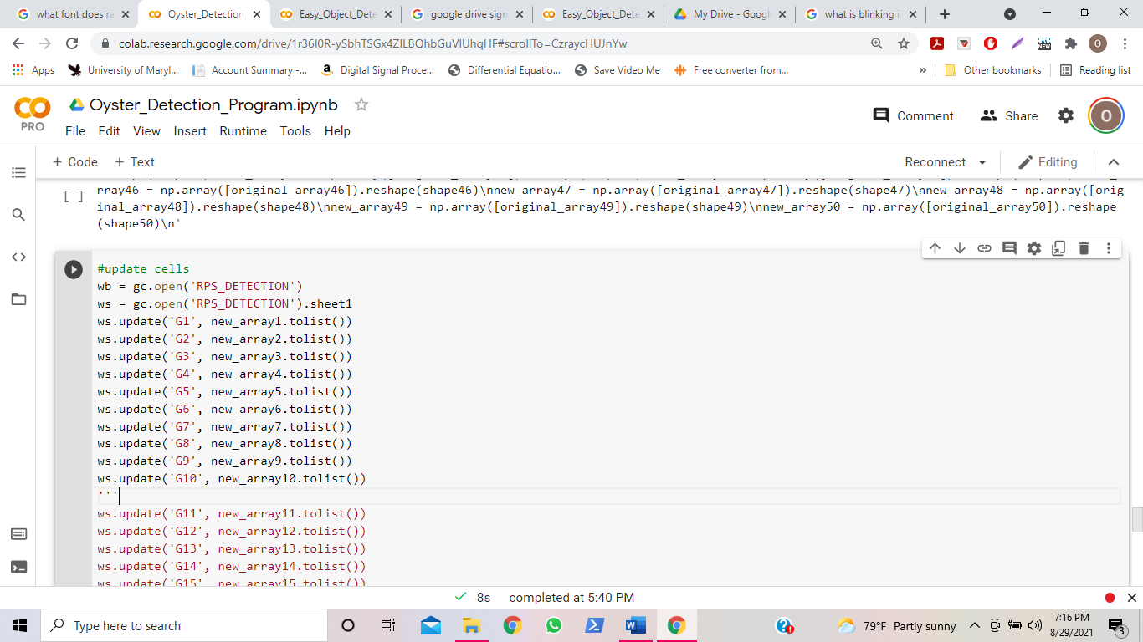

You should see all the text in the lines beneath the three single quotation marks turn red.

Also, create a new blank at the end of the cell as well, underneath the line “ws.update('G50', new_array10.tolist())”. Within this blank line, write three single quotation marks, like so: ‘’’

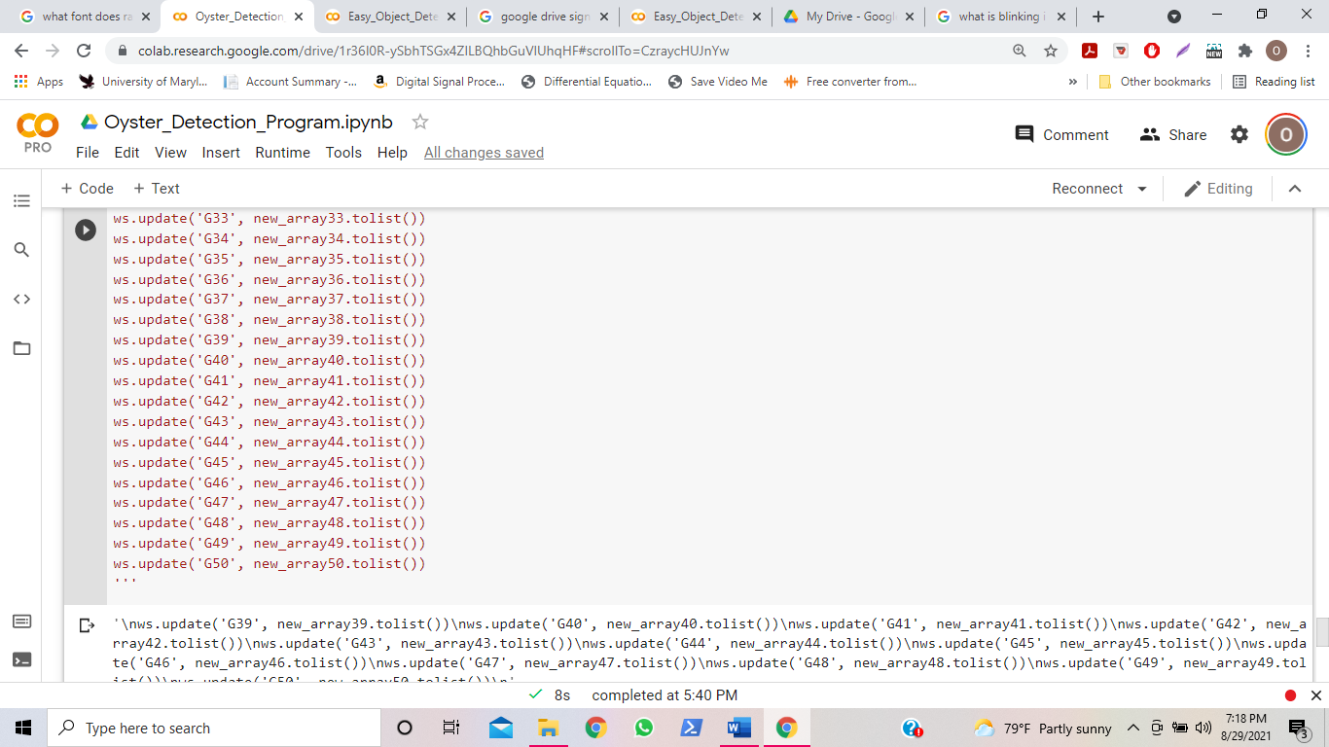

Then, run the play button for this cell.

**If you have more than 50 images, follow the following steps:**

Run the cells that are underneath the text “You Can Continue if you Have Over 50 Images “. On the left have side of the page, go to the folder “more_cellz”, under content. Double click on all 4 files in this folder, and do the same 3 single quotation mark process described earlier in pages 14-18. End the last 3 quotations under the 600th iteration in the code. And lastly, click” ctrl” + “s” when you are done with editing those filed. Then, run the rest of the cells. Remember, be sure to run the images one by one, sequentially, and wait until the previous cell is finished before you run the next cell.

**When you are done running the program,** you can head over to the website to see the data analysis of the oyster movements.

Tabs on website

**How to Read Data on Website**

There is a website that depicts all of the results for the position of the oysters. The link to the website can be found here: <https://aafueh.wixsite.com/oyster-aa-sn>

On the website, you can find charts depicting the number of oysters that was in the large opening position, the small opening position, the closed position, and the total oysters that were opened. Also, you can find numerical and visual (pictural) data depicting the oyster position. You can toggle between these depictions by navigating through the tabs on the website.



The first tab, “Large and Small Openings”, have two graphs. The first graph will tell you how many oysters in the trial had the position of a large opening, and the second graph will tell you how many oysters in the trial had a position of a small opening.

 

The second tab, “Total Openings”, has a graph that adds the large and small openings to depict the total number of oysters throughout the trial that were opened.



The third tab, “Total Closings”, has a graph that adds the large and small openings to depict the total number of oysters throughout the trial that were closed.

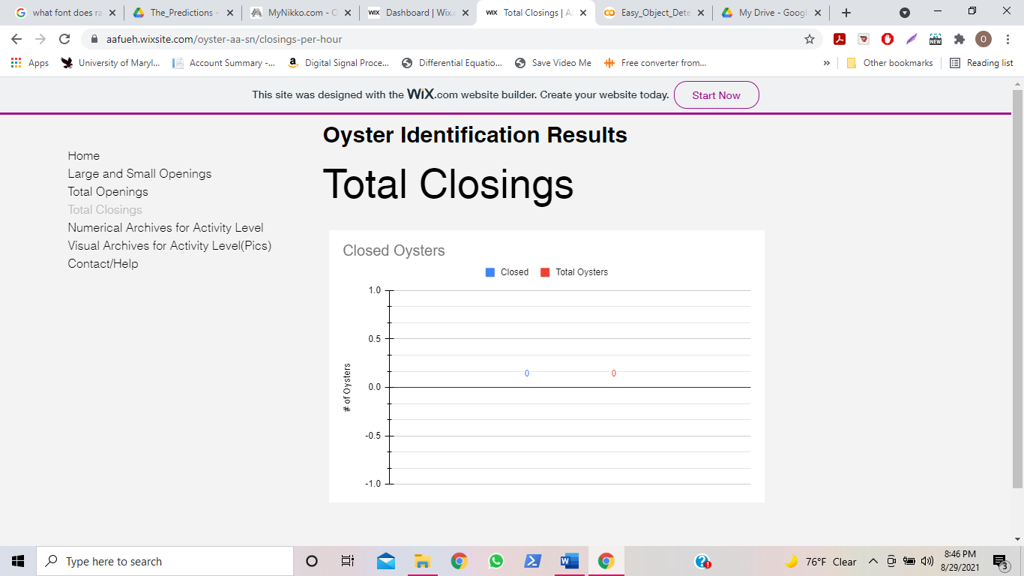

The fourth tab depicts the link for showing the numerical data of the oyster position identification after they undergo the image processing program. The first chart depicts the sum of all the oyster movements while the second chart depicts the individual oyster movement numerical archives.

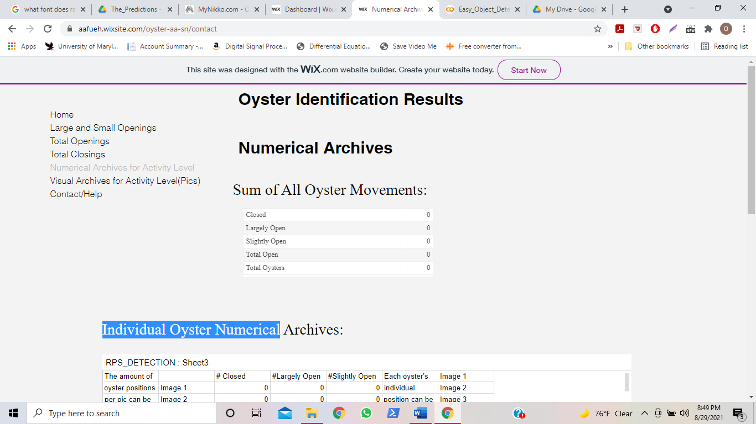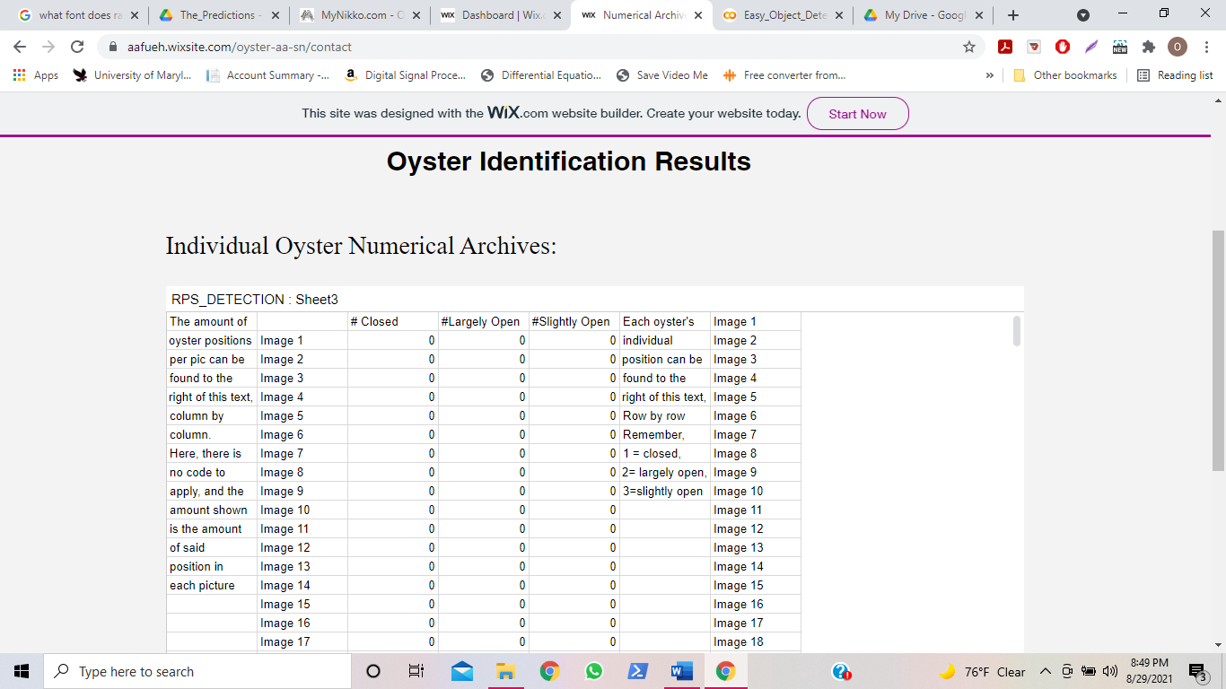

The fifth tab depicts the link for showing the visual data of the oyster position identification after they undergo the image processing program. They will be viewable in google drive, via a google drive folder.

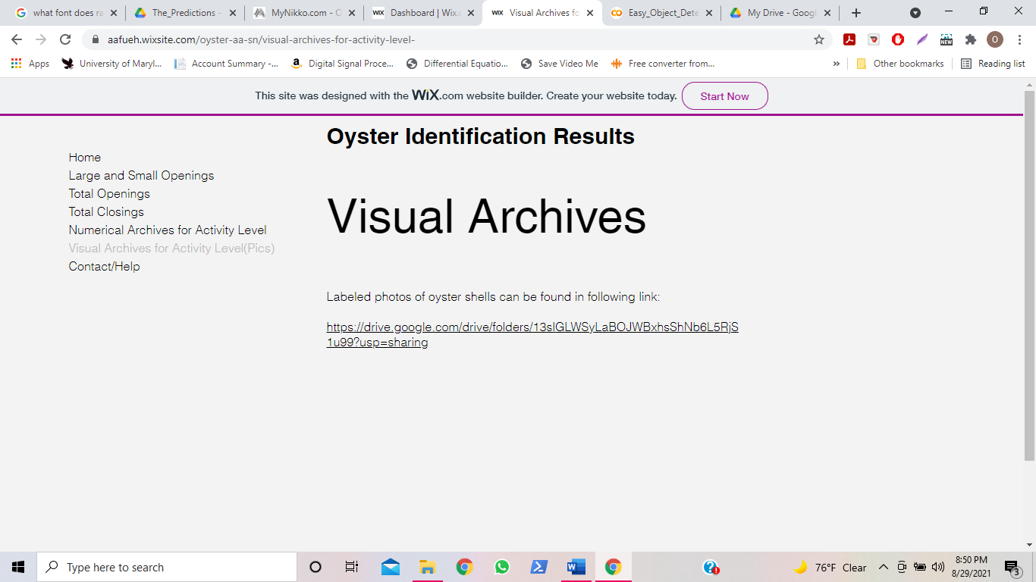

The sixth (and final) tab depicts the link for any questions, comments, or concerns the user might have about using the website. After submitting their name, email, and comment, the user will be responded to in 24-48 hours.

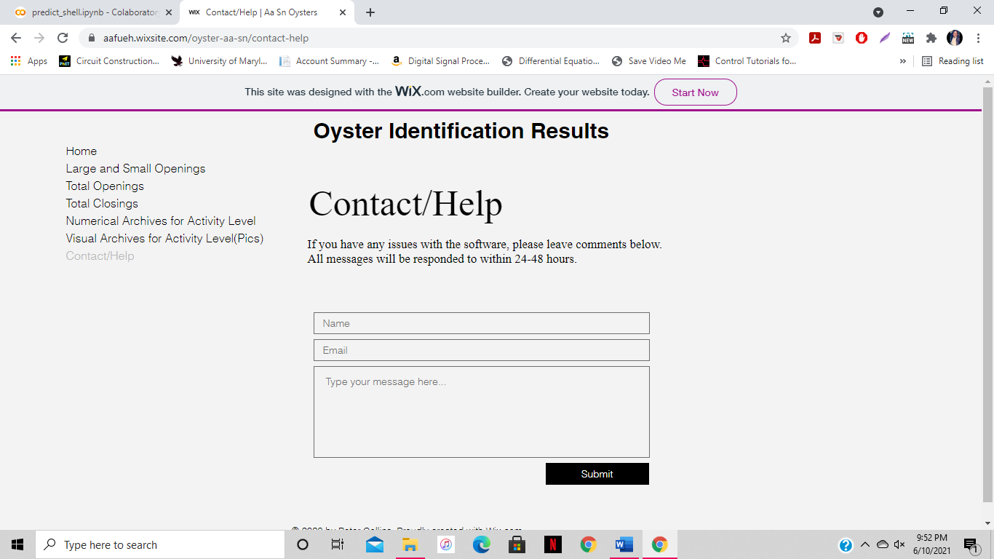

### Source Code for taking time-lapse pictures

**sudo apt-get install motion** #INTALLS NESSESARY PACKAGES

**lsusb** #INTALLS NESSESARY PACKAGES

**sudo cat /proc/mounts**

**sudo nano /etc/motion/motion.conf** #GOES TO CONFIGURATION PAGE

#THE FOLLOWING CHANGES ALL PARAMETERS NEEDED FOR THE TIME LAPSE TO WORK

**'ctrl + w**'

**'ctrl + w**' + **'daemon'** #Makes sure **'daemon'** is **ON**.

**'ctrl + w**' + '**framerate**' #Set '**framerate**' anywhere in between **1000 to 1500.**

**'ctrl + w**' + '**Stream_quality**' #**Stream_quality** should be **100**.

**'ctrl + w**' + ‘'**Stream_localhost**'’ #Change '**Stream_localhost**' to **OFF**.

**'ctrl + w**' + '**webcontrol_localhost**' #Change '**webcontrol_localhost**' to **OFF**.

**'ctrl + w**' + ‘**quality**' Set '**quality**' to **100**.

**'ctrl + w**' + '**width**' & '**height**' #Set '**width**' & '**height**' to **1280** & **720**.

**'ctrl + w**' + '**Snapshot_interval'** #Set '**Snapshot_interval'**equals to **10**. ( ***every 10 seconds 1 photo will be taken*** )

**'ctrl + w**' + '**target_dir**' #Set '**target_dir**' as the path that was stated earlier.

'**sudo nano /etc/default/motion** ' #ALLOWS USER TO SEE CONFIGURATION

' **start_motion_daemon** ' # TURNS ON DAEMON FEATURE

**'sudo service motion restart'**#RESTARTS SYSTEM TO PREPARE FOR PICTURE TAKING

**'sudo motion'** #STARTS TAKING PICTURES

### 3. Source Code for User Based Google Collab Image Processing System

#this attaches the google drive account to the program, so the results can be stored #in this specific account

from google.colab import drive

drive.mount('/content/gdrive', force_remount=True)

#this unzips the YOLOv5 training model in order for the pictures to go through them

!wget http://1.34.213.113/yolov5_shell.zip

!unzip yolov5_shell.zip

#this unzips the folder full images in order to prepare for the images to be processed

!unzip data.zip

#this runs the images through the image processing system, and creates predictions about the position #the oysters are in

from predict_colab import predict

predict('data')

#this creates a folder in your google drive account that was connected at the beginning of the program #and the output images will be stored in this folder

!cp -r /content/output /content/gdrive/MyDrive/

!cp /content/result.xlsx /content/gdrive/MyDrive/output/result.xlsx

#the puts all of the content from the output of the image processing program inside of the google drive #folder. It put the pictures from the output here. It also puts a spreadsheet containing a list of what the #oysters identified, the estimated accuracy for the identification, the name of the picture, and graphs #depicting all of the three former listed things

!pip install gspread

!pip install oauth2client

import pandas as pd

import gspread

from oauth2client.service_account import ServiceAccountCredentials

!wget http://1.34.213.113/stock-20201108-34a2582d1af6.json

sheet_id = "1jC2d0XvQidyNQg--0uJX1XUdNuhckhRzQzcI-fG9acM"

df_new = pd.read_excel("result.xlsx")

auth_json_path = '/content/stock-20201108-34a2582d1af6.json'

gss_scopes = ['https://spreadsheets.google.com/feeds']

credentials = ServiceAccountCredentials.from_json_keyfile_name(auth_json_path,gss_scopes)

gss_client = gspread.authorize(credentials)

sheet = gss_client.open_by_key(sheet_id).sheet1

for i in range(len(df_new)):

  file_name,labels,x,y,w,h = df_new.iloc[i,0:6].tolist()

  sheet.append_row([file_name,labels,int(x),int(y),int(w),int(h)])

### 4) Source Code for TENSORFLOW OBJECT DETECTION TRAINING MODEL

# %%capture

#After this cell executes runtime will restart to finish the install, ignore and close the crash message, continue running cells starting with the one below

!pip install numpy==1.17.5;

#Installs dependencies

%tensorflow_version 1.x

!pip install tf_slim

#we have 600 training images

# For faster training time, images should be resized to 300x300 and then annotated

# Images should contain the objects of interest at various scales, angles, lighting conditions, locations

# For acceptable results - mAP@0.5 of 0.9 the model was trained with batch size of 24

# and 12500 steps. this takes about 1h using 2 augmentations.

# using 5 augmentations it takes about 2h

num_steps = 12500

# A step means using a single batch of data. larger batch, less steps required

#Number of evaluation steps.

num_eval_steps = 125

#Batch size 24 is a setting that generally works well. can be changed higher or lower

MODELS_CONFIG = {

        'ssd_mobilenet_v2': {

        'model_name': 'ssd_mobilenet_v2_coco_2018_03_29',

        'pipeline_file': 'ssd_mobilenet_v2_coco.config',

        'batch_size': 24

    }

}

selected_model = 'ssd_mobilenet_v2'

# Name of the object detection model to use.

MODEL = MODELS_CONFIG[selected_model]['model_name']

# Name of the pipline file in tensorflow object detection API.

pipeline_file = MODELS_CONFIG[selected_model]['pipeline_file']

# Training batch size fits in Colab's GPU memory for selected model.

batch_size = MODELS_CONFIG[selected_model]['batch_size']

repo_url = 'https://github.com/GotG/object_detection_demo_flow'

import os

%cd /content

repo_dir_path = os.path.abspath(os.path.join('.', os.path.basename(repo_url)))

!rm -rf {repo_dir_path}

!git clone {repo_url} {repo_dir_path}

%cd {repo_dir_path}

!git pull

#mount your google drive.

#it will be visible in the file navigator on the left of this notebook

#there should be a folder in your drive with your data

from google.colab import drive

drive.mount('/content/gdrive')

#To train on your own data:

#Remove repo data (images) for training/testing/final testing

!rm -r /content/object_detection_demo_flow/data/images/final_test/

!rm -r /content/object_detection_demo_flow/data/images/train/

!rm -r /content/object_detection_demo_flow/data/images/test/

#copy files from gdrive to colab drive. this takes a few minutes, depending on the number of files.

#Go on the file explorer on the left of this notebook and access your gdrive. find the folders

#with your train, test and final_test images.

#Right click on each and copy the path. paste it btw the first " " in the corresponding lines

#training folder

!cp -r "/content/drive/My Drive/UPDATED_OYSTER_PROJECT/Train_Pics_Xmls" "/content/object_detection_demo_flow/data/images/train"

#testing folder

!cp -r "/content/gdrive/My Drive/UPDATED_OYSTER_PROJECT/Test_Pics_Xmls” "/content/object_detection_demo_flow/data/images/test"

#final testing folder

!cp -r "/content/gdrive/My Drive/UPDATED_OYSTER_PROJECT/The_Validation" "/content/object_detection_demo_flow/data/images/final_test"

# quick check for training data files. you can also browse to the object_detection_demo_flows

# on the left and see if they were copied

!ls /content/object_detection_demo_flow/data/images/train

# %%capture

%cd /content

!git clone --quiet https://github.com/tensorflow/models.git

%cd /content/models/

!git checkout 58d19c67e1d30d905dd5c6e5092348658fed80af

!apt-get update && apt-get install -y -qq protobuf-compiler python-pil python-lxml python-tk

!pip install -q Cython contextlib2 pillow lxml matplotlib

!pip install -q pycocotools

%cd /content/models/research

!protoc object_detection/protos/*.proto --python_out=.

import os

os.environ['PYTHONPATH'] += ':/content/models/research/:/content/models/research/slim/'

!python object_detection/builders/model_builder_test.py

%%capture

%cd {repo_dir_path}

# Convert train folder annotation xml files to a single csv file,

# generate the `label_map.pbtxt` file to `data/` directory as well.

!python xml_to_csv.py -i data/images/train -o data/annotations/train_labels.csv -l data/annotations

# Convert test folder annotation xml files to a single csv.

!python xml_to_csv.py -i data/images/test -o data/annotations/test_labels.csv

# Generate `train.record`

!python generate_tfrecord.py --csv_input=data/annotations/train_labels.csv --output_path=data/annotations/train.record --img_path=data/images/train --label_map data/annotations/label_map.pbtxt

# Generate `test.record`

!python generate_tfrecord.py --csv_input=data/annotations/test_labels.csv --output_path=data/annotations/test.record --img_path=data/images/test --label_map data/annotations/label_map.pbtxt

# Set the paths

test_record_fname = '/content/object_detection_demo_flow/data/annotations/test.record'

train_record_fname = '/content/object_detection_demo_flow/data/annotations/train.record'

label_map_pbtxt_fname = '/content/object_detection_demo_flow/data/annotations/label_map.pbtxt'

%cd /content/models/research

import os

import shutil

import glob

import urllib.request

import tarfile

MODEL_FILE = MODEL + '.tar.gz'

DOWNLOAD_BASE = 'http://download.tensorflow.org/models/object_detection/'

DEST_DIR = '/content/models/research/pretrained_model'

if not (os.path.exists(MODEL_FILE)):

    urllib.request.urlretrieve(DOWNLOAD_BASE + MODEL_FILE, MODEL_FILE)

tar = tarfile.open(MODEL_FILE)

tar.extractall()

tar.close()

os.remove(MODEL_FILE)

if (os.path.exists(DEST_DIR)):

    shutil.rmtree(DEST_DIR)

os.rename(MODEL, DEST_DIR)

!echo {DEST_DIR}

!ls -alh {DEST_DIR}

#TF pretrained model checkpoint

fine_tune_checkpoint = os.path.join(DEST_DIR, "model.ckpt")

fine_tune_checkpoint

import os

pipeline_fname = os.path.join('/content/models/research/object_detection/samples/configs/', pipeline_file)

assert os.path.isfile(pipeline_fname), '`{}` not exist'.format(pipeline_fname)

def get_num_classes(pbtxt_fname):

    from object_detection.utils import label_map_util

    label_map = label_map_util.load_labelmap(pbtxt_fname)

    categories = label_map_util.convert_label_map_to_categories(

        label_map, max_num_classes=90, use_display_name=True)

    category_index = label_map_util.create_category_index(categories)

    return len(category_index.keys())

from pathlib import Path

parent = Path(label_map_pbtxt_fname).parent

!ls {parent}

import re

iou_threshold = 0.50

num_classes = get_num_classes(label_map_pbtxt_fname)

with open(pipeline_fname) as f:

    s = f.read()

with open(pipeline_fname, 'w') as f:

    # fine_tune_checkpoint

    s = re.sub('fine_tune_checkpoint: ".*?"',

               'fine_tune_checkpoint: "{}"'.format(fine_tune_checkpoint), s)

    # tfrecord files train and test.

    s = re.sub(

        '(input_path: ".*?)(train.record)(.*?")', 'input_path: "{}"'.format(train_record_fname), s)

    s = re.sub(

        '(input_path: ".*?)(val.record)(.*?")', 'input_path: "{}"'.format(test_record_fname), s)

    # label_map_path

    s = re.sub(

        'label_map_path: ".*?"', 'label_map_path: "{}"'.format(label_map_pbtxt_fname), s)

    # Set training batch_size.

    s = re.sub('batch_size: [0-9]+',

               'batch_size: {}'.format(batch_size), s)

    # Set training steps, num_steps

    s = re.sub('num_steps: [0-9]+',

               'num_steps: {}'.format(num_steps), s)

    # Set number of classes num_classes.

    s = re.sub('num_classes: [0-9]+',

               'num_classes: {}'.format(num_classes), s)

    # Set number of classes num_classes.

    s = re.sub('iou_threshold: [0-9].[0-9]+',

               'iou_threshold: {}'.format(iou_threshold), s)

    f.write(s)

# #Have a look at the config file with various settings

!cat {pipeline_fname}

#After running this cell click on the link in the output cell to open tensorboard

#Tensoarboard will show you graphically different training parameters as the model is training

#when training finishes after the set number of steps, tensorboard can be used to see a nice summary of the training process

#Visuals will load in Tensorboard after the model has gone through a few hundred steps

model_dir = 'content/object_detection_demo_flow/deploy'

!wget https://bin.equinox.io/c/4VmDzA7iaHb/ngrok-stable-linux-amd64.zip

!unzip ngrok-stable-linux-amd64.zip

LOG_DIR = model_dir

get_ipython().system_raw(

    'tensorboard --logdir {} --host 0.0.0.0 --port 6006 &'

    .format(LOG_DIR)

)

get_ipython().system_raw('./ngrok http 6006 &')

! curl -s http://localhost:4040/api/tunnels | python3 -c \

    "import sys, json; print(json.load(sys.stdin)['tunnels'][0]['public_url'])"

model_dir = 'content/object_detection_demo_flow/deploy'

# Optionally remove content in output model directory for a fresh start.

# !rm -rf {model_dir}

# os.makedirs(model_dir, exist_ok=True)

!python /content/models/research/object_detection/model_main.py \

    --pipeline_config_path={pipeline_fname} \

    --model_dir={model_dir} \

    --alsologtostderr \

    --num_train_steps={num_steps} \

    --num_eval_steps={num_eval_steps}

#model dir check for the trained model

!ls {model_dir}

#clean output_directory if necessary to start fresh:

!rm -rf /content/object_detection_demo/fine_tuned_model/

os.makedirs('/content/object_detection_demo_flow/fine_tuned_model/', exist_ok=True)

%%capture

import re

import numpy as np

output_directory = 'content/model/research/object_detection/’

# output_directory = '/content/gdrive/My\ Drive/data/'

lst = os.listdir(model_dir)

lst = [l for l in lst if 'model.ckpt-' in l and '.meta' in l]

steps=np.array([int(re.findall('\d+', l)[0]) for l in lst])

last_model = lst[steps.argmax()].replace('.meta', '')

last_model_path = os.path.join(model_dir, last_model)

print(last_model_path)

!python /content/models/research/object_detection/export_inference_graph.py \

    --input_type=image_tensor \

    --pipeline_config_path={pipeline_fname} \

    --output_directory={output_directory} \

    --trained_checkpoint_prefix={last_model_path}

#export directory check

!ls {output_directory}

import os

pb_fname = os.path.join(os.path.abspath(output_directory), "frozen_inference_graph.pb")

assert os.path.isfile(pb_fname), '`{}` not exist'.format(pb_fname)

!ls -alh {pb_fname}

import os

import glob

# Path to frozen detection graph. This is the actual model that is used for the object detection.

PATH_TO_CKPT = pb_fname

# List of the strings that is used to add correct label for each box.

PATH_TO_LABELS = label_map_pbtxt_fname

# If you want to test the code with your images, just add images files to the PATH_TO_TEST_IMAGES_DIR.

PATH_TO_TEST_IMAGES_DIR =  os.path.join(repo_dir_path, "data/images/final_test")

assert os.path.isfile(pb_fname)

assert os.path.isfile(PATH_TO_LABELS)

TEST_IMAGE_PATHS = glob.glob(os.path.join(PATH_TO_TEST_IMAGES_DIR, "*.*"))

assert len(TEST_IMAGE_PATHS) > 0, 'No image found in `{}`.'.format(PATH_TO_TEST_IMAGES_DIR)

print(TEST_IMAGE_PATHS)

%cd /content/models/research/object_detection

import numpy as np

import os

import six.moves.urllib as urllib

import sys

import tarfile

import tensorflow as tf

import zipfile

from collections import defaultdict

from io import StringIO

# This is needed to display the images.

%matplotlib inline

import matplotlib.pyplot as plt

from PIL import Image

# This is needed since the notebook is stored in the object_detection folder.

sys.path.append("..")

from object_detection.utils import ops as utils_ops

from object_detection.utils import label_map_util

from object_detection.utils import visualization_utils as vis_util

detection_graph = tf.Graph()

with detection_graph.as_default():

    od_graph_def = tf.GraphDef()

    with tf.gfile.GFile(PATH_TO_CKPT, 'rb') as fid:

        serialized_graph = fid.read()

        od_graph_def.ParseFromString(serialized_graph)

        tf.import_graph_def(od_graph_def, name='')

label_map = label_map_util.load_labelmap(PATH_TO_LABELS)

categories = label_map_util.convert_label_map_to_categories(

    label_map, max_num_classes=num_classes, use_display_name=True)

category_index = label_map_util.create_category_index(categories)

def load_image_into_numpy_array(image):

    (im_width, im_height) = image.size

    return np.array(image.getdata()).reshape(

        (im_height, im_width, 3)).astype(np.uint8)

# Size, in inches, of the output images.

IMAGE_SIZE = (12, 8)

def run_inference_for_single_image(image, graph):

    with graph.as_default():

        with tf.Session() as sess:

            # Get handles to input and output tensors

            ops = tf.get_default_graph().get_operations()

            all_tensor_names = {

                output.name for op in ops for output in op.outputs}

            tensor_dict = {}

            for key in [

                'num_detections', 'detection_boxes', 'detection_scores',

                'detection_classes', 'detection_masks'

            ]:

                tensor_name = key + ':0'

                if tensor_name in all_tensor_names:

                    tensor_dict[key] = tf.get_default_graph().get_tensor_by_name(

                        tensor_name)

            if 'detection_masks' in tensor_dict:

                # The following processing is only for single image

                detection_boxes = tf.squeeze(

                    tensor_dict['detection_boxes'], [0])

                detection_masks = tf.squeeze(

                    tensor_dict['detection_masks'], [0])

                # Reframe is required to translate mask from box coordinates to image coordinates and fit the image size.

                real_num_detection = tf.cast(

                    tensor_dict['num_detections'][0], tf.int32)

                detection_boxes = tf.slice(detection_boxes, [0, 0], [

                                           real_num_detection, -1])

                detection_masks = tf.slice(detection_masks, [0, 0, 0], [

                                           real_num_detection, -1, -1])

                detection_masks_reframed = utils_ops.reframe_box_masks_to_image_masks(

                    detection_masks, detection_boxes, image.shape[0], image.shape[1])

                detection_masks_reframed = tf.cast(

                    tf.greater(detection_masks_reframed, 0.5), tf.uint8)

                # Follow the convention by adding back the batch dimension

                tensor_dict['detection_masks'] = tf.expand_dims(

                    detection_masks_reframed, 0)

            image_tensor = tf.get_default_graph().get_tensor_by_name('image_tensor:0')

            # Run inference

            output_dict = sess.run(tensor_dict,

                                   feed_dict={image_tensor: np.expand_dims(image, 0)})

            # all outputs are float32 numpy arrays, so convert types as appropriate

            output_dict['num_detections'] = int(

                output_dict['num_detections'][0])

            output_dict['detection_classes'] = output_dict[

                'detection_classes'][0].astype(np.uint8)

            output_dict['detection_boxes'] = output_dict['detection_boxes'][0]

            output_dict['detection_scores'] = output_dict['detection_scores'][0]

            if 'detection_masks' in output_dict:

                output_dict['detection_masks'] = output_dict['detection_masks'][0]

    return output_dict

for image_path in TEST_IMAGE_PATHS:

    image = Image.open(image_path)

    print(image_path)

    # the array based representation of the image will be used later in order to prepare the

    # result image with boxes and labels on it.

    image_np = load_image_into_numpy_array(image)

    # Expand dimensions since the model expects images to have shape: [1, None, None, 3]

    image_np_expanded = np.expand_dims(image_np, axis=0)

    # Actual detection.

    output_dict = run_inference_for_single_image(image_np, detection_graph)

    # Visualization of the results of a detection.

    vis_util.visualize_boxes_and_labels_on_image_array(

        image_np,

        output_dict['detection_boxes'],

        output_dict['detection_classes'],

        output_dict['detection_scores'],

        category_index,

        instance_masks=output_dict.get('detection_masks'),

        use_normalized_coordinates=True,

        line_thickness=8)

    plt.figure(figsize=IMAGE_SIZE)

    plt.imshow(image_np)

    plt.show()

#save files

!zip -r '/content/annotations.zip"'’content/folder/object_detection_demo_flow/data/annotations.zip '

!zip -r '/content/fine_tined_modell.zip"'’content/folder/object_detection_demo_flow/fine_tuned_model.zip '

!zip -r '/content/deployz.zip"'’content/folder/object_detection_demo_flow/deploy.zip '

!zip -r '/content/model_ob_detect.zip"'’content/folder/model/research/object_detection.zip '

### 5) Source Code for Model Deployment

!pip install numpy==1.17.5;

%tensorflow_version 1.x

!pip install tf_slim

import os

import os

import shutil

import glob

import urllib.request

import tarfile

repo_url = 'https://github.com/GotG/object_detection_demo_flow'

import os

%cd /content

repo_dir_path = os.path.abspath(os.path.join('.', os.path.basename(repo_url)))

!rm -rf {repo_dir_path}

!git clone {repo_url} {repo_dir_path}

%cd {repo_dir_path}

!git pull

%%capture

%cd /content

!git clone --quiet https://github.com/tensorflow/models.git

%cd /content/models/

!git checkout 58d19c67e1d30d905dd5c6e5092348658fed80af

!apt-get update && apt-get install -y -qq protobuf-compiler python-pil python-lxml python-tk

!pip install -q Cython contextlib2 pillow lxml matplotlib

!pip install -q pycocotools

%cd /content/models/research

!protoc object_detection/protos/*.proto --python_out=.

import os

os.environ['PYTHONPATH'] += ':/content/models/research/:/content/models/research/slim/'

!python object_detection/builders/model_builder_test.py

!rm -r /content/models/research/object_detection/export_inference_graph.py

from google.colab import drive

drive.mount('/content/drive')

#for training stuff

!cp -r "/content/drive/My Drive/test_deployment/" "/content/models/research/object_detection"

!cp -r "/content/drive/My Drive/Test/" "/content/object_detection_demo_flow/deploy/"

import os

pipeline_fname = os.path.join('/content/models/research/object_detection/test_deployment/fine_tuned_modell/pipeline.config')

assert os.path.isfile(pipeline_fname), '`{}` not exist'.format(pipeline_fname)

def get_num_classes(pbtxt_fname):

    from object_detection.utils import label_map_util

    label_map = label_map_util.load_labelmap(pbtxt_fname)

    categories = label_map_util.convert_label_map_to_categories(

        label_map, max_num_classes=90, use_display_name=True)

    category_index = label_map_util.create_category_index(categories)

    return len(category_index.keys())

import re

iou_threshold = 0.50

label_map_pbtxt_fname = '/content/models/research/object_detection/test_deployment/contains_label_map/label_map.pbtxt'

num_classes = get_num_classes(label_map_pbtxt_fname)

from pathlib import Path

parent = Path(label_map_pbtxt_fname).parent

!ls {parent}

import os

output_directory = '/content/models/research/object_detection/test_deployment/fine_tuned_modell'

pb_fname = os.path.join(os.path.abspath(output_directory), "frozen_inference_graph.pb")

assert os.path.isfile(pb_fname), '`{}` not exist'.format(pb_fname)

!ls -alh {pb_fname}

import os

import glob

# Path to frozen detection graph. This is the actual model that is used for the object detection.

PATH_TO_CKPT = pb_fname

# List of the strings that is used to add correct label for each box.

PATH_TO_LABELS = label_map_pbtxt_fname

repo_dir_path = ("/content/object_detection_demo_flow/deploy/")

# If you want to test the code with your images, just add images files to the PATH_TO_TEST_IMAGES_DIR.

PATH_TO_TEST_IMAGES_DIR =  os.path.join(repo_dir_path, "/content/object_detection_demo_flow/deploy/Test/")

assert os.path.isfile(pb_fname)

assert os.path.isfile(PATH_TO_LABELS)

TEST_IMAGE_PATHS = glob.glob(os.path.join(PATH_TO_TEST_IMAGES_DIR, "*.*"))

assert len(TEST_IMAGE_PATHS) > 0, 'No image found in `{}`.'.format(PATH_TO_TEST_IMAGES_DIR)

print(TEST_IMAGE_PATHS)

import os

predictions = "/content/object_detection_demo_flow/data/predictions"

os.mkdir(predictions)

!pip install --upgrade gspread

import numpy as np

import pandas as pd

from google.colab import auth

auth.authenticate_user()

import gspread

import numpy as np

from oauth2client.client import GoogleCredentials

gc = gspread.authorize(GoogleCredentials.get_application_default())

import pandas as pd

import matplotlib.pyplot as plt

%cd /content/models/research/object_detection

import numpy as np

import os

import six.moves.urllib as urllib

import sys

import tarfile

import tensorflow as tf

import zipfile

import six

import json

import pandas as pd

from collections import defaultdict

from io import StringIO

# This is needed to display the images.

%matplotlib inline

import matplotlib.pyplot as plt

from PIL import Image

# This is needed since the notebook is stored in the object_detection folder.

sys.path.append("..")

from object_detection.utils import ops as utils_ops

from object_detection.utils import label_map_util

from object_detection.utils import visualization_utils as vis_util

from object_detection.utils import json_utils as js_util

detection_graph = tf.Graph()

with detection_graph.as_default():

    od_graph_def = tf.GraphDef()

    with tf.gfile.GFile(PATH_TO_CKPT, 'rb') as fid:

        serialized_graph = fid.read()

        od_graph_def.ParseFromString(serialized_graph)

        tf.import_graph_def(od_graph_def, name='')

label_map = label_map_util.load_labelmap(PATH_TO_LABELS)

categories = label_map_util.convert_label_map_to_categories(

    label_map, max_num_classes=num_classes, use_display_name=True)

category_index = label_map_util.create_category_index(categories)

def load_image_into_numpy_array(image):

    (im_width, im_height) = image.size

    return np.array(image.getdata()).reshape(

        (im_height, im_width, 3)).astype(np.uint8)

# Size, in inches, of the output images.

IMAGE_SIZE = (12, 8)

def run_inference_for_single_image(image, graph):

    with graph.as_default():

        with tf.Session() as sess:

            # Get handles to input and output tensors

            ops = tf.get_default_graph().get_operations()

            all_tensor_names = {

                output.name for op in ops for output in op.outputs}

            tensor_dict = {}

            for key in [

                'num_detections', 'detection_boxes', 'detection_scores',

                'detection_classes', 'detection_masks'

            ]:

                tensor_name = key + ':0'

                if tensor_name in all_tensor_names:

                    tensor_dict[key] = tf.get_default_graph().get_tensor_by_name(

                        tensor_name)

            if 'detection_masks' in tensor_dict:

                # The following processing is only for single image

                detection_boxes = tf.squeeze(

                    tensor_dict['detection_boxes'], [0])

                detection_masks = tf.squeeze(

                    tensor_dict['detection_masks'], [0])

                # Reframe is required to translate mask from box coordinates to image coordinates and fit the image size.

                real_num_detection = tf.cast(

                    tensor_dict['num_detections'][0], tf.int32)

                detection_boxes = tf.slice(detection_boxes, [0, 0], [

                                           real_num_detection, -1])

                detection_masks = tf.slice(detection_masks, [0, 0, 0], [

                                           real_num_detection, -1, -1])

                detection_masks_reframed = utils_ops.reframe_box_masks_to_image_masks(

                    detection_masks, detection_boxes, image.shape[0], image.shape[1])

                detection_masks_reframed = tf.cast(

                    tf.greater(detection_masks_reframed, 0.5), tf.uint8)

                # Follow the convention by adding back the batch dimension

                tensor_dict['detection_masks'] = tf.expand_dims(

                    detection_masks_reframed, 0)

            image_tensor = tf.get_default_graph().get_tensor_by_name('image_tensor:0')

            # Run inference

            output_dict = sess.run(tensor_dict,

                                   feed_dict={image_tensor: np.expand_dims(image, 0)})

            # all outputs are float32 numpy arrays, so convert types as appropriate

            output_dict['num_detections'] = int(

                output_dict['num_detections'][0])

            output_dict['detection_classes'] = output_dict[

                'detection_classes'][0].astype(np.uint8)

            output_dict['detection_boxes'] = output_dict['detection_boxes'][0]

            output_dict['detection_scores'] = output_dict['detection_scores'][0]

            if 'detection_masks' in output_dict:

                output_dict['detection_masks'] = output_dict['detection_masks'][0]

    return output_dict

thing = 0

tkr = 0

from PIL import Image, ImageFont, ImageDraw

for image_path in TEST_IMAGE_PATHS:

    image = Image.open(image_path)

    print(image_path)

    # the array based representation of the image will be used later in order to prepare the

    # result image with boxes and labels on it.

    image_np = load_image_into_numpy_array(image)

    # Expand dimensions since the model expects images to have shape: [1, None, None, 3]

    image_np_expanded = np.expand_dims(image_np, axis=0)

    # Actual detection.

    output_dict = run_inference_for_single_image(image_np, detection_graph)

    # Visualization of the results of a detection.

    vis_util.visualize_boxes_and_labels_on_image_array(

        image_np,

        output_dict['detection_boxes'],

        output_dict['detection_classes'],

        output_dict['detection_scores'],

        category_index,

        instance_masks=output_dict.get('detection_masks'),

        use_normalized_coordinates=True,

        line_thickness=8)

    s_class = output_dict['detection_classes'][output_dict['detection_scores']>0.5]

    array = np.array([s_class])

    plt.figure(figsize=IMAGE_SIZE)

    plt.imshow(image_np)

    thing += 1

    image_name = '/content/object_detection_demo_flow/data/predictions/plot' + str(thing)

    plt.savefig(image_name + '.jpg', dpi=300)

    tkr += 1

    a_file = open('/content/models/research/object_detection/testtt' + str(tkr) + ".txt" , "w")

    for row in array:

        np.savetxt(a_file, row)

    a_file.close()

    print('', s_class)

    #print('', category_index)

    #print ('', output_dict['real_num_detection'])

    plt.show()

!cp -r "/content/object_detection_demo_flow/data/predictions" "/content/drive/My Drive/The_Predictions/"

#creating texts from arrays

import numpy as np

import codecs, json

original_array1 = np.loadtxt("testtt1.txt")

original_array2 = np.loadtxt("testtt2.txt")

original_array3 = np.loadtxt("testtt3.txt")

original_array4 = np.loadtxt("testtt4.txt")

original_array5 = np.loadtxt("testtt5.txt")

original_array6 = np.loadtxt("testtt6.txt")

original_array7 = np.loadtxt("testtt7.txt")

original_array8 = np.loadtxt("testtt8.txt")

original_array9 = np.loadtxt("testtt9.txt")

original_array10 = np.loadtxt("testtt10.txt")

original_array11 = np.loadtxt("testtt11.txt")

original_array12 = np.loadtxt("testtt12.txt")

original_array13 = np.loadtxt("testtt13.txt")

original_array14 = np.loadtxt("testtt14.txt")

original_array15 = np.loadtxt("testtt15.txt")

original_array16 = np.loadtxt("testtt16.txt")

original_array17 = np.loadtxt("testtt17.txt")

original_array18 = np.loadtxt("testtt18.txt")

original_array19 = np.loadtxt("testtt19.txt")

original_array20 = np.loadtxt("testtt20.txt")

original_array21 = np.loadtxt("testtt21.txt")

original_array22 = np.loadtxt("testtt22.txt")

original_array23 = np.loadtxt("testtt23.txt")

original_array24 = np.loadtxt("testtt24.txt")

original_array25 = np.loadtxt("testtt25.txt")

original_array26 = np.loadtxt("testtt26.txt")

original_array27 = np.loadtxt("testtt27.txt")

original_array28 = np.loadtxt("testtt28.txt")

original_array29 = np.loadtxt("testtt29.txt")

original_array30 = np.loadtxt("testtt30.txt")

original_array31 = np.loadtxt("testtt31.txt")

original_array32 = np.loadtxt("testtt32.txt")

original_array33 = np.loadtxt("testtt33.txt")

original_array34 = np.loadtxt("testtt34.txt")

original_array35 = np.loadtxt("testtt35.txt")

original_array36 = np.loadtxt("testtt36.txt")

original_array37 = np.loadtxt("testtt37.txt")

original_array38 = np.loadtxt("testtt38.txt")

original_array39 = np.loadtxt("testtt39.txt")

original_array40 = np.loadtxt("testtt40.txt")

original_array41 = np.loadtxt("testtt41.txt")

original_array42 = np.loadtxt("testtt42.txt")

original_array43 = np.loadtxt("testtt43.txt")

original_array44 = np.loadtxt("testtt44.txt")

original_array45 = np.loadtxt("testtt45.txt")

original_array46 = np.loadtxt("testtt46.txt")

original_array47 = np.loadtxt("testtt47.txt")

original_array48 = np.loadtxt("testtt48.txt")

original_array49 = np.loadtxt("testtt49.txt")

original_array50 = np.loadtxt("testtt50.txt")

#shape

shape1 = (1, len([original_array1]))

shape2 = (1, len([original_array2]))

shape3 = (1, len(original_array3))

shape4 = (1, len(original_array4))

shape5 = (1, len(original_array5))

shape6 = (1, len(original_array6))

shape7 = (1, len(original_array7))

shape8 = (1, len(original_array8))

shape9 = (1, len(original_array9))

shape10 = (1, len(original_array10))

shape11 = (1, len(original_array11))

shape12 = (1, len(original_array12))

shape13 = (1, len(original_array13))

shape14 = (1, len(original_array14))

shape15 = (1, len(original_array15))

shape16 = (1, len(original_array16))

shape17 = (1, len(original_array17))

shape18 = (1, len(original_array18))

shape19 = (1, len(original_array19))

shape20 = (1, len(original_array20))

shape21 = (1, len(original_array21))

shape22 = (1, len(original_array22))

shape23 = (1, len(original_array23))

shape24 = (1, len(original_array24))

shape25 = (1, len(original_array25))

shape26 = (1, len(original_array26))

shape27 = (1, len(original_array27))

shape28 = (1, len(original_array28))

shape29 = (1, len(original_array29))

shape30 = (1, len(original_array30))

shape31 = (1, len(original_array31))

shape32 = (1, len(original_array32))

shape33 = (1, len(original_array33))

shape34 = (1, len(original_array34))

shape35 = (1, len(original_array35))

shape36 = (1, len(original_array36))

shape37 = (1, len(original_array37))

shape38 = (1, len(original_array38))

shape39 = (1, len(original_array39))

shape40 = (1, len(original_array40))

shape41 = (1, len(original_array41))

shape42 = (1, len(original_array42))

shape43 = (1, len(original_array43))

shape44 = (1, len(original_array44))

shape45 = (1, len(original_array45))

shape46 = (1, len(original_array46))

shape47 = (1, len(original_array47))

shape48 = (1, len(original_array48))

shape49 = (1, len(original_array49))

shape50 = (1, len(original_array50))

#new array

new_array1 = np.array([original_array1]).reshape(shape1)

new_array2 = np.array([original_array2]).reshape(shape2)

new_array3 = np.array([original_array3]).reshape(shape3)

new_array4 = np.array([original_array4]).reshape(shape4)

new_array5 = np.array([original_array5]).reshape(shape5)

new_array6 = np.array([original_array6]).reshape(shape6)

new_array7 = np.array([original_array7]).reshape(shape7)

new_array8 = np.array([original_array8]).reshape(shape8)

new_array9 = np.array([original_array9]).reshape(shape9)

new_array10 = np.array([original_array10]).reshape(shape10)

new_array11 = np.array([original_array11]).reshape(shape11)

new_array12 = np.array([original_array12]).reshape(shape12)

new_array13 = np.array([original_array13]).reshape(shape13)

new_array14 = np.array([original_array14]).reshape(shape14)

new_array15 = np.array([original_array15]).reshape(shape15)

new_array16 = np.array([original_array16]).reshape(shape16)

new_array17 = np.array([original_array17]).reshape(shape17)

new_array18 = np.array([original_array18]).reshape(shape18)

new_array19 = np.array([original_array19]).reshape(shape19)

new_array20 = np.array([original_array20]).reshape(shape20)

new_array21 = np.array([original_array21]).reshape(shape21)

new_array22 = np.array([original_array22]).reshape(shape22)

new_array23 = np.array([original_array23]).reshape(shape23)

new_array24 = np.array([original_array24]).reshape(shape24)

new_array25 = np.array([original_array25]).reshape(shape25)

new_array26 = np.array([original_array26]).reshape(shape26)

new_array27 = np.array([original_array27]).reshape(shape27)

new_array28 = np.array([original_array28]).reshape(shape28)

new_array29 = np.array([original_array29]).reshape(shape29)

new_array30 = np.array([original_array30]).reshape(shape30)

new_array31 = np.array([original_array31]).reshape(shape31)

new_array32 = np.array([original_array32]).reshape(shape32)

new_array33 = np.array([original_array33]).reshape(shape33)

new_array34 = np.array([original_array34]).reshape(shape34)

new_array35 = np.array([original_array35]).reshape(shape35)

new_array36 = np.array([original_array36]).reshape(shape36)

new_array37 = np.array([original_array37]).reshape(shape37)

new_array38 = np.array([original_array38]).reshape(shape38)

new_array39 = np.array([original_array39]).reshape(shape39)

new_array40 = np.array([original_array40]).reshape(shape40)

new_array41 = np.array([original_array41]).reshape(shape41)

new_array42 = np.array([original_array42]).reshape(shape42)

new_array43 = np.array([original_array43]).reshape(shape43)

new_array44 = np.array([original_array44]).reshape(shape44)

new_array45 = np.array([original_array45]).reshape(shape45)

new_array46 = np.array([original_array46]).reshape(shape46)

new_array47 = np.array([original_array47]).reshape(shape47)

new_array48 = np.array([original_array48]).reshape(shape48)

new_array49 = np.array([original_array49]).reshape(shape49)

new_array50 = np.array([original_array50]).reshape(shape50)

#update cells

wb = gc.open('RPS_DETECTION')

ws = gc.open('RPS_DETECTION').sheet1

ws.update('G1', new_array1.tolist())

ws.update('G2', new_array2.tolist())

ws.update('G3', new_array3.tolist())

ws.update('G4', new_array4.tolist())

ws.update('G5', new_array5.tolist())

ws.update('G6', new_array6.tolist())

ws.update('G7', new_array7.tolist())

ws.update('G8', new_array8.tolist())

ws.update('G9', new_array9.tolist())

ws.update('G10', new_array10.tolist())

ws.update('G11', new_array11.tolist())

ws.update('G12', new_array12.tolist())

ws.update('G13', new_array13.tolist())

ws.update('G14', new_array14.tolist())

ws.update('G15', new_array15.tolist())

ws.update('G16', new_array16.tolist())

ws.update('G17', new_array17.tolist())

ws.update('G18', new_array18.tolist())

ws.update('G19', new_array19.tolist())

ws.update('G20', new_array20.tolist())

ws.update('G21', new_array21.tolist())

ws.update('G22', new_array22.tolist())

ws.update('G23', new_array23.tolist())

ws.update('G24', new_array24.tolist())

ws.update('G25', new_array25.tolist())

ws.update('G26', new_array26.tolist())

ws.update('G27', new_array27.tolist())

ws.update('G28', new_array28.tolist())

ws.update('G29', new_array29.tolist())

ws.update('G30', new_array30.tolist())

ws.update('G31', new_array31.tolist())

ws.update('G32', new_array32.tolist())

ws.update('G33', new_array33.tolist())

ws.update('G34', new_array34.tolist())

ws.update('G35', new_array35.tolist())

ws.update('G36', new_array36.tolist())

ws.update('G37', new_array37.tolist())

ws.update('G38', new_array38.tolist())

ws.update('G39', new_array39.tolist())

ws.update('G40', new_array40.tolist())

ws.update('G41', new_array41.tolist())

ws.update('G42', new_array42.tolist())

ws.update('G43', new_array43.tolist())

ws.update('G44', new_array44.tolist())

ws.update('G45', new_array45.tolist())

ws.update('G46', new_array46.tolist())

ws.update('G47', new_array47.tolist())

ws.update('G48', new_array48.tolist())

ws.update('G49', new_array49.tolist())

ws.update('G50', new_array50.tolist())

!cp -r "/content/drive/My Drive/test_deployment/more_cellz/" "/content/"

!python3 "/content/more_cellz/creating_txt_from_arrays.py"

!python3 "/content/more_cellz/shape.py/"

!python3 "/content/more_cellz/new_array.py/"

!python3 "/content/more_cellz/update_cells.py/"

## REFERENCES

(Clam Biology) (wikiHOW Reference ) (Pandora) (Staff-Member) (FRESHWATER CLAMS: CARE, FOOD, & SIZE – VIDEO) (Dave) (Train) (Rodriguez, Rico and Rabuñal) (Jones) (Chaoyu) (Fulton III) (How to Send Data to ThingSpeak Cloud using Raspberry Pi) (Rosebrock) (SRIVASTAVA) (Image classification) (Python | Image Classification using keras) (Learn about Convolutional Neural Networks (CNN) from Scratch) (Ognjanovski) (PAI) (Lee, How to train neural networks for image classification — Part 1) (Wang) (Garbade) (Moses) (G. Developers) (Lee, How to train neural networks for image classification — Part 2) (Bruns) (Solawetz, The Ultimate Guide to Object Detection) (FileInfo.com-Team) (Solawetz, YOLOv5 New Version - Improvements And Evaluation) (Solowetz) (RoboFlow) (Daniel Kobran) (Sandler, Howard and Zhu) (Nakik) (Luxonis, Pilatowski and GotG) ("deeplizard") (U. @. Tensorflow) (D. @. Tensorflow, Training Models) (K. Developers) (D. @. Tensorflow, Using the savedModel Format) (D. @. Tensorflow, Architecture)

"deeplizard", User. *Deploy Keras neural network to Flask web service | Part 5 - Host VGG16 model with Flask*. 19 5 2018. Video. 19 08 2021.

*10.1: Intro to Images - Processing Tutorial*. Dir. Coding Train. 2015.

Bruns, Dave. *Count Specific Words in a Range - ExcelJet*. 23 05 2015. Web Page.

Chaoyu. *Data Collection With Raspberry Pi*. 2016.

*Clam Biology*. 14 May 2013. <https://www.pac.dfo-mpo.gc.ca/fm-gp/commercial/shellfish-mollusques/clam-palourde/bio-eng.html>.

Daniel Kobran, David Banys. *Weights and Biases*. 2020. <https://docs.paperspace.com/machine-learning/wiki/weights-and-biases>.

Developers, Google. *Data Preperation and Feature Engineering for Machine Learning* . 2 February 2020. <https://developers.google.com/machine-learning/data-prep/transform/normalization>.

Developers, Keras. *MobileNet and MobileNetV2*. 2020. Document. 20 08 2021.

FileInfo.com-Team. *.JSON File Extension*. 1 February 2021. <https://fileinfo.com/extension/json>.

*FRESHWATER CLAMS: CARE, FOOD, & SIZE – VIDEO*. n.d. <https://www.aquariumcarebasics.com/freshwater-clams/>.

Fulton III, Scott. *What Google Cloud Platform is and why you’d use it*. 20 May 2019. <https://www.zdnet.com/article/what-google-cloud-platform-is-and-why-youd-use-it/>.

Garbade, Michael J. *3 top open source JavaScript chart libraries*. 6 September 2018. <https://opensource.com/article/18/9/open-source-javascript-chart-libraries>.

*How to Send Data to ThingSpeak Cloud using Raspberry Pi*. 18 January 2019. <https://iotdesignpro.com/projects/how-to-send-data-to-thingspeak-cloud-using-raspberry-pi>.

*Image classification*. 3 February 2021. <https://www.tensorflow.org/tutorials/images/classification>.

*Image Processing tutorial part 1: Basic object tracking tutorial by Student dave*. Dir. Student Dave. 2012.

Jones, dave. *Sending pictures/images to remote database*. 9 September 2017. <https://raspberrypi.stackexchange.com/questions/72301/sending-pictures-images-to-remote-database>.

*Learn about Convolutional Neural Networks (CNN) from Scratch*. 15 January 2020. <https://courses.analyticsvidhya.com/courses/convolutional-neural-networks-cnn-from-scratch?utm_source=blog&utm_medium=learn-image-classification-cnn-convolutional-neural-networks-3-datasets>.

Lee, Sandy. *How to train neural networks for image classification — Part 1*. 16 August 2020. <https://medium.com/nerd-for-tech/how-to-train-neural-networks-for-image-classification-part-1-21327fe1cc1>.

—. *How to train neural networks for image classification — Part 2*. 21 Augus1 2020. <https://sandy-lee.medium.com/how-to-train-neural-networks-for-image-classification-part-2-c9935445c562>.

Luxonis, Brandon, Lucas Pilatowski and GotG. *Easy_Object_Detection_With_Custom_Data_Demo_Training.ipynb*. 2 6 2021. Google Colab Notebook. 20 08 2021.

Moses, Olafenwa. *ImageAIDocumentation*. 5 January 2021. <https://github.com/OlafenwaMoses/ImageAIDocumentation/blob/master/detection/index.rst>.

Nakik, Krish. *Deployment of Deep Learning Model using Flask*. 7 6 2019. Video. 20 08 2021.

Ognjanovski, Gavril. *Everything you need to know about Neural Networks and Backpropagation — Machine Learning Easy and Fun*. 14 January 2019. <https://towardsdatascience.com/everything-you-need-to-know-about-neural-networks-and-backpropagation-machine-learning-made-easy-e5285bc2be3a#:~:text=The%20Neural%20Network%20is,the%20result%20for%20given%20inputs.>.

PAI, ARAVIND. *CNN vs. RNN vs. ANN – Analyzing 3 Types of Neural Networks in Deep Learning*. 17 February 2020. <https://www.analyticsvidhya.com/blog/2020/02/cnn-vs-rnn-vs-mlp-analyzing-3-types-of-neural-networks-in-deep-learning/>.

Pandora, Isadora. *How to Keep and Care for Freshwater Clams in Aquariums*. 5 August 2019. <https://pethelpful.com/fish-aquariums/Introduction-Keeping-Clams-In-Aquariums>.

*Python | Image Classification using keras*. 24 April 2020. <https://www.geeksforgeeks.org/python-image-classification-using-keras/>.

RoboFlow, Team. *How to Train YOLOv5 on Custom Objects*. 25 August 2019. <https://colab.research.google.com/drive/1gDZ2xcTOgR39tGGs-EZ6i3RTs16wmzZQ#scrollTo=GD9gUQpaBxNa>.

Rodriguez, Alvaro, et al. *Fish Monitoring and Sizing Using Computer Vision*. June 2015. <https://www.researchgate.net/publication/277871043_Fish_Monitoring_and_Sizing_Using_Computer_Vision>.

Rosebrock, Adrian. *How to (quickly) build a deep learning image dataset*. 9 April 2018. <https://www.pyimagesearch.com/2018/04/09/how-to-quickly-build-a-deep-learning-image-dataset/>.

Sandler, Mark, et al. *MobileNetV2: Inverted Residuals and Linear Bottlenecks*. 21 March 2019. 20 08 2021.

Solawetz, Jacob. *The Ultimate Guide to Object Detection*. 1 February 2021. <https://blog.roboflow.com/object-detection/>.

—. *YOLOv5 New Version - Improvements And Evaluation*. 29 June 2020. <https://blog.roboflow.com/yolov5-improvements-and-evaluation/>.

Solowetz, Jacob. *How to Train A Custom Object Detection Model with YOLO v5*. 15 June 2020. <https://towardsdatascience.com/how-to-train-a-custom-object-detection-model-with-yolo-v5-917e9ce13208>.

SRIVASTAVA, TAVISH. *Basics of Image Processing in Python*. 30 December 2019. <https://www.analyticsvidhya.com/blog/2014/12/image-processing-python-basics/>.

Staff-Member. *Hook, Line, & Sinker - Ocean Facts - How Do Clams Get Their Shells* . 1 May 2015. <https://www.app.com/story/sports/outdoors/fishing/hook-line-and-sinker/2015/04/30/clams-shells-formed-grow/26660869/>.

Tensorflow, Developers @. *Architecture*. 28 01 2021. Document . 30 08 2021.

—. *Training Models*. 17 03 2021. Document. 21 08 2021.

—. *Using the savedModel Format*. 25 06 2021. Document. 20 08 2021.

Tensorflow, Users @. *Models and layers*. 17 03 2021. Document. 20 08 2021.

Wang, Chi-Feng. *A Newbie’s Introduction to Convolutional Neural Networks*. 15 July 2018. <https://towardsdatascience.com/what-is-a-neural-network-6010edabde2b#:~:text=Neural%20networks%20have%20a%20set,with%2064%20x%2064%20pixels.>.

wikiHOW Reference . *How to Take Care of a Live Clam*. 20 February 2020. <https://www.wikihow.com/Take-Care-of-a-Live-Clam>.